

CAPSTONE PROJECT REPORT
Report 3 – Software Requirement Specification

– Hanoi, Fall 2025 –
Table of Contents
I. Record of Changes 7
II. Software Requirement Specification 9
1. Overall Requirements 9
1.1 Context Diagram 9
1.2 Main Workflows 10
1.2.1 Order Processing 10
1.2.2 Purchase Order / Import Goods 10
1.2.3 Work Shift 10
1.3 User Requirements 11
1.3.1 Actors 11
1.3.2 Use Cases (UC) 12
1.3.2.1 Use Cases for Sale Staff 12
1.3.2.2 Use Cases for Warehouse Staff 13
1.3.2.3 Use Cases for Shop Owner 14
1.3.2.4 Use Cases for Admin 15
1.3.2.5 Descriptions 15
1.4 System Functionalities 21
1.4.1 Screens Flow 21
1.4.2 Screen Authorization 21
1.4.3 Non-UI Functions 25
1.5 Entity Relationship Diagram 27
2. Use Case Specifications 29
2.1 Authentication 29
2.1.1 Log in 29
2.1.2 Log out 29
2.1.3 Forgot password 30
2.1.4 Change password 31
2.2 Category management 31
2.2.1 View category list 31
2.2.2 Create category 32
2.2.3 Update category 33
2.2.4 Search category 34
2.2.5 Delete category 35
2.3 Product management 35
2.3.1 View product list 35
2.3.2 View product details 36
2.3.3 Create product 37
2.3.4 Update product 38
2.3.5 Search product 39
2.3.6 Delete product 39
2.4 Order management 40
2.4.1 View order list 40
2.4.2 Create orders 41
2.4.3 View order details 41
2.4.4 Update order 42
2.4.5 Search order 42
2.4.6 Delete order 43
2.5 Account management 43
2.5.1 View account list 43
2.5.2 View account details 44
2.5.3 Add new account 44
2.5.4 Edit account 45
2.5.5 Delete account 45
2.5.6 Search account 46
2.6 Role & Permission Management 46
2.6.1 View role list 46
2.6.2 Add new role 47
2.6.3 Edit role 47
2.6.4 Delete role 48
2.7 Supplier Management 48
2.7.1 View supplier list 48
2.7.2 View supplier details 49
2.7.3 Create supplier 49
2.7.4 Update supplier 50
2.7.5 Search supplier 51
2.7.6 Delete supplier 51
2.8 Customer Management 52
2.8.1 View customer list 52
2.8.2 Add new customer 53
2.8.3 Edit customer 53
2.8.4 Delete customer 54
2.8.5 Search customer 54
2.8.6 View customer detail 55
2.9 Purchase order Management 55
2.9.1 View Purchase order list 55
2.9.2 View Purchase order detail 56
2.9.3 Create Purchase order 56
2.9.4 Update Purchase order 57
2.9.5 Search Purchase order 58
2.9.6 Delete Purchase order 58
2.10 Promotion Management 59
2.10.1 View promotion list 59
2.10.2 View promotion detail 59
2.10.3 Add new promotion 60
2.10.4 Edit promotion 60
2.10.5 Delete promotion 61
2.10.6 Assign products to promotion 61
2.10.7 Remove product from promotion 62
2.10.8 Search promotion 62
2.11 System Interaction 63
2.11.1 View activity history 63
2.11.2 View notifications 63
2.12 Workshift management 64
2.12.1 View workshift list 64
2.12.2 View workshift detail 64
2.12.3 Open workshift 65
2.12.4 Close workshift 65
2.13 Report Management 66
2.13.1 Revenue Report 66
2.13.2 Report Product 67
2.13.3 Report Customer 67
2.13.4 Report Supplier 68
3. Functional Requirements 68
3.1 Authentication 68
3.1.1 Log in screen 68
3.1.2 Forgot password screen 69
3.1.3 Change password screen 70
3.2 Category management 71
3.2.1 Category list screen 71
3.2.2 Create category screen 72
3.2.3 Update category screen 73
3.2.4 Delete category screen 74
3.3 Product management 75
3.3.1 Product list screen 75
3.3.2 Product details screen 76
3.3.3 Create product screen 78
3.3.4 Update product screen 79
3.3.5 Delete product screen 81
3.4 Order management 82
3.4.1 Order list screen 82
3.4.2 Create orders screen 83
3.4.3 Order details screen 83
3.5 Account management 85
3.5.1 Account list screen 85
3.5.2 Add new account screen 86
3.5.3 Edit account screen 87
3.5.4 Delete account screen 87
3.6 Role & Permission Management 88
3.6.1 Role list screen 88
3.6.2 Add new role screen 89
3.6.3 Edit role screen 90
3.6.4 Delete role screen 91
3.7 Supplier Management 92
3.7.1 Supplier list screen 92
3.7.2 Create supplier screen 93
3.7.4 Update supplier screen 94
3.7.5 Delete supplier screen 95
3.8 Customer Management 96
3.8.1 Customer list screen 96
3.8.2 Add new customer screen 97
3.8.3 Edit customer screen 98
3.9 Purchase order management 99
3.9.1 Purchase order list screen 99
3.9.2 Purchase order detail screen 101
3.9.3 Create purchase order screen 102
3.9.4 Update purchase order screen 103
3.10 Promotion Management 104
3.10.1 View promotion list 104
3.10.2 Add new promotion 105
3.10.4 Edit promotion 106
3.10.5 Delete promotion 107
3.11 Product price 108
3.11.1 Product price list screen 108
3.11.2 Edit product price screen 109
3.12 Report 109
3.12.1 Revenue Report 109
3.12.2 Product Report 111
3.12.3 Customer Report 113
3.12.4 Supplier Report 115
3.13 Workshift management 116
3.13.1 Workshift list screen 116
3.13.2 Workshift detail screen 118
3.13.3 Open workshift screen 120
3.13.4 Close workshift screen 122
4. Non-Functional Requirements 124
4.1 External Interfaces 124
4.2 Quality Attributes 125
4.2.1 Usability 125
4.2.2 Performance 125
4.2.3 Reliability 125
4.2.4 Security 126
5. Requirement Appendix 126
5.1 Business Rules 126
5.2 Application Messages List 127

I. Record of Changes
Date | A*  M, D | In charge | Change Description
30/09/2025 | A | NamNV | Added 3.3 Manage users
30/09/2025 | A | DatVV | Added 3.4 Manage Products
30/09/2025 | A | DuongNT17 | Added 3.2 Authentication
01/10/2025 | M | HuyNX | Modified 3.2 Authentication
06/10/2025 | A | DuongNT18 | Added Entity Relationship Diagram
06/10/2025 | M | DatVV | Modified Entity Relationship Diagram
07/10/2025 | A, M | HuyNX | Added Product Overview  Added Functional Requirement
07/10/2025 | A, M | NamNV | Added Use Cases
07/10/2025 | M | DatVV | Modified User Requirement
07/10/2025 | M | DuongNT18 | Modified Manage Users  Modified Non-Functional Requirements
07/10/2025 | M | DuongNT17 | Modified Authentication
08/10/2025 | M | NamNV | Modified Requirement Appendix
09/10/2025 | A | DuongNT18 | Added 1.3 User Requirements
09/10/2025 | A | HuyNX | Added 1.4 System Functionalities
09/10/2025 | A | DuongNT17 | Added 1.5 Entity Relationship Diagram
13/10/2025 | M | DuongNT18 | Modified 1.3 User Requirements
14/10/2025 | M | DatVV | Modified 1.4 System Functionalities
14/10/2025 | A | NamNV | Added 2.1 Authentication
14/10/2025 | A | HuyNX | Added 2.2 Category Management
15/10/2025 | M | DuongNT17 | Modified 2.1 Authentication
15/10/2025 | M | DatVV | Modified 2.2 Category Management
15/10/2025 | A | DuongNT17 | Added 4.1 External Interfaces
15/10/2025 | A | HuyNX | Added 4.2 Quality Attributes
16/10/2025 | M | HuyNX | Modified 1.4 System Functionalities
16/10/2025 | A | DatVV | Added 2.3 Product Management
16/10/2025 | A | DuongNT17 | Added 2.4 Order Management
16/10/2025 | A | DuongNT18 | Added 2.5 Account Management  Added 2.6 Role & Permission Management
17/10/2025 | A | DatVV | Added 2.7 Supplier Management
18/10/2025 | A | DuongNT17 | Added 2.8 Customer Management
18/10/2025 | A | NamVV | Added 2.9 Purchase Order Management
18/10/2025 | A | DuongNT18 | Added 2.10 Promotion Management
18/10/2025 | A | HuyNX | Added 2.11 System Interaction
18/10/2025 | A | DatVV | Added 2.12 Inventory Management
19/10/2025 | M | HuyNX | Modified 1.4 System Functionalities
20/10/2025 | M | DuongNT17 | Modified 4.1 External Interfaces
20/10/2025 | M | HuyNX | Modified 4.2 Quality Attributes
26/10/2025 | A | NamVV | Added 1.2.1 Order Processing
26/10/2025 | A | HuyNX | Added 1.2.2 Receipt/ Import Goods
26/10/2025 | M | DuongNT18 | Modified 1.3 User Requirements
*A - Added M - Modified D - Deleted

II. Software Requirement Specification

1. Overall Requirements

1.1 Context Diagram
Link diagram: Diagram
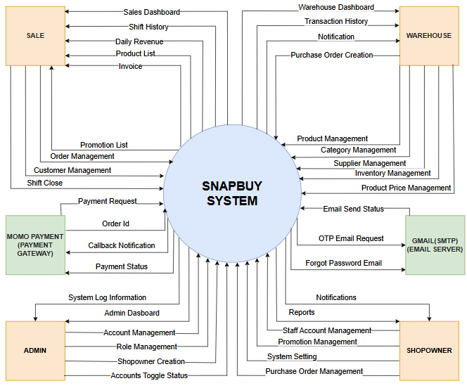
Figure 1.1: Context diagram

1.2 Main Workflows

1.2.1 Order Processing
Link diagram: Diagram
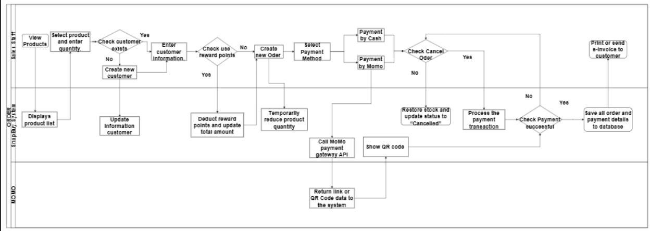

1.2.2 Purchase Order / Import Goods
Link diagram: Diagram
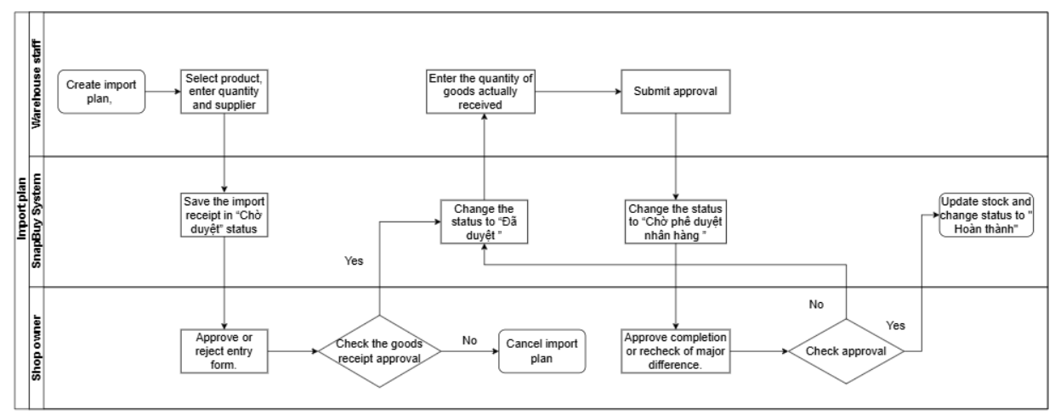

1.2.3 Work Shift
Link diagram: Diagram
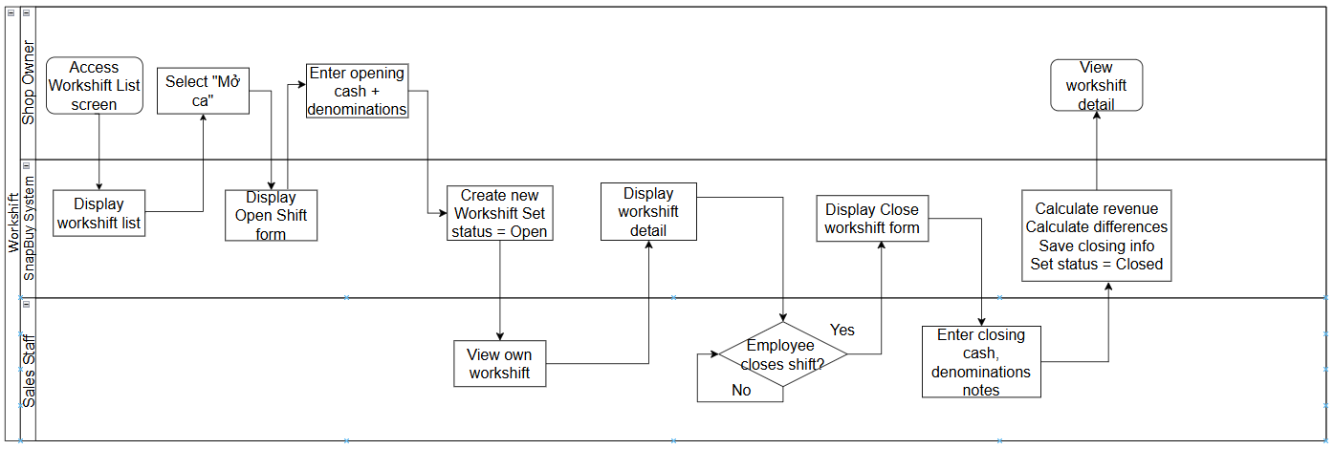

1.3 User Requirements

1.3.1 Actors
# | Actor | Description
1 | Admin | System administrators have full control over users, assign roles and permissions, configure system settings, and oversee overall system operations.
2 | Shop Owner | Business owner responsible for overseeing operations, managing products, inventory, promotions, staff, and reviewing financial and performance reports.
3 | Warehouse Staff | Warehouse personnel responsible for receiving and issuing goods, performing stock adjustments, monitoring inventory levels, and managing purchase orders.
4 | Sales Staff | Sales personnel use the POS system to process orders, handle payments, print invoices, manage customer interactions, and support in-store operations.

1.3.2 Use Cases (UC)

1.3.2.1 Use Cases for Sale Staff
Link diagram: Diagram
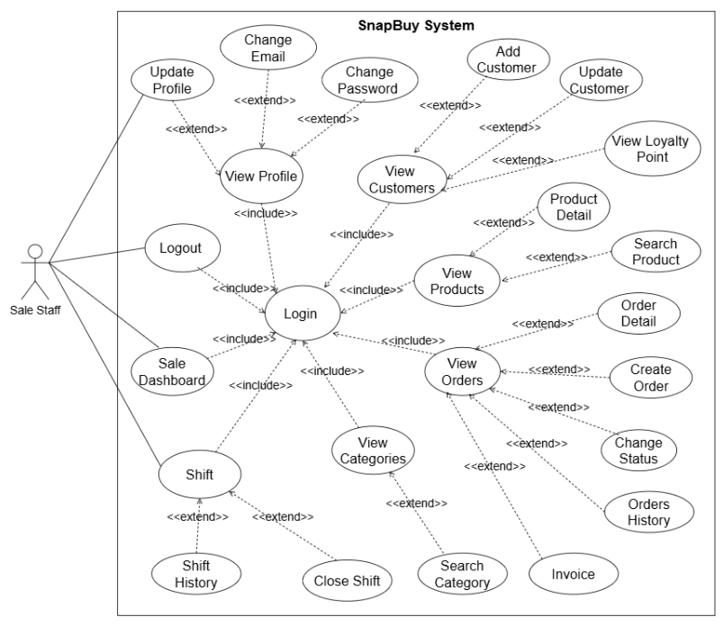

Figure 1.2: UC Sale Staff

1.3.2.2 Use Cases for Warehouse Staff
Link diagram: Diagram
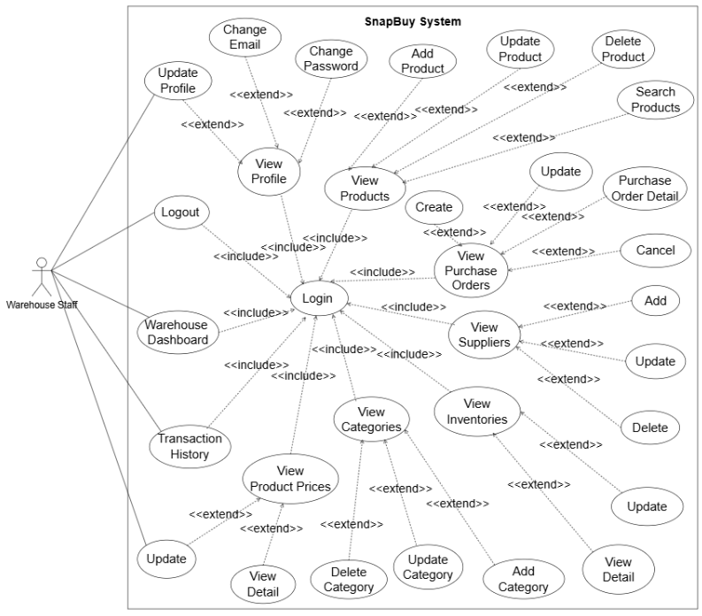

Figure 1.3: UC Warehouse Staff

1.3.2.3 Use Cases for Shop Owner
Link diagram: Diagram
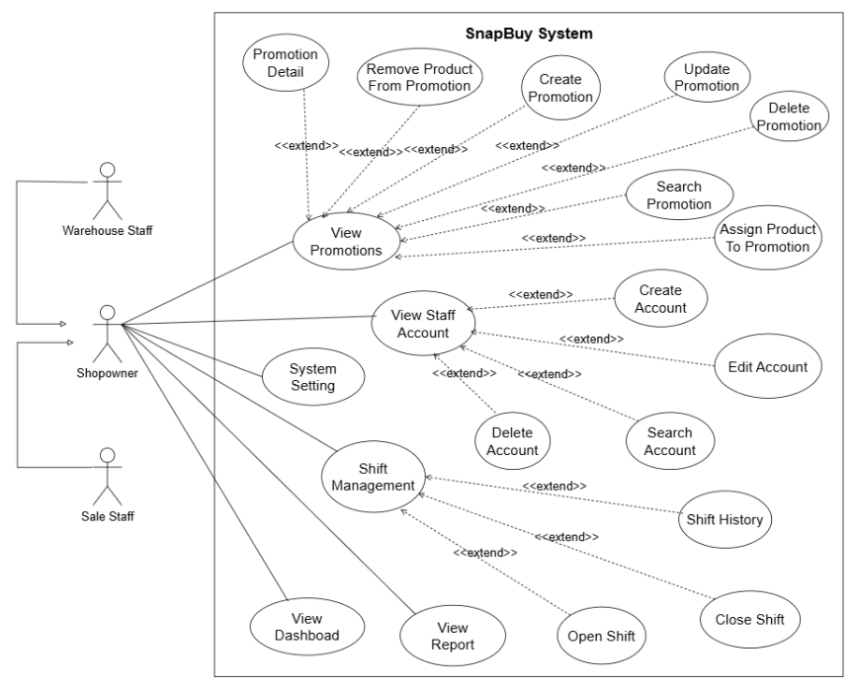

Figure 1.4: UC Shop Owner

1.3.2.4 Use Cases for Admin
Link diagram: Diagram
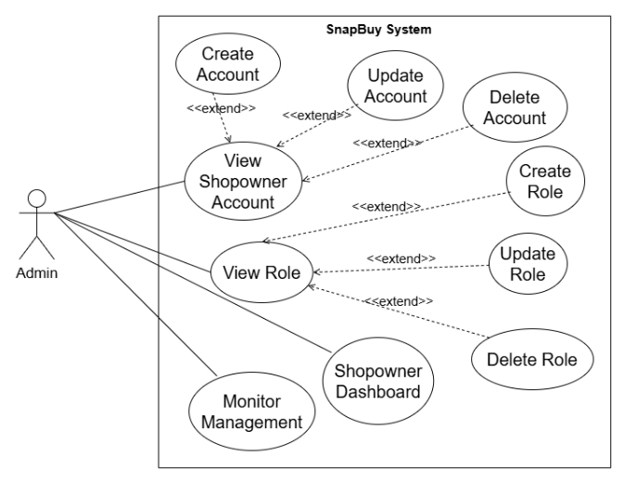

Figure 1.5: UC Admin

1.3.2.5 Descriptions
ID | Use Case | Actors | Use Case Description
1 | View Dashboard page | Admin, Shop Owner | The user can view Dashboard
2 | Login to the system | Admin, Sales Staff, Warehouse Staff, Shop Owner | The user logs into the system by entering a valid account and password
3 | Logout of the system | Admin, Sales Staff, Warehouse Staff, Shop Owner | The user logs out of the system, ending the current session.
4 | Forgot password | Admin, Sales Staff, Warehouse Staff, Shop Owner | The user requests to recover the password by receiving an email containing a password reset link.
5 | Register new customer | Sales Staff | Users enter personal information to register, the system creates a new account and sends a confirmation email if necessary.
6 | Change password | Admin, Sales Staff, Warehouse Staff, Shop Owner | Allows users to securely change their password while logged into the system, ensuring that the new password meets security requirements and updates their credentials in the system
7 | View category list | Admin, Warehouse Staff, Shop Owner | View the list of existing categories in the system.
8 | Add new category | Admin, Warehouse Staff, Shop Owner | Add a new category to the system with necessary information such as name and description.
9 | Edit category | Admin, Warehouse Staff, Shop Owner | Edit information of an existing category, including name or other attributes.
10 | Search Category | Admin, Warehouse Staff, Shop Owner | Search for categories in the system based on criteria like name or category code.
11 | Delete category | Admin, Warehouse Staff, Shop Owner | Delete unused categories from the system.
12 | View product list | Admin, Warehouse Staff, Shop Owner | View the list of all products available in the system.
13 | View product details | Admin, Warehouse Staff, Shop Owner | View detailed information about a product, including category, price, and stock quantity.
14 | Add a product | Admin, Warehouse Staff, Shop Owner | Add a new product to the system with details such as name, category, price, and unit of measure.
15 | Edit product information | Admin, Warehouse Staff, Shop Owner | Edit the details of an existing product, including price, quantity, or other attributes.
16 | Delete product | Admin, Warehouse Staff, Shop Owner | Remove products no longer in use from the system.
17 | Search product | Admin, Warehouse Staff, Shop Owner | Search for product
18 | View product list (Customer) | Customer, Sales Staff, Shop Owner, Admin | The system allows users to view a list of products in the store.
19 | Create Orders | Customer, Sales Staff, Shop Owner, Admin | The system allows users to create new orders when they want to buy products.
20 | Order details | Customer, Sales Staff, Shop Owner, Admin | The system allows users to view details of their orders, including product information, quantity, value and delivery status.
21 | Order history | Sales Staff, Shop Owner, Admin | The system allows users to view order history.
22 | View transaction list | Admin, Shop Owner | The system allows Admin and Shop Owner to view the list of completed transactions.
23 | View account list | Admin, Shop Owner | The system allows Admin and Shop Owner to view the list of all accounts in the system.
24 | View account details | Admin, Shop Owner | The system allows Admin and Shop Owner to view the details of individual accounts, including information such as name, email, role, and activity history.
25 | Add new account | Admin, Shop Owner | The system allows Admin and Shop Owner to create a new account, providing information such as name, email, password, and assigning a role to the account.
26 | Edit account | Admin, Shop Owner | The system allows Admin and Shop Owner to edit account information, including changing name, email, password, or role.
27 | Delete account | Admin, Shop Owner | The system allows Admin and Shop Owner to delete an account from the system, ensuring the account is no longer active.
28 | Search account | Admin, Shop Owner | The system allows Admin and Shop Owner to search for accounts based on criteria such as name, email, role, or other parameters.
29 | Assign user roles | Admin, Shop Owner | Allows the Admin or Shop Owner to assign roles to users. The user is selected from a list, a role is chosen, and the system saves the assignment.
30 | View role list | Admin, Shop Owner | Allows viewing the list of all existing roles in the system. The system displays each role’s name and details.
31 | Add new role | Admin, Shop Owner | Allows adding a new role to the system by entering the role name and saving it. The system confirms and displays the new role.
32 | Edit role | Admin, Shop Owner | Allows editing information of an existing role. The user selects a role, updates its details, and saves the changes.
33 | Delete role | Admin, Shop Owner | Allows deleting a role from the system. The system asks for confirmation before deleting to prevent data loss.
34 | Supplier list | Warehouse Staff, Shop Owner, Admin | View the list of all suppliers with their contact .
35 | View supplier details | Warehouse Staff, Shop Owner, Admin | View detailed information of a specific supplier, including products supplied
36 | Add new supplier | Warehouse Staff, Shop Owner, Admin | Add a new supplier to the system with necessary details like name, contact, and supplied products.
37 | Edit supplier information | Warehouse Staff, Shop Owner, Admin | Update supplier details such as contact information or supplied products.
38 | Delete supplier | Warehouse Staff, Shop Owner, Admin | Remove a supplier from the system if no longer associated with the business.
39 | Search supplier | Warehouse Staff, Shop Owner, Admin | Search for suppliers based on criteria such as name or product category.
40 | Customer list | Admin, Shop Owner | View the list of all customers with their contact and transaction details.
41 | Add new customer | Shop Owner, Admin | Add a new customer to the system by providing personal and contact details.
42 | Edit customer information | Shop Owner, Admin | Update the details of an existing customer, such as contact information or preferences.
43 | Delete customer | Shop Owner, Admin | Remove a customer from the system if no longer active.
44 | Search customer | Shop Owner, Admin | Search for customers based on criteria like name, ID, or contact information.
45 | View customer details | Shop Owner, Admin | View detailed information about a specific customer, including transaction history and preferences.
46 | View transaction list | Shop Owner, Admin | View the list of all transactions made, including their status and associated details.
47 | Create transaction | Shop Owner, Admin | Search for transactions based on criteria such as date, customer, or amount.
48 | Update transaction | Shop Owner, Admin | Add a new transaction to the system, specifying details like customer, amount, and payment method.
49 | Search transaction | Shop Owner, Admin | Modify an existing transaction, such as updating payment details or correcting errors.
50 | View order list | Shop Owner, Admin | View the list of all orders placed, including statuses and details.
51 | View order detail | Shop Owner, Admin | Can view order details
52 | Create new order | Shop Owner, Admin | Place a new order for customers with product and quantity details.
53 | Update Order | Sales Staff, Shop Owner, Admin | Modify an existing order, such as updating products or quantities.
54 | Search order | Shop Owner, Admin | Allows the Admin or Shop Owner to search for orders by order ID, status, creation date, or customer name. The system displays the results matching the search criteria.
55 | Delete order | Shop Owner, Admin | Allows the Admin or Shop Owner to delete an order from the system. The system asks for confirmation before deletion to prevent data loss.
56 | View promotion list | Shop Owner, Admin | Allows viewing the list of all promotions available in the system. The system displays each promotion’s name, period, and status.
57 | View promotion details | Shop Owner, Admin | Allows viewing detailed information of a specific promotion, including its description, applicable products, duration, and discount rate.
58 | Add new promotion | Shop Owner, Admin | Allows creating a new promotion by entering details such as name, description, active period, and discount rate. The system saves and displays the new promotion.
59 | Edit promotion | Shop Owner, Admin | Allows editing the details of an existing promotion. The user selects the promotion, updates its information, and saves the changes.
60 | Delete promotion | Shop Owner, Admin | Allows deleting a promotion from the system. The system requests confirmation before deleting to avoid affecting related sales data.
61 | Assign products to promotion | Shop Owner, Admin | Allows assigning specific products to a promotion. The user selects a promotion, chooses products, and saves. The system updates the product list under that promotion.
62 | Remove product from promotion | Shop Owner, Admin | Allows removing one or more products from a promotion. The system updates the promotion’s product list after removal.
63 | Search promotion | Shop Owner, Admin | Allows searching for promotions by name, date, or status. The system displays the list of promotions matching the search criteria.
64 | Activity history | Admin, Shop Owner, Sales Staff, Warehouse Staff | View a history of actions performed in the system, including changes and updates.
65 | Notifications | Admin, Shop Owner, Sales Staff, Warehouse Staff | View system notifications regarding tasks, updates, or alerts.
66 | Revenue Report | Admin, Shop Owner | View revenue reports in list form, according to basic filtering conditions such as time, branch, product, sales staff.
67 | Product Reports | Admin, Shop Own | View product list reports, including inventory information, selling price, status, and other attributes.
68 | Customer Reports | Admin, Shop Own | Displays a list of customers according to criteria such as customer type, region, registration date, etc
69 | Supplier Reports | Admin, Shop Own | Displays a list of suppliers and related information (supplier code, name, address, status, debt...)
70 | View Workshift List | Admin, Shop Owner | Allows the user to view all employees, their workshift status, and the history of workshifts. Includes searching and filtering by status.
71 | Open Workshift | Admin, Shop Owner | Allows the user to open a new workshift for an employee by entering initial cash and optional denomination details.
72 | Close Workshift | Admin, Shop Owner | Allows the user to close an employee’s active workshift by entering closing cash, denomination details, and optional notes.
73 | View Workshift Detail | Admin, Shop Owner | Allows the user to review detailed shift information including cash reconciliation, revenue, order list, and shift duration.
74 | Search Employee Workshift | Admin, Shop Owner | Allows the user to search workshift records by employee name, username, or shift status.

1.4 System Functionalities

1.4.1 Screens Flow
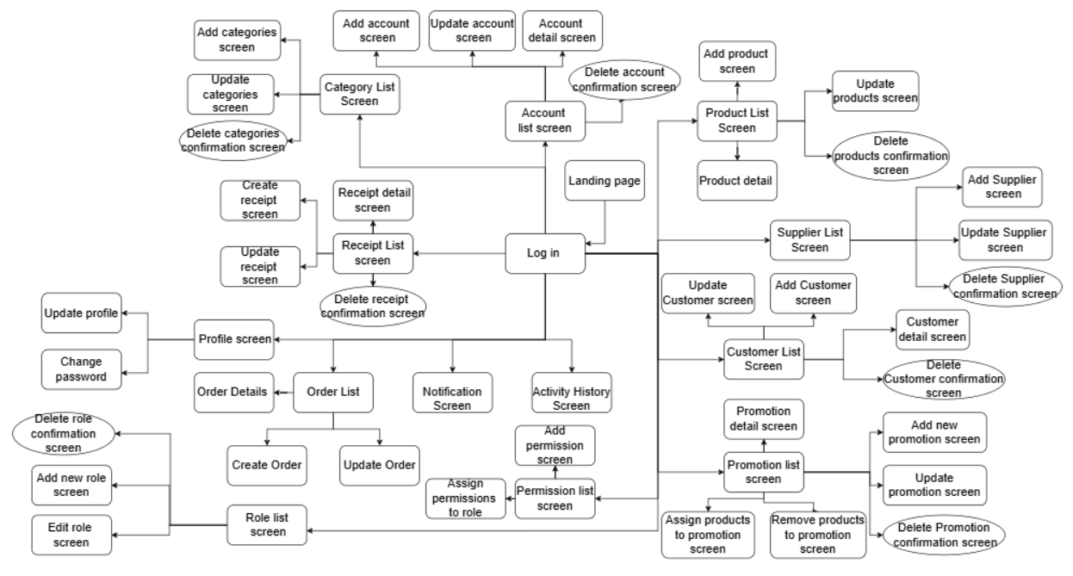
Figure 1.6. Screens Flows

1.4.2 Screen Authorization
Screen | Admin | Shop Owner | Sales Staff | Warehouse Staff
Landing Page | X | X | X | X
View Dashboard page | X | X
Login screen | X | X | X | X
Logout | X | X | X | X
Forgot password | X | X | X | X
Change password | X | X | X | X
View category list | X | X | X | X
Add new category | X | X
Edit category | X | X
View product list | X | X | X | X
View product details | X | X | X | X
Add a product | X | X
Edit product information | X | X
Create Orders | X | X | X
Order details | X | X | X
Update order | X | X | X
Order history | X | X | X
View account list | X | X
View account details | X | X
Add new account | X | X
Edit account | X | X
Assign account roles | X | X
View role list | X
Add new role | X
Edit role | X
Delete role | X
Supplier list | X | X |  | X
View supplier details | X | X |  | X
Add new supplier | X | X
Edit supplier information | X | X
Customer list | X | X | X
Add new customer | X | X | X
Edit customer information | X | X | X
Customer details | X | X | X
Purchase order list | X | X |  | X
Purchase order detail | X | X |  | X
Create Purchase order | X | X |  | X
Update Purchase order | X | X |  | X
Order list | X | X | X
Promotion list | X | X | X
Promotion details | X | X | X
Add new promotion | X | X
Edit promotion | X | X
Assign products to promotion | X | X
Remove product from promotion | X | X
Activity history | X | X | X | X
Notifications | X | X | X | X
Revenue Report | X | X
Product Reports | X | X
Customer Reports | X | X
Supplier Reports | X | X
View Workshift List | X | X
Open Workshift | X | X
Close Workshift | X | X
View Workshift Detail | X | X
Search Employee Workshift | X | X

1.4.3 Non-UI Functions
# | Feature | System Function | Description
1 | Authentication and Role-Based Access | User Authentication | Validates username and password, granting access to role-specific functionalities (Admin, Shop Owner, Warehouse Staff, Sales Staff) based on assigned roles and permissions.
2 | Inventory Tracking | Real-Time Inventory Updates | Automatically updates inventory levels in real-time based on sales, returns, goods Purchase orders, and stock adjustments, ensuring accurate stock data across the system.
3 | Low Stock Alerts | Stock Threshold Monitoring | Continuously monitors inventory levels, generating automatic alerts and purchase suggestions when products fall below predefined reorder points.
4 | Promotion Application | Discount Calculation | Automatically applies promotions, discounts, or customer-specific offers during sales transactions based on predefined rules and promotion periods.
5 | Loyalty Program Management | Points Calculation and Redemption | Tracks customer purchases, calculates loyalty points, and processes point redemptions automatically during transactions or at the customer service counter.
6 | Payment Processing | Multi-Method Payment Handling | Processes multiple payment methods (cash, card, digital wallet) and split payments, ensuring accurate transaction recording and reconciliation.
7 | Tax Calculation | Tax Computation | Automatically calculates applicable taxes for sales transactions based on configured tax rates and ensures compliance with tax reporting requirements.
8 | Inventory Transaction Logging | Audit Trail Generation | Records all inventory movements (Purchase orders, issues, adjustments) in a transaction log, maintaining an audit trail for accountability and analysis.
9 | Commission Calculation | Sales Commission Tracking | Automatically calculates sales commissions for staff based on their sales performance and predefined commission rules, updating payout records.
10 | Notification System | Alert and Message Delivery | Sends system-generated notifications, alerts, and promotional messages to relevant users (all roles) based on system events or user actions.
11 | Employee Time Tracking | Work Hours Calculation | Tracks employee clock-in/out times, calculates total work hours, and manages overtime records for payroll processing.
12 | Customer Data Synchronization | Customer Profile Updates | Synchronizes customer data (profiles, purchase history, loyalty status) across the system to ensure consistency during customer interactions.

1.5 Entity Relationship Diagram
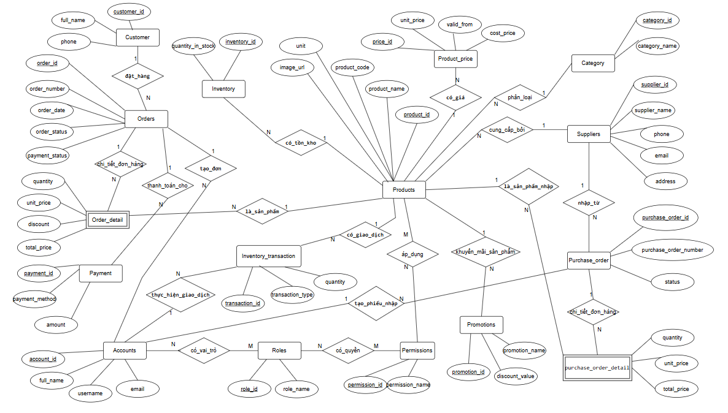
Entities Description
# | Entity | Description
1 | accounts | Stores information about user accounts, including authentication details and user profiles.
2 | categories | Manages product categories, supporting hierarchical organization for product classification.
3 | suppliers | Contains details about suppliers providing products to the system.
4 | products | Holds information about products available for sale, linked to categories and suppliers.
5 | product_price | Tracks pricing details for products, including unit price, cost price, and validity periods.
6 | inventory | Manages stock levels for products, including quantity and reorder thresholds.
7 | inventory_transaction | Records transactions affecting inventory, such as stock additions or deductions.
8 | customers | Stores customer information for order processing and customer management.
9 | roles | Defines user roles with specific access levels within the system.
10 | account_roles | Maps accounts to their assigned roles, enabling role-based access control.
11 | permissions | Defines specific permissions for system actions, organized by module.
12 | role_permission | Associates roles with permissions to control access to system functionalities.
13 | orders | Manages customer orders, including order status, total amount, and related details.
14 | order_detail | Contains details of items in each order, including product, quantity, and pricing.
15 | payments | Tracks payment transactions for orders, including payment method and status.
16 | purchase_order | Manages purchase orders placed with suppliers for restocking products.
17 | purchase_order_detail | Contains details of items in each purchase order, including product and quantity.
18 | promotions | Stores information about promotional campaigns, including discount types and validity.
19 | promotion_product | Links promotions to specific products eligible for the promotional offers.

2. Use Case Specifications

2.1 Authentication

2.1.1 Log in
UC ID and Name | [UC-01] - Log in
Created by | DuongNT17 | Created Date | 03/10/2025
Primary Actor | User | Secondary Actor | N/A
Description | This use case allows users to authenticate into the system using their credentials (username and password).
Trigger | The user opens the login page and provides their credentials to access the system.
Pre-conditions | [PRE-01]- The user must have an existing account and valid login credentials. The login page must be accessible.
Post-conditions | [POST-01] The user is successfully authenticated and granted access to the system based on their role. If the login fails, an error message is displayed.
Normal Flow | - The user navigates to the login page.  - The user enters their username and password.  - The system validates the credentials.  - If valid, the system grants access to the dashboard
Alternative Flow | N/A

2.1.2 Log out
UC ID and Name | [UC-2] Logout
Created by | DuongNT17 | Created Date | 02/10/2025
Primary Actor | User | Secondary Actor | N/A
Description | Allows the administrator or user to securely log out of the system, ensuring that their session is terminated and no unauthorized access can occur after logout.
Trigger | The administrator or user clicks on the "Đăng xuất" button in the system interface.
Pre-conditions | [PRE-01] The user must be logged in.  [PRE-02] The user is on any system page where the logout option is available.
Post-conditions | [POST-01] The user session is terminated, and they are redirected to the login page.  [POST-02] The system ensures no unauthorized access to the previous session data.
Normal Flow | - The user clicks the "Đăng xuất t" button in the system interface.  - The system prompts the user for confirmation of logout (optional).  - The user confirms the action.  - The system terminates the session and clears all session-related data.  - The system redirects the user to the login screen, ensuring the session is closed securely.
Alternative Flow | N/A

2.1.3 Forgot password
UC ID and Name | [UC-03] - Forgot password
Created by | DuongNT17 | Created Date | 02/10/2025
Primary Actor | User | Secondary Actor | N/A
Description | Allows users to reset their password if they forget it, ensuring secure access to the system via an email-based password recovery process.
Trigger | The user clicks on the "Quên mật khẩu" link on the login page.
Pre-conditions | [PRE-01] The user must have a registered account in the system with a valid email address.  [PRE-02] The system must have an active email service to send recovery emails.
Post-conditions | [POST-01] The user receives a password reset link via email.  [POST-02] The user can reset their password and regain access to the system.
Normal Flow | - The user navigates to the login page and clicks on the "Quên mật khẩu" link.  - The system prompts the user to enter their registered email address.  - The user submits their email address.  - The system checks if the provided email exists in the system.  - If the email exists, the system sends a password reset email containing a secure link to the user.  - The user receives the email and clicks on the password reset link.  - The system displays a password reset form, where the user enters a new password and confirms it.  - The system validates the new password (e.g., password strength, match with confirmation) and updates the user's password in the database.  - The system confirms the successful password reset and redirects the user to the login page.
Alternative Flow | N/A

2.1.4 Change password
UC ID and Name | [UC-04] - Change password
Created by | DuongNT17 | Created Date | 02/10/2025
Primary Actor | User | Secondary Actor | N/A
Description | Allows users to securely change their password while logged into the system, ensuring that the new password meets security requirements and updates their credentials in the system.
Trigger | The user clicks on the "Change Password" option in their account settings or profile page.
Pre-conditions | [PRE-01] The user must be logged into the system.  [PRE-02] The user must have access to the change password functionality (typically available in account settings).
Post-conditions | [POST-01] The user's password is updated to the new password.  [POST-02] The system stores the new password securely and invalidates any sessions using the old password (optional).
Normal Flow | - The user navigates to their account settings and selects the "Change Password" option.  - The system prompts the user to enter their current password, a new password, and a confirmation of the new password.  - The user submits the password change request.  - The system verifies that the current password matches the one stored in the database for that user.  - The system validates the new password against security rules (e.g., minimum length, special characters, no reuse of previous passwords, etc.).  - If the validation passes, the system updates the user's password in the database.  - The system confirms the password change and notifies the user of a successful update.  - The system optionally logs the user out and requires a login with the new password for enhanced security.
Alternative Flow | N/A

2.2 Category management

2.2.1 View category list
UC ID and Name | [UC-05]- View Category list
Created by | DatVV | Created Date | 02/10/2025
Primary Actor | Shop Owner, Admin | Secondary Actor | Sales Staff,Warehouse Staff,
Description | Allows the administrator to view the list of product categories available in the system, displaying relevant information such as category name, description, and associated products.
Trigger | The administrator or user clicks on the "Danh mục" tab or option in the system's menu.
Pre-conditions | [PRE-01] The administrator or user must be logged into the system.  [PRE-02] The system contains existing categories.
Post-conditions | [POST-01] The system displays the list of categories, including relevant details like category name, description, and product count (if applicable).  [POST-02] The user can navigate or filter the category list based on available options (if implemented).
Normal Flow | - The administrator or user navigates to the "Danh mục" section via the system's menu.  - The system retrieves the list of categories from the database.  - The system displays the category list, including details such as category name, description, and the number of products in each category.  - The user can scroll through the list to view all categories or use search and filter options (if available) to find specific categories.  - The user can click on a category to view more detailed information or associated products (if supported by the system).
Alternative Flow | N/A

2.2.2 Create category
UC ID and Name | [UC-06] - Create category
Created by | DatVV | Created Date | 02/10/2025
Primary Actor | Admin, Shop Owner | Secondary Actor
Description | Allows the administrator to add a new product category into the system, ensuring that the category is correctly recorded with necessary details such as category name and description.
Trigger | The administrator clicks on the "Thêm danh mục" button in the category management screen.
Pre-conditions | [PRE-01] The administrator must be logged in.  [PRE-02] The administrator has access to the category management screen.
Post-conditions | [POST-01] The new category is successfully added to the system and is visible in the category list.  [POST-02] The system confirms the addition of the new category with a success message.
Normal Flow | - The administrator navigates to the "Danh mục" section of the system.  - The administrator clicks on the "Thêm danh mục" button.  - The system displays a form where the administrator can input details such as:  - Category Name (required)  - Description (optional)  - The administrator fills in the required fields and submits the form.  - The system validates the input (e.g., ensuring the category name is not empty or already exists).  - If the input is valid, the system saves the new category to the database.  - The system displays a success message confirming that the new category has been added.  - The administrator is redirected back to the category list, where the new category is now visible.
Alternative Flow | N/A

2.2.3 Update category
UC ID and Name | [UC-07] - Update category
Created by | DatVV | Created Date | 02/10/2025
Primary Actor | Shop Owner, Admin | Secondary Actor
Description | Allows the administrator to update the details of an existing product category, including the category name and description, ensuring the system reflects the latest category information.
Trigger | The administrator clicks on the edit (pen) icon next to the category they want to modify in the category management screen.
Pre-conditions | [PRE-01] The administrator must be logged into the system.  [PRE-02] The system contains existing categories.  [PRE-03] The administrator has access to the category management screen.
Post-conditions | [POST-01] The category information is successfully updated in the system.  [POST-02] The updated information is reflected in the category list.
Normal Flow | - The administrator navigates to the "Categories" section and views the category list.  - The administrator clicks the edit (pen) icon next to the category they want to modify.  - The system displays a form with the current category details (name, description).  - The administrator updates the category name, description, or other editable fields.  - The administrator submits the changes.  - The system validates the updated information (e.g., ensuring the category name is not a duplicate or empty).  - If validation passes, the system updates the category in the database.  - The system displays a success message confirming that the category has been updated.  - The administrator is redirected back to the category list with the updated information displayed.
Alternative Flow | N/A

2.2.4 Search category
UC ID and Name | [UC-08] - Search category
Created by | DatVV | Created Date | 02/10/2025
Primary Actor | Shop Owner, Admin | Secondary Actor | Sales Staff,Warehouse Staff
Description | Enables users to search for product categories based on keywords or filters.
Trigger | The user initiates a search by entering a keyword or selecting a filter on the search page.
Pre-conditions | [PRE-01] The user has access to the search functionality.  [PRE-02] Categories are available in the database.
Post-conditions | [POST-01] The system displays a list of categories matching the search criteria..
Normal Flow | 1.The user navigates to the Search section.  2. The user enters a keyword in the search bar or selects predefined filters (e.g., category type, popularity).  3. The system validates the search input.  4. The system queries the database for matching categories.  5. The system displays the results in a list format with relevant details (e.g., category name, description).  6. The user selects a category to view more information or associated products.
Alternative Flow | N/A

2.2.5 Delete category
UC ID and Name | [UC-09]-Delete Category
Created by | DatVV | Created Date | 02/10/2025
Primary Actor | Admin , Shop Owner | Secondary Actor | Sales Staff,Warehouse Staff,
Description | Allows the administrator to delete an existing product category from the system, ensuring that the category is removed and no longer available for product assignments.
Trigger | The administrator clicks on the delete (trash) icon next to the category they want to remove in the category management screen.
Pre-conditions | [PRE-01] The administrator must be logged into the system.  [PRE-02] The system contains existing categories.  [PRE-03] The administrator has access to the category management screen.  [PRE-04] The category to be deleted must not be assigned to any active products.
Post-conditions | [POST-01] The selected category is deleted from the system.  [POST-02] The category list is updated, and the deleted category no longer appears.
Normal Flow | - The administrator navigates to the "Categories" section and views the category list.  - The administrator clicks the delete (trash) icon next to the category they want to delete.  - The system displays a confirmation message (e.g., "Bạn có chắc muốn xóa ").  - The administrator confirms the deletion.  - The system checks if the category is currently assigned to any products.  - If the category is assigned to any products, the system displays an error message (e.g., "Không thể xóa danh mục vì nó được gán cho sản phẩm").  - If the category is not assigned, the system deletes the category.  - The system updates the database to remove the category.  - The system displays a success message confirming that the category has been deleted.  - The updated category list is displayed, excluding the deleted category.
Alternative Flow | N/A

2.3 Product management

2.3.1 View product list
UC ID and Name | [UC-10] - View Product List
Created by | DuongNT18 | Created Date | 02/10/2025
Primary Actor | Admin , Shop Owner | Secondary Actor | Sales Staff,Warehouse Staff
Description | Allows the administrator or user to view a list of all products available in the system, displaying relevant details such as product name, price, stock levels, and categories.
Trigger | The administrator or user clicks on the "Sản phẩm" tab or menu option in the system.
Pre-conditions | [PRE-01] The administrator or user must be logged in.  [PRE-02] The system contains products in the product database.
Post-conditions | [POST-01] The system displays the list of products, including product details such as name, price, category, and stock quantity.  [POST-02] The user can interact with the product list, such as searching, filtering, or sorting (if applicable).
Normal Flow | - The administrator or user navigates to the "Sản phẩm" section via the system's menu.  - The system retrieves the list of products from the database.  - The system displays the list of products, including the following details for each product  - The user can scroll through the list to view all products.  - (Optional) The user can use search, filter, or sort functionality (e.g., search by product name, filter by category, or sort by price).  - The user may click on a product for more detailed information or to edit/delete it (depending on system permissions).
Alternative Flow | N/A

2.3.2 View product details
UC ID and Name | [UC-11]-View Product Detail
 | DuongNT18 | Created Date | 02/10/2025
Primary Actor | Admin, Shop Owner | Secondary Actor | Sales Staff,Warehouse Staff
Description | Allows the administrator or user to view detailed information about a specific product, including its name, price, stock levels, description, category, and other related details.
Trigger | The administrator or user clicks on a specific product from the product list.
Pre-conditions | [PRE-01] The administrator or user must be logged in.  [PRE-02] The product exists in the system's product database.
Post-conditions | [POST-01] The system displays detailed information about the selected product.  [POST-02] The user is able to view the complete product details.
Normal Flow | - The administrator or user navigates to the "Sản phẩm" section and selects a specific product from the list.  - The system retrieves the product details from the database based on the product's unique identifier (e.g., Product ID, SKU).  - The system displays the following detailed information about the selected product  - The user reviews the detailed information.  - (Optional) If the user has the necessary permissions, they can choose to edit or delete the product from this screen.
Alternative Flow | N/A

2.3.3 Create product
UC ID and Name | [UC-12] - Create Product
Created by | DuongNT18 | Created Date | 02/10/2025
Primary Actor | Admin , Shop Owner | Secondary Actor | N/A
Description | Allows the administrator to add a new product to the system, including key details like product name, price, category, stock levels, and any other relevant information. The product will then be available for viewing and management within the system.
Trigger | The administrator clicks on the "Thêm sản phẩm" button in the product management screen.
Pre-conditions | [PRE-01] The administrator must be logged into the system.  [PRE-02] The administrator must have access to the product management screen.  [PRE-03] The system must have defined categories to assign to the product (if applicable).
Post-conditions | [POST-01] The new product is successfully added to the product database.  [POST-02] The product is available for viewing, editing, and managing in the product list.
Normal Flow | - The administrator navigates to the "Products" section and clicks on the "Thêm sản phẩm" button.  - The system displays a form to input the new product details.  - The administrator fills out the product information.  - The system validates the input (e.g., ensuring that the product name is unique, price is non-negative, stock levels are integers, etc.).  - The administrator submits the form.  - The system saves the product information in the database.  - The system displays a success message confirming the product has been added.  - The new product appears in the product list, ready for further actions (e.g., edits, deletions).
Alternative Flow | N/A.

2.3.4 Update product
UC ID and Name | [UC-13] - Update Product
Created by | DuongNT18 | Created Date | 02/10/2025
Primary Actor | Admin | Secondary Actor | Shop Owner
Description | Allows the administrator to edit the details of an existing product in the system, enabling updates to information such as product name, price, stock levels, description, and category.
Trigger | The administrator clicks on the pen icon next to the product they want to modify in the product list.
Pre-conditions | [PRE-01] The administrator must be logged into the system.  [PRE-02] The administrator must have access to the product management screen.  [PRE-03] The product to be edited must exist in the product database.
Post-conditions | [POST-01] The product information is successfully updated in the product database.  [POST-02] The updated product details are reflected in the product list.
Normal Flow | - The administrator navigates to the "Products" section and views the product list.  - The administrator clicks the pen icon next to the specific product they wish to edit.  - The system retrieves the current product details and displays them in an editable form.  - The administrator makes the necessary changes to the product information.  - The system validates the input (e.g., ensuring that the product name remains unique, price is non-negative, stock levels are integers, etc.).  - The administrator submits the updated product information.  - The system saves the updated product information in the database.  - The system displays a success message confirming that the product has been updated.  - The updated product appears in the product list with the new details.
Alternative Flow | N/A

2.3.5 Search product
UC ID and Name | [UC-14] - Search Product
Created by | DuongNT18 | Created Date | 02/10/2025
Primary Actor | Admin | Secondary Actor | Warehouse manager
Description | Enables users to search for products by entering keywords or applying filters..
Trigger | The user initiates a search by entering a keyword or selecting filters on the search interface.
Pre-conditions | [PRE-01] The user has access to the search functionality.  [PRE-02] Products are available in the database.
Post-conditions | [POST-01] The system displays a list of products matching the search criteria
Normal Flow | 1. The user navigates to the Search section.  2. The user enters a keyword in the search bar or applies filters (e.g., price range, category, rating).  3. The system validates the search input.  4. The system queries the database for products matching the criteria.  5. The system displays a list of products with relevant details such as name, price, description, and availability.  6. The user selects a product to view its details or add it to the cart.
Alternative Flow | N/A

2.3.6 Delete product
UC ID and Name | [UC-15] - Delete Product
Created by | DuongNT18 | Created Date | 02/10/2025
Primary Actor | Admin | Secondary Actor | Shop Owner
Description | Remove products no longer in use from the system.
Trigger | The administrator clicks on the delete (trash) icon next to the product they want to remove in the product management screen.
Pre-conditions | [PRE-01] The administrator must be logged into the system.  [PRE-02] The system contains existing product  [PRE-03] The administrator has access to the product management screen.  [PRE-04] The category to be deleted must not be assigned to any active order in status “ Chờ duyệt”
Post-conditions | [POST-01] The selected product is deleted from the system.  [POST-02] The product list is updated, and the deleted product no longer appears.
Normal Flow | - The administrator navigates to the "Product" section and views the category list.  - The administrator clicks the delete (trash) icon next to the Product they want to delete.  - The system displays a confirmation message (e.g., "Bạn có chắc muốn xóa ").  - The administrator confirms the deletion.  - The system checks if the product is currently assigned to any order .  - If the category is assigned to any order, the system displays an error message (e.g., "Không thể xóa sản phẩm vì nó được gán với đơn hàng đang ở trạng thái chờ duyệt").  - If the product is not assigned, the system deletes the product.  - The system updates the database to remove the product .  - The system displays a success message confirming that the product has been deleted.  - The updated product list is displayed, excluding the deleted product
Alternative Flow | N/A

2.4 Order management

2.4.1 View order list
UC ID and Name | [UC-16] -View order list
Created by | DatVV | Created Date | 02/10/2025
Primary Actor | Sales Staff | Secondary Actor | Shop Owner, Admin
Description | Allows users to view the order list.
Trigger | User confirm product they want and click on “Đặt hàng”
Pre-conditions | [PRE-01] The user has access to the Orders functionality.  [PRE-02] Products and customer details are available in the database.
Post-conditions | [POST-01] A new order is created and saved to the database in the pending confirmation status.
Normal Flow | 1. User navigates to the Create Order page.  2. User confirms the products in the cart  3. User clicks "Đặt hàng" button  4.The system saves the order in the database in the pending confirmation status.  5. The system displays a success message and provides the order details
Alternative Flow | N/A

2.4.2 Create orders
UC ID and Name | [UC-17] -Create Orders
Created by | DatVV | Created Date | 02/10/2025
Primary Actor | Sale Staff | Secondary Actor | Shop Owner, Admin
Description | Allows sales staff to create a new order by entering customer information, product, quantity and value.
Trigger | Sales staff select the “Tạo đơn hàng” function in the system.
Pre-conditions | [PRE-01] Sales staff is logged in and has permission to create orders.
Post-conditions | [POST-01] A new order is created and saved to the database in the pending confirmation status.
Normal Flow | 1. Sales staff selects “Create Order”.  2. Enter customer and product information.  3. Confirm and save the order.  4. The system displays a success message and provides the order details
Alternative Flow | N/A

2.4.3 View order details
UC ID and Name | [UC-18] -View Order Details
Created by | DatVV | Created Date | 02/10/2025
Primary Actor | Sale Staff | Secondary Actor | Shop Owner, Admin
Description | Allows the user to view detailed information of a specific order, including customer details, product list, total amount, and order status.
Trigger | Sales staff selects an order from the order list.
Pre-conditions | [PRE-01] Sales staff is logged in  [PRE-02] The selected order exists in the system.
Post-conditions | [POST-01] The system displays all order details.
Normal Flow | 1. The sales staff opens the order list.  2. Selects a specific order.  3. The system displays the full order details.
Alternative Flow | N/A

2.4.4 Update order
UC ID and Name | [UC-19] -Update order
Created by | DatVV | Created Date | 02/10/2025
Primary Actor | Sale Staff | Secondary Actor | Shop Owner, Admin
Description | Allows the sales staff to modify existing order details such as product quantity, customer info, or notes before the order is confirmed.
Trigger | Sales staff selects the edit button on order list screen
Pre-conditions | [PRE-01] The order exists and is in “Đang chờ xử lý” status.  [PRE-02] Sales staff is logged in
Post-conditions | [POST-01] The updated order is saved successfully in the system.
Normal Flow | 1. Sales staff open an existing order.  2. Updates order details.  3. Click “Lưu”.  4. The system updates the order information.
Alternative Flow | N/A

2.4.5 Search order
UC ID and Name | [UC-20] -Search order
Created by | DatVV | Created Date | 02/10/2025
Primary Actor | Sale Staff | Secondary Actor | Shop Owner, Admin
Description | Allows searching for orders based on criteria such as order ID, customer name, or date created.
Trigger | Sales staff enter search criteria in the search field.
Pre-conditions | [PRE-01] -Sale staff must be logged into the system.  [PRE-02] -Orders exist in the system.
Post-conditions | [POST-01] - The system displays orders matching the search criteria.
Normal Flow | 1. Sales staff opens the “Search Order” function.  2. Enter search information.  3. Click “Search”.  4. The system shows matching results.
Alternative Flow | N/A

2.4.6 Delete order
UC ID and Name | [UC-21] -Delete Order
Created by | DatVV | Created Date | 02/10/2025
Primary Actor | Sales Staff | Secondary Actor | Shop Owner, Admin
Description | Allows sales staff to delete an order from the system if it has not been processed yet.
Trigger | Sales staff selects the Delete icon on Order list screen
Pre-conditions | [PRE-01] -Sale staff must be logged into the system..  [PRE-02] -The order exists and is in “Chờ phê duyệt” status.
Post-conditions | [POST-01] -The order is permanently removed from the order list.
Normal Flow | 1. Sales staff selects an order to delete.  2. The system shows a confirmation message.  3. Sales staff confirms deletion.  4. The system removes the order from the database.
Alternative Flow | N/A

2.5 Account management

2.5.1 View account list
UC ID and Name | [UC-22] -View account list
Created by | DuongNT18 | Created Date | 08/10/2025
Primary Actor | Admin | Secondary Actor | Shop Owner
Description | Allows the Admin or Shop Owner to view all user accounts registered in the system, including Sales Staff and Warehouse Staff.
Trigger | Admin or Shop Owner selects the “Tài khoản nội bột” function.
Pre-conditions | [PRE-01] The user is logged in with permission to view accounts.
Post-conditions | [POST-01] The system displays all existing user accounts.
Normal Flow | 1. Admin/Shop Owner opens the “Account List” page.  2. The system retrieves and displays all accounts with details such as username, name, role, and status.
Alternative Flow | N/A

2.5.2 View account details
UC ID and Name | [UC-23] -View account details
Created by | DuongNT18 | Created Date | 08/10/2025
Primary Actor | Admin | Secondary Actor | Shop Owner
Description | Allows the Admin or Shop Owner to view detailed information of a specific user account, including profile information and assigned roles.
Trigger | Admin or Shop Owner selects a specific account from the list.
Pre-conditions | [PRE-01] The user must log in to system  [PRE-02] The selected account exists in the system.
Post-conditions | [POST-01] Detailed account information is displayed.
Normal Flow | 1. Admin/Shop Owner selects an account.  2. System retrieves and displays detailed information
Alternative Flow | N/A

2.5.3 Add new account
UC ID and Name | [UC-24] -Add new account
Created by | DuongNT18 | Created Date | 08/10/2025
Primary Actor | Admin | Secondary Actor | Shop Owner
Description | Allows the Admin or Shop Owner to create a new user account for Sales Staff or Warehouse Staff.
Trigger | Admin or Shop Owner clicks “Thêm mới”
Pre-conditions | [PRE-01] The user must login to system  [PRE-02] The user has permission to create new accounts
Post-conditions | [POST-01] A new user account is successfully created and stored in the system.
Normal Flow | 1. Admin/Shop Owner selects “Thêm mới.”  2. Enter account information (username, password, role, contact).  3. Clicks “Tạo mới.”  4. The system validates and creates the new account.
Alternative Flow | N/A

2.5.4 Edit account
UC ID and Name | [UC-25] -Edit account
Created by | DuongNT18 | Created Date | 08/10/2025
Primary Actor | Admin | Secondary Actor | Shop Owner
Description | Allows the Admin or Shop Owner to update existing account information (e.g., name, contact info, role).
Trigger | Admin or Shop Owner selects Edit icon on account list page
Pre-conditions | [PRE-01] The user must login to system  [PRE-02] The account exists and the user has edit permission.
Post-conditions | [POST-01] The account is successfully updated in the system.
Normal Flow | 1. Admin/Shop Owner selects an account.  2. Updates account information.  3. Clicks “Cập nhật.”  4. The system validates and updates the account.
Alternative Flow | N/A

2.5.5 Delete account
UC ID and Name | [UC-26] -Delete account
Created by | DuongNT18 | Created Date | 08/10/2025
Primary Actor | Admin | Secondary Actor | Shop Owner
Description | Allows the Admin or Shop Owner to deactivate a user account (e.g., when an employee leaves the company).
Trigger | Admin or Shop Owner selects “Ngừng hoạt động”
Pre-conditions | [PRE-01] The user must login to system  [PRE-02] The user has permission to deactivate accounts
Post-conditions | [POST-01] The account will be deactivated and unable to log into the system.
Normal Flow | 1. Admin/Shop Owner selects the account to deactivate  2. The system asks for confirmation.  3. User confirms deletion.  4. The system removes the account.
Alternative Flow | N/A

2.5.6 Search account
UC ID and Name | [UC-27] -Add new account
Created by | DuongNT18 | Created Date | 08/10/2025
Primary Actor | Admin | Secondary Actor | Shop Owner
Description | Allows the Admin or Shop Owner to search for user accounts by username, name, or role.
Trigger | The user enters search criteria and clicks “Search.”
Pre-conditions | [PRE-01] The user must login to system  [PRE-02] Accounts exist in the system.
Post-conditions | [POST-01] The system displays a list of matching accounts.
Normal Flow | 1. Admin/Shop Owner opens “Search Account.”  2. Enter search keyword.  3. Click “Search.”  4. The system displays matching results.
Alternative Flow | N/A

2.6 Role & Permission Management

2.6.1 View role list
UC ID and Name | [UC-28] -View role list
Created by | DuongNT18 | Created Date | 08/10/2025
Primary Actor | Admin | Secondary Actor | N/A
Description | Allows the Admin to view all roles currently defined in the system.
Trigger | Admin selects “Danh sách vai trò.”
Pre-conditions | [PRE-01] Admin is logged in and has system access.
Post-conditions | [POST-01] The system displays all existing roles with details (e.g., role name, description).
Normal Flow | 1. Admin opens the “Danh sách vai trò” page.  2. The system retrieves and displays all roles.
Alternative Flow | N/A

2.6.2 Add new role
UC ID and Name | [UC-29] -Add new role
Created by | DuongNT18 | Created Date | 08/10/2025
Primary Actor | Admin | Secondary Actor | N/A
Description | Allows the Admin to create a new role that can be later assigned to users.
Trigger | Admin clicks “Thêm vai trò”
Pre-conditions | [PRE-01] Admin is logged in and has permission to manage roles.
Post-conditions | [POST-01] A new role is created and saved in the system.
Normal Flow | 1. Admin selects “Thêm vai trò ”  2. Enter role name and description.  3. Click “Thêm mới”  4. The system validates and creates the new role.
Alternative Flow | N/A

2.6.3 Edit role
UC ID and Name | [UC-30] -Edit role
Created by | DuongNT18 | Created Date | 08/10/2025
Primary Actor | Admin | Secondary Actor | N/A
Description | Allows the Admin to edit the information of an existing role (e.g., name or description).
Trigger | Admin selects a role to edit.
Pre-conditions | [PRE-01] The selected role exists in the system.
Post-conditions | [POST-01] Role information is updated successfully.
Normal Flow | 1. Admin selects a role from the list.  2. Updates role details.  3. Clicks “Cập nhật”  4. The system validates and updates the role.
Alternative Flow | N/A

2.6.4 Delete role
UC ID and Name | [UC-31] -View role list
Created by | DuongNT18 | Created Date | 08/10/2025
Primary Actor | Admin | Secondary Actor | N/A
Description | Allows the Admin to delete an existing role from the system
Trigger | Admin selects Delete icon on Role list page
Pre-conditions | [PRE-01] The role exists and is not currently assigned to any user.
Post-conditions | [POST-01] The role is removed from the system.
Normal Flow | 1. Admin selects a role.  2. The system asks for confirmation.  3. Admin confirms deletion.  4. The system removes the role.
Alternative Flow | N/A

2.7 Supplier Management

2.7.1 View supplier list
UC ID and Name | [UC-32] -View supplier list
Created by | DatVV | Created Date | 08/10/2025
Primary Actor | Admin, Shop Owner | Secondary Actor | Warehouse Staff
Description | Displays a list of all suppliers with key details like name, contact information, and status.
Trigger | The admin selects the "Nhà cung cấp" option from the system.
Pre-conditions | [PRE-01] -The admin must be logged in.  [PRE-02] -The system must have supplier data stored.
Post-conditions | [POST-01] - The system displays the supplier list with relevant details (name, contact information, status).
Normal Flow | - The admin clicks on the "Nhà cung cấp" option.  - The system retrieves the supplier data.  - The supplier list is displayed with key information (name, contact details, status).
Alternative Flow | N/A

2.7.2 View supplier details
UC ID and Name | [UC-33] -View supplier details
Created by | DatVV | Created Date | 08/10/2025
Primary Actor | Admin, Shop Owner | Secondary Actor | Warehouse Staff
Description | Displays detailed information of a specific supplier, including contact information, products provided, and contract status..
Trigger | The admin selects a specific supplier from the supplier list.
Pre-conditions | [PRE-01] -The admin must be logged in.  [PRE-02] -There must be supplier data available in the system.
Post-conditions | [POST-01] - The system displays the selected supplier's detailed information.
Normal Flow | - The admin clicks on a supplier from the supplier list.  - The system retrieves the supplier's details.  - The system displays detailed supplier information, including name, contact information, products/services, and contract status.
Alternative Flow | N/A

2.7.3 Create supplier
UC ID and Name | [UC-34] -Create supplier
Created by | DatVV | Created Date | 3/10/2025
Primary Actor | Admin, Shop Owner | Secondary Actor | Warehouse Staff
Description | Allows the admin to add a new supplier to the system, including details like name, email and contact information
Trigger | The admin clicks on the "Thêm nhà cung cấp" and enters the supplier add page.
Pre-conditions | [PRE-01] -The admin must be logged in.  [PRE-02] -The system must provide a supplier form for input.
Post-conditions | [POST-01] - The system saves the new supplier's information and updates the supplier list.
Normal Flow | - The admin selects "Thêm nhà cung cấp" button  - The admin inputs the new supplier's details.  - The system validates the information.  - The system adds the new supplier to the database and confirms the action.
Alternative Flow | N/A

2.7.4 Update supplier
UC ID and Name | [UC-35] -Update supplier
Created by | DatVV | Created Date | 3/10/2025
Primary Actor | Admin, Shop Owner | Secondary Actor | Warehouse Staff
Description | Allows the admin to update the information of an existing supplier, such as email, phone number or contact information.
Trigger | The admin select a supplier in the list and choose to edit their information
Pre-conditions | [PRE-01] -The admin must be logged in.  [PRE-02] -There must be existing supplier data in the database to edit
Post-conditions | [POST-01] - The system saves the updated information and reflects the changes in the supplier list.
Normal Flow | - The admin selects a supplier to edit.  - The system displays the supplier's current details.  - The admin edits the information.  - The system validates the changes and saves the updated information.
Alternative Flow | N/A

2.7.5 Search supplier
UC ID and Name | [UC-36] -Search supplier
Created by | DatVV | Created Date | 3/10/2025
Primary Actor | Admin, Shop Owner | Secondary Actor | Warehouse Staff
Description | Allows users to search for supplier records using various criteria, such as supplier name, ID
Trigger | The user initiates a search by entering specific criteria in the supplier search bar or applies filters.
Pre-conditions | [PRE-01] The admin must be logged in.  [PRE-02] The user has access to the Supplier List screen  [PRE-03] Supplier records are available in the database.
Post-conditions | [POST-01] -The system displays a list of suppliers matching the search criteria
Normal Flow | 1. The user navigates to the Search Supplier section.  2. The user enters search criteria, such as supplier name, ID, location, or products offered, or applies specific filters (e.g., active/inactive status).  3. The system validates the search input.  4. The system queries the database for suppliers matching the criteria.  5. The system displays a list of suppliers, including details like supplier name, ID, location, and contact information.  6. The user selects a supplier from the list to view detailed information or perform actions like editing details, viewing orders, or updating status.
Alternative Flow | N/A

2.7.6 Delete supplier
UC ID and Name | [UC-37] -Delete supplier
Created by | DatVV | Created Date | 3/10/2025
Primary Actor | Admin, Shop Owner | Secondary Actor | Warehouse Staff
Description | Allows users to "soft delete" a supplier, which means marking the supplier as inactive or hidden, without actually removing it from the system.
Trigger | The user selects a supplier and clicks the delete icon to hide the supplier from the active list.
Pre-conditions | [PRE-01] - The admin must to login  [PRE-02] - The supplier exists in the database.
Post-conditions | [POST-01] - The supplier record is marked as inactive or hidden, but the data remains in the system.  [POST-02]- The supplier no longer appears in the active supplier list but can still be viewed in archived
Normal Flow | 1.The user navigates to the Supplier List section.  2. The user searches for and selects the supplier to be soft deleted.  3. The user clicks the Delete icon.  4. The system prompts the user to confirm the action.  5. The user confirms the soft deletion.  6. The system marks the supplier as inactive, updating a field like "is_deleted" or "status" in the database (e.g., setting "is_deleted" to true or "status" to "inactive").  7. The supplier is hidden from the active supplier list but remains in the system for historical records.  8. The system displays a success message confirming the deletion.
Alternative Flow | N/A

2.8 Customer Management

2.8.1 View customer list
UC ID and Name | [UC-38] -View customer list
Created by | DuongNT17 | Created Date | 08/10/2025
Primary Actor | Sale Staff | Secondary Actor | Admin, Shop Owner
Description | Allows Sales Staff to view the list of all customers who have been registered in the system. This helps during sales to identify returning customers for loyalty points or promotions..
Trigger | Sales Staff selects “Khách hàng” from the menu during or outside a sale transaction.
Pre-conditions | [PRE-01] -The Sales Staff is logged in  [PRE-02] -Customers exist in the system.
Post-conditions | [POST-01] - - The system displays the supplier list with relevant details (name, contact information, status).
Normal Flow | 1. Sales Staff opens “Danh sách”  2. The system retrieves and displays all customers with details such as name, phone, total purchases, and loyalty status.
Alternative Flow | N/A

2.8.2 Add new customer
UC ID and Name | [UC-39] -Add new customer
Created by | DuongNT17 | Created Date | 08/10/2025
Primary Actor | Sale Staff | Secondary Actor | Admin, Shop Owner
Description | Allows Sales Staff to add a new customer’s information into the system when the customer makes a purchase and wishes to earn loyalty points or receive promotions.
Trigger | Sales Staff clicks “Thêm khách hàng” during or after a sales transaction.
Pre-conditions | [PRE-01] The Sales Staff is logged in  [PRE-02] Sales Staff has permission to register customers.
Post-conditions | [POST-01] A new customer profile is created and stored in the database.
Normal Flow | 1. Sales Staff opens the “Thêm khách hàng” form.  2. Inputs customer details such as name, phone, and contact info.  3. Clicks “Thêm mới”  4. The system validates and creates the new customer profile.
Alternative Flow | N/A

2.8.3 Edit customer
UC ID and Name | [UC-40] -Edit customer
Created by | DuongNT17 | Created Date | 08/10/2025
Primary Actor | Sale Staff | Secondary Actor | Admin, Shop Owner
Description | Allows Sales Staff to update customer information when contact details change or corrections are needed.
Trigger | Sales Staff selects edit icons for an existing customer.
Pre-conditions | [PRE-01] The Sales Staff is logged in  [PRE-02] The customer record exists in the system.
Post-conditions | [POST-01] Updated information is stored successfully.
Normal Flow | 1. Sales Staff selects a customer from the list.  2. Updates relevant information.  3. Clicks “Lưu”  4. The system validates and updates the record.
Alternative Flow | N/A

2.8.4 Delete customer
UC ID and Name | [UC-41] -Delete customer
Created by | DuongNT17 | Created Date | 08/10/2025
Primary Actor | Sale Staff | Secondary Actor | Admin, Shop Owner
Description | Allows Sales Staff to delete incorrect or duplicate customer records. Customers are not system users, so deleting does not affect system login or security.
Trigger | Sales Staff selects delete icons on a customer record.
Pre-conditions | [PRE-01] The Sales Staff is logged in  [PRE-02] The selected customer exists and is not linked to ongoing or pending transactions.
Post-conditions | [POST-01] The customer record is removed from the system.
Normal Flow | 1. Sales Staff selects the customer to delete.  2. The system asks for confirmation.  3. Sales Staff confirms deletion.  4. The system deletes the customer.
Alternative Flow | N/A

2.8.5 Search customer
UC ID and Name | [UC-42] -Search customer
Created by | DuongNT17 | Created Date | 08/10/2025
Primary Actor | Sale Staff | Secondary Actor | Admin, Shop Owner
Description | Allows Sales Staff to quickly find customer information by name or phone number to apply loyalty points or check promotion eligibility.
Trigger | Sales Staff enters customer data in the search bar and clicks “Search.” icons
Pre-conditions | [PRE-01] The Sales Staff is logged in  [PRE-02] Customer data exists in the system.
Post-conditions | [POST-01] Matching customer records are displayed.
Normal Flow | 1. Sales Staff enter the customer’s name or phone number.  2. Click “Search.” icons  3. The system retrieves and displays matching results.
Alternative Flow | N/A

2.8.6 View customer detail
UC ID and Name | [UC-43] -View customer detail
Created by | DuongNT17 | Created Date | 08/10/2025
Primary Actor | Sale Staff | Secondary Actor | Admin, Shop Owner
Description | Allows Sales Staff to view detailed information about a customer, including contact details, purchase history, loyalty points, and applied promotions.
Trigger | Sales Staff selects a customer from the customer list.
Pre-conditions | [PRE-01] The Sales Staff is logged in  [PRE-02] The customer exists in the system.
Post-conditions | [POST-01] Customer details are displayed for reference.
Normal Flow | 1. Sales Staff selects a customer.  2. The system retrieves detailed information (contact, transaction history, loyalty status).  3. Data is displayed on screen.
Alternative Flow | N/A

2.9 Purchase order Management

2.9.1 View Purchase order list
UC ID and Name | [UC-44] -View Purchase order list
Created by | DuongNT17 | Created Date | 08/10/2025
Primary Actor | Warehouse Staff | Secondary Actor | Admin, Shop Owner
Description | The system allows the user to view the list of all warehouse entry Purchase orders, including details of each entry such as date, supplier, product, and quantity.
Trigger | In warehouse manager interface user click on “Phiếu nhập kho”
Pre-conditions | [PRE-01] The warehouse or storage location must exist in the system.  [PRE-02] A purchase order or delivery note related to the received goods may exist  [PRE-03] The warehouse staff must be logged into the system
Post-conditions | [POST-01] The warehouse staff can see a list of warehouse entry Purchase orders.
Normal Flow | 1.The warehouse manager navigates to the "Phiếu nhập kho" section.  2.The system displays a list of warehouse entry Purchase orders.  3.The user can filter and search the list by date, product, or supplier.  4.The user selects a Purchase order to view detailed information.
Alternative Flow | N/A

2.9.2 View Purchase order detail
UC ID and Name | [UC-45] -View Purchase order detail
Created by | DuongNT17 | Created Date | 08/10/2025
Primary Actor | Warehouse Staff | Secondary Actor | Admin, Shop Owner
Description | Allows Warehouse Staff to view detailed information about a specific Purchase order, including items received, quantities, and supplier details.
Trigger | Warehouse Staff selects a specific Purchase order from the list.
Pre-conditions | [PRE-01] The selected Purchase order exists in the system.  [PRE-02] The warehouse staff must be logged into the system
Post-conditions | [POST-01] Detailed Purchase order information is displayed.
Normal Flow | 1. Warehouse Staff selects a Purchase order.  2. The system retrieves and displays full details: supplier info, items, quantities, total cost, and date.
Alternative Flow | N/A

2.9.3 Create Purchase order
UC ID and Name | [UC-46] -Create Purchase order
Created by | DuongNT17 | Created Date | 08/10/2025
Primary Actor | Warehouse Staff | Secondary Actor | Admin, Shop Owner
Description | This use case describes the process of creating a new warehouse entry (Purchase order) to record the Purchase order of goods or products into the warehouse after a purchase order or delivery is fulfilled
Trigger | In warehouse manager interface user click on “Tạo phiếu nhập” button
Pre-conditions | [PRE-01] The warehouse or storage location must exist in the system.  [PRE-02] A purchase order or delivery note related to the received goods may exist  [PRE-03] The user must have the necessary permissions to create warehouse entries.
Post-conditions | [POST-01] The Purchase order is successfully created, and the inventory is updated to reflect the newly received products.  [POST-02] The system has logged the warehouse entry for future reference and tracking.  [POST-03] Any discrepancies (overages, shortages, or damages) are recorded and reported to relevant stakeholders.
Normal Flow | 1. Warehouse Staff selects “Tạo phiếu nhập”  2. Enters supplier and item details (product, quantity, unit price).  3. Clicks “Thêm mới”  4. The system validates and saves the Purchase order, updating stock levels.
Alternative Flow | N/A

2.9.4 Update Purchase order
UC ID and Name | [UC-47] -Update Purchase order
Created by | DuongNT17 | Created Date | 08/10/2025
Primary Actor | Warehouse Staff | Secondary Actor | Admin, Shop Owner
Description | Allows Warehouse Staff to modify an existing Purchase order (e.g., update quantity, item, or supplier details) before final confirmation.
Trigger | Warehouse Staff selects “Sửa phiếu” on a specific Purchase order.
Pre-conditions | [PRE-01] The warehouse or storage location must exist in the system.  [PRE-02] The Purchase order exists and has not been finalized or approved.  [PRE-03] The warehouse staff must be logged into the system
Post-conditions | [POST-01] The Purchase order is successfully updated.
Normal Flow | 1. Warehouse Staff opens the Purchase order to edit.  2. Updates necessary fields.  3. Click “Lưu”  4. The system validates and updates the Purchase order information.
Alternative Flow | N/A

2.9.5 Search Purchase order
UC ID and Name | [UC-48] -Search Purchase order
Created by | DuongNT17 | Created Date | 08/10/2025
Primary Actor | Warehouse Staff | Secondary Actor | Admin, Shop Owner
Description | Allows Warehouse Staff to search for Purchase orders based on criteria such as Purchase order number, supplier name, or date.
Trigger | Warehouse Staff enters search criteria and clicks “Search.” icons
Pre-conditions | [PRE-01] Purchase orders exist in the system.  [PRE-02] The warehouse staff must be logged into the system
Post-conditions | [POST-01] Matching Purchase orders are displayed.
Normal Flow | 1. Warehouse Staff enters search filters (Purchase order code, supplier, date, etc.).  2. Click “Search.” icon  3. The system retrieves and displays matching results.
Alternative Flow | N/A

2.9.6 Delete Purchase order
UC ID and Name | [UC-49] -Delete Purchase order
Created by | DuongNT17 | Created Date | 08/10/2025
Primary Actor | Warehouse Staff | Secondary Actor | Admin, Shop Owner
Description | Allows Warehouse Staff to delete a Purchase order record that was created incorrectly or is no longer needed.
Trigger | Warehouse Staff selects “Hủy phiếu”
Pre-conditions | [PRE-01] The Purchase order exists and is not finalized or linked to completed transactions.  [PRE-02] The Purchase orders must be in "Draft" status  [PRE-03] The warehouse staff must be logged into the system
Post-conditions | [POST-01] The Purchase order is removed from the system and stock levels are reverted if necessary.
Normal Flow | 1. Warehouse Staff selects a Purchase order to delete.  2. The system asks for confirmation.  3. Warehouse Staff confirms deletion.  4. The system deletes the Purchase order and adjusts stock.
Alternative Flow | N/A

2.10 Promotion Management

2.10.1 View promotion list
UC ID and Name | [UC-50] -View promotion list
Created by | DuongNT18 | Created Date | 08/10/2025
Primary Actor | Admin, Shop Owner | Secondary Actor | Sale Staff
Description | Allows the Shop Owner to view a list of all existing promotions in the system, including active, upcoming, and expired ones.
Trigger | The shop owner selects “Khuyến mãi” from the menu.
Pre-conditions | [PRE-01] The user is logged in  [PRE-02] The user has permission to view promotions.
Post-conditions | [POST-01] The system displays all promotions with key details.
Normal Flow | 1. The shop owner navigates to the “Khuyến mãi” page.  2. The system retrieves and displays a list of promotions with details such as name, duration, discount type, and status.
Alternative Flow | N/A

2.10.2 View promotion detail
UC ID and Name | [UC-51] -View promotion detail
Created by | DuongNT18 | Created Date | 08/10/2025
Primary Actor | Admin, Shop Owner | Secondary Actor | Sale Staff
Description | Displays detailed information about a selected promotion, including product list, discount type, duration, and usage conditions.
Trigger | Shop Owner clicks on a promotion from the list.
Pre-conditions | [PRE-01] The user is logged in  [PRE-02] The selected promotion exists in the system.
Post-conditions | [POST-01] The promotion details are displayed to the user.
Normal Flow | 1. Shop Owner selects a promotion.  2. The system displays full promotion details: name, discount value, start/end date, applicable products, and terms.
Alternative Flow | N/A

2.10.3 Add new promotion
UC ID and Name | [UC-52] -Add new promotion
Created by | DuongNT18 | Created Date | 08/10/2025
Primary Actor | Admin, Shop Owner | Secondary Actor | N/A
Description | Allows the Shop Owner to create a new promotion campaign with rules, discount type, and applicable products.
Trigger | Shop Owner clicks “Thêm mới khuyến mãi”
Pre-conditions | [PRE-01] The user is logged in  [PRE-02] The user has permission to create promotions.
Post-conditions | [POST-01] A new promotion is created and saved in the system.
Normal Flow | 1. Shop Owner selects “Thêm mới khuyến mãi”  2. Enter promotion details: name, type, value, duration, and conditions.  3. Click “Thêm mới.”  4. The system validates and saves the new promotion.
Alternative Flow | N/A

2.10.4 Edit promotion
UC ID and Name | [UC-53] -Edit promotion
Created by | DuongNT18 | Created Date | 08/10/2025
Primary Actor | Admin, Shop Owner | Secondary Actor | N/A
Description | Allows the Shop Owner to modify details of an existing promotion before it becomes active or while it’s ongoing.
Trigger | Shop Owner clicks “Edit” icons for a promotion.
Pre-conditions | [PRE-01] The user is logged in  [PRE-02] The promotion exists and is editable.
Post-conditions | [POST-01] The promotion information is updated in the system.
Normal Flow | 1. Shop Owner opens a promotion for editing.  2. Modifies details (discount, duration, product list, etc.).  3. Click “Lưu.”  4. The system validates and updates the record.
Alternative Flow | N/A

2.10.5 Delete promotion
UC ID and Name | [UC-54] -Delete promotion
Created by | DuongNT18 | Created Date | 08/10/2025
Primary Actor | Admin, Shop Owner | Secondary Actor | N/A
Description | Allows the Shop Owner to delete a promotion that is no longer needed or was created in error.
Trigger | Shop Owner selects “Delete Promotion.” icons
Pre-conditions | [PRE-01] The user is logged in  [PRE-02] The promotion exists and is not linked to completed sales.
Post-conditions | [POST-01] The promotion is removed from the system.
Normal Flow | 1. Shop Owner selects a promotion.  2. Click “Delete.” icons  3. The system asks for confirmation.  4. Shop Owner confirms.  5. The system deletes the promotion.
Alternative Flow | N/A

2.10.6 Assign products to promotion
UC ID and Name | [UC-55] -Assign products to promotion
Created by | DuongNT18 | Created Date | 08/10/2025
Primary Actor | Admin, Shop Owner | Secondary Actor | N/A
Description | Allows the Shop Owner to assign selected products to a promotion so that the discount rules apply to them.
Trigger | Shop Owner opens a promotion and chooses “Chỉ định sản phẩm”
Pre-conditions | [PRE-01] The user is logged in  [PRE-02] The promotion exists and is in an editable state.
Post-conditions | [POST-01] Selected products are linked to the promotion.
Normal Flow | 1. Shop Owner opens a promotion.  2. Selects one or more products to assign.  3. Click “Lưu”  4. The system links the products to the promotion.
Alternative Flow | N/A

2.10.7 Remove product from promotion
UC ID and Name | [UC-56] -Remove product from promotion
Created by | DuongNT18 | Created Date | 08/10/2025
Primary Actor | Admin, Shop Owner | Secondary Actor | N/A
Description | Allows the Shop Owner to remove products from a promotion if they should no longer receive the discount.
Trigger | Shop Owner opens the promotion and removes specific products.
Pre-conditions | [PRE-01] The user is logged in  [PRE-02] Products are already assigned to the promotion.
Post-conditions | [POST-01] The selected products are unlinked from the promotion.
Normal Flow | 1. Shop Owner opens promotion details.  2. Selects product(s) to remove.  3. Click “Xóa.”  4. The system unlinks products from the promotion.
Alternative Flow | N/A

2.10.8 Search promotion
UC ID and Name | [UC-57] -Search promotion
Created by | DuongNT18 | Created Date | 08/10/2025
Primary Actor | Admin, Shop Owner | Secondary Actor | Sale Staff
Description | Allows the Shop Owner to search for promotions using keywords such as name, type, or date range.
Trigger | Shop Owner enters search criteria and clicks “Search.” icons
Pre-conditions | [PRE-01] The user is logged in  [PRE-02] Promotions exist in the system.
Post-conditions | [POST-01] The system displays all matching promotions.
Normal Flow | 1. Shop Owner enters search filters (name, status, date, etc.).  2. Click “Search.” icons  3. The system retrieves and displays results matching criteria.
Alternative Flow | N/A

2.11 System Interaction

2.11.1 View activity history
UC ID and Name | [UC-58] -View activity history
Created by | HuyNX | Created Date | 08/10/2025
Primary Actor | Admin, Shop Owner | Secondary Actor | Warehouse Staff
Description | Allows users to view the system activity log, including stock updates, order creation, and Purchase order modifications.
Trigger | User selects “Lịch sử hoạt động” from the menu.
Pre-conditions | [PRE-01] The user is logged in with permission to view activity logs.
Post-conditions | [POST-01] The system displays a list of recent activities.
Normal Flow | 1. User selects “Lịch sử hoạt động.”  2. The system retrieves and displays the list of recent operations sorted by time.  3. Each entry includes user, action, timestamp, and module.
Alternative Flow | N/A

2.11.2 View notifications
UC ID and Name | [UC-59] -View notifications
Created by | HuyNX | Created Date | 08/10/2025
Primary Actor | Admin, Shop Owner | Secondary Actor | Warehouse Staff
Description | Displays system notifications such as low stock alerts, new Purchase orders, or order updates.
Trigger | The user clicks the “Notifications” icon.
Pre-conditions | [PRE-01] User clicks the “Notifications” icon.
Post-conditions | [POST-01] Notifications are displayed, and unread ones are marked as read.
Normal Flow | 1. The user clicks the notification icon.  2. The system displays all unread and recent notifications.  3. User reviews messages or alerts..
Alternative Flow | N/A

2.12 Workshift management

2.12.1 View workshift list
UC ID and Name | [UC-60] -View workshift list
Created by | HuyNX | Created Date | 3/10/2025
Primary Actor | Admin,Shop Owner | Secondary Actor
Description | The system allows users to view the list of employee workshifts. The list includes employee information, current shift status, and action buttons such as “Mở ca”, “Đóng ca”, and “Lịch sử ca”.
Trigger | The user click “ Quản lý ca làm việc của nhân viên”
Pre-conditions | [PRE-01] User is logged in.  [PRE-02] User has permission to view workshift data.
Post-conditions | [POST-01] - Workshift list is displayed.
Normal Flow | 1. The user click “ Quản lý ca làm việc của nhân viên”  2. The system displays the employee, shift status and action buttons and displays the employee's entire shift history.  3. The user can perform actions depending on the permissions and shift status.
Alternative Flow | N/A

2.12.2 View workshift detail
UC ID and Name | [UC-61] -View workshift detail
Created by | HuyNX | Created Date | 3/10/2025
Primary Actor | Admin,Show Owner | Secondary Actor | N/A
Description | The system allows the user to view details of a selected workshift, including start time, end time, opening cash, closing cash, notes, and related information.
Trigger | User selects a workshift item from the list.
Pre-conditions | [PRE-01] -The admin must be logged into the system.  [PRE-02] A valid workshift exists.
Post-conditions | [POST-01] - Workshift details are shown.
Normal Flow | 1. User selects a shift record.  2. System retrieves and displays workshift details.
Alternative Flow | N/A

2.12.3 Open workshift
UC ID and Name | [UC-62] -Open workshift
Created by | HuyNX | Created Date | 3/10/2025
Primary Actor | Admin,Shop Owner | Secondary Actor | N/A
Description | The system allows the manager to start a new workshift for an employee and enter the opening cash amount and denomination breakdown.
Trigger | User clicks the “Mở ca” button in the Workshift List.
Pre-conditions | [PRE-01] User is logged in.  [PRE-02] User has permission to open shifts.  [PRE-03] The employee does not have an active shift.
Post-conditions | [POST-01] A new workshift is created and opening cash is recorded.
Normal Flow | 1. User clicks “Mở ca”.  2. The system shows the Open Shift form.  3. The user enters opening cash and optional denomination details.  4. User clicks “Mở ca” to confirm.  5. The system saves shifts and displays success messages..
Alternative Flow | N/A

2.12.4 Close workshift
UC ID and Name | [UC-63] -Close workshift
Created by | HuyNX | Created Date | 3/10/2025
Primary Actor | Admin,Shop Owner | Secondary Actor | N/A
Description | The system allows the manager to end an employee’s workshift by entering the closing cash amount and optional denomination details.
Trigger | The user clicks “Đóng ca” in the Workshift List.
Pre-conditions | [PRE-01] User has permission to close shifts.  [PRE-02] The employee currently has an active workshift.
Post-conditions | [POST-01] Workshift is closed and closing cash is recorded.
Normal Flow | 1. User clicks “Đóng ca”.  2. The system displays the Close Shift form.  3. The user enters closing cash and optional denomination details.  4. The user adds optional notes.  5. The user clicks “Đóng ca” to confirm.  6. The system calculates cash difference and closes the shift.
Alternative Flow | N/A

2.13 Report Management

2.13.1 Revenue Report
UC ID and Name | [UC-64] -Revenue Report
Created by | HuyNX | Created Date | 3/10/2025
Primary Actor | Admin,Shop Owner | Secondary Actor
Description | The system allows users to view revenue reports in list form, according to basic filtering conditions such as time, branch, product, sales staff.
Trigger | Users access the “Báo cáo doanh thu” function from the report menu.
Pre-conditions | [PRE-01] User is logged in.  [PRE-02] The user has permission to view reports.  [PRE-03] Revenue data is already in the system.
Post-conditions | [POS-01] The list of revenue reports is displayed on the interface.
Normal Flow | 1. User opens menu “Báo cáo → Doanh thu”.  2. The system displays an interface to select filter conditions.  3. The user clicks “Xem”.  4. System displays revenue list in table/list format.
Alternative Flow | N/A

2.13.2 Report Product
UC ID and Name | [UC-65] -Report Product
Created by | HuyNX | Created Date | 3/10/2025
Primary Actor | Admin,Shop Owner | Secondary Actor
Description | The system allows users to view product list reports, including inventory information, selling price, status, and other attributes.
Trigger | User selects menu “Báo cáo → Sản phẩm”
Pre-conditions | [PRE-01] User is logged in.  [PRE-02] Has permission to view product reports.  [PRE-03]Product data exists in the system.
Post-conditions | [POS-01]The product list is displayed on the interface.
Normal Flow | 1. The user opens the menu “Report → Product”.  2. System displays filter  3. The user selects the filter condition.  4. User clicks “View”.  5. The system displays product lists in tabular form.
Alternative Flow | N/A

2.13.3 Report Customer
UC ID and Name | [UC-66] -Report Customer
Created by | HuyNX | Created Date | 3/10/2025
Primary Actor | Admin,Shop Owner | Secondary Actor
Description | The system displays a list of customers according to criteria such as customer type, region, registration date, etc
Trigger | The user selects the menu “Báo cáo → Khách hàng”.
Pre-conditions | [PRE-01] User is logged in.  [PRE-02] Has permission to view customer reports.  [PRE-03] Customer data is already in the system.
Post-conditions | [POS-01] The customer list is displayed.
Normal Flow | 1. User selects “Báo cáo → Khách hàng”.  2. System displays filter  3. The user selects the filter condition.  4. Click “Xem”.  5. System displays list.
Alternative Flow | N/A

2.13.4 Report Supplier
UC ID and Name | [UC-67] -Report Supplier
Created by | HuyNX | Created Date | 3/10/2025
Primary Actor | Admin,Shop Owner | Secondary Actor
Description | The system displays a list of suppliers and related information (supplier code, name, address, status, debt...)
Trigger | - User selects “Báo cáo → Nhà cung cấp”.
Pre-conditions | [PRE-01] User is logged in.  [PRE-02]Has permission to view Supplier reports.  [PRE-03]Supplier data exists in the system.
Post-conditions | [POS-01] Display list of suppliers.
Normal Flow | 1. User accesses “Báo cáo → Nhà cung cấp”.  2. System displays filter  3. The user enters/selects the condition.  4. Click “Xem”.  5. Supplier list is displayed.
Alternative Flow | N/A

3. Functional Requirements

3.1 Authentication

3.1.1 Log in screen
This screen allows the User, all actors of system to:
● Login: log into the system using their credentials
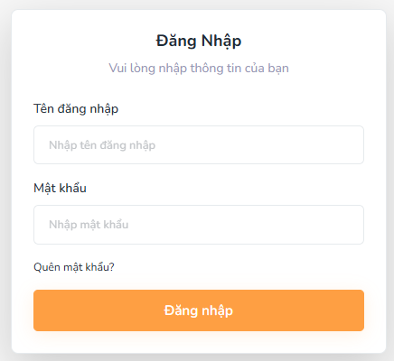
Figure 3.1.1. Log in
Field Name | Description
Tên đăng nhập | Data type: String  Format: must be a valid email format (e.g., user@example.com)  Initial: empty  Required: Yes
Mật khẩu | Data type: String  Masked input. Initial: empty. Required: Yes.
“Đăng Nhập” button | Action button: triggers authentication logic.  Enabled only when both Email & Password fields are valid and filled.
Quên Mật Khẩu | Hyperlink: navigates user to Forgot Password screen. No input required.

3.1.2 Forgot password screen
This screen allows the User, all system agents:
- Forgot password: Allows users to reset their password if they forget it, ensuring secure access to the system via an email-based password recovery process.
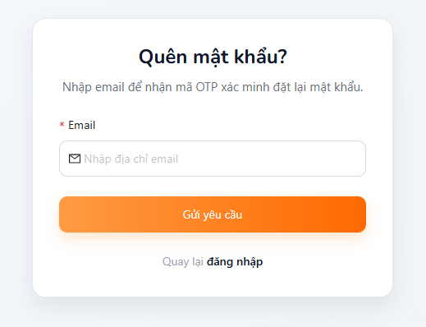
Figure 3.1.2. Forgot password
Field Name | Description
Email | Data type: String  Format: must be a valid email format (e.g., user@example.com)  Initial: empty  Required: Yes
“Gửi yêu cầu ” button | Action button: enable sending email to user  Only enabled when email exists on the system with correct username
“Quay lại đăng nhập ” button | Hyperlink: navigates the user to the Login screen. No input required.

3.1.3 Change password screen
This screen allows the User to:
● Change password: change password of system login account
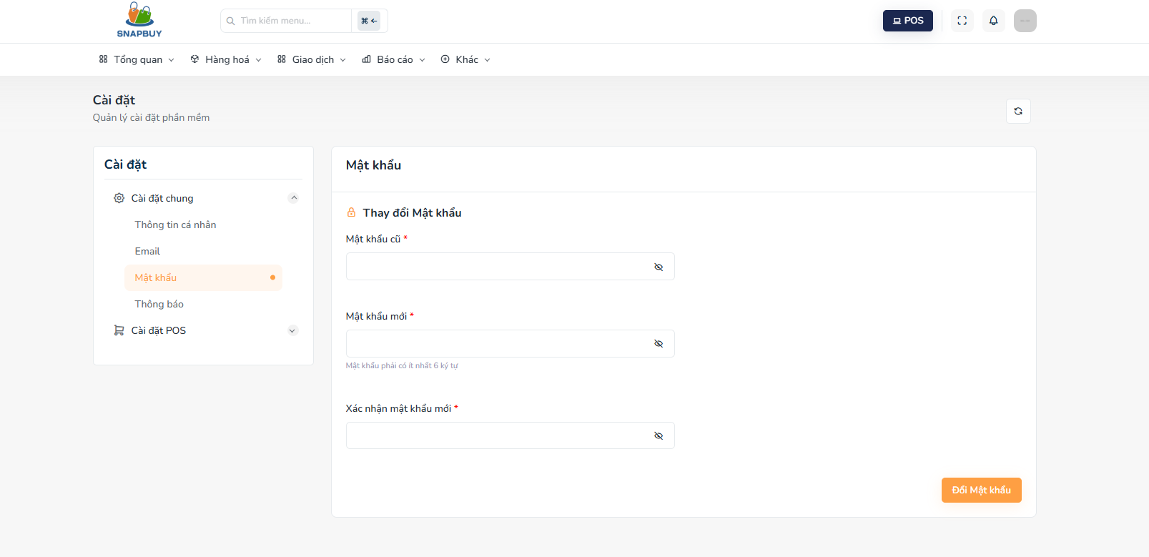
Figure 3.1.3. Change Password
Field Name | Description
Mật khẩu cũ | String, masked, required.
Mật khẩu mới | String, at least 1 uppercase, 1 lowercase, 1 digit, 1 special char, masked, required.
Xác nhận mật khẩu mới | String, must match New Password, masked, required.
“Đổi mật khẩu” button | Submit form to update password.

3.2 Category management

3.2.1 Category list screen
This screen allows the Admin to:
- View category list
- Create category
- Search category
- Edit category
- Delete category

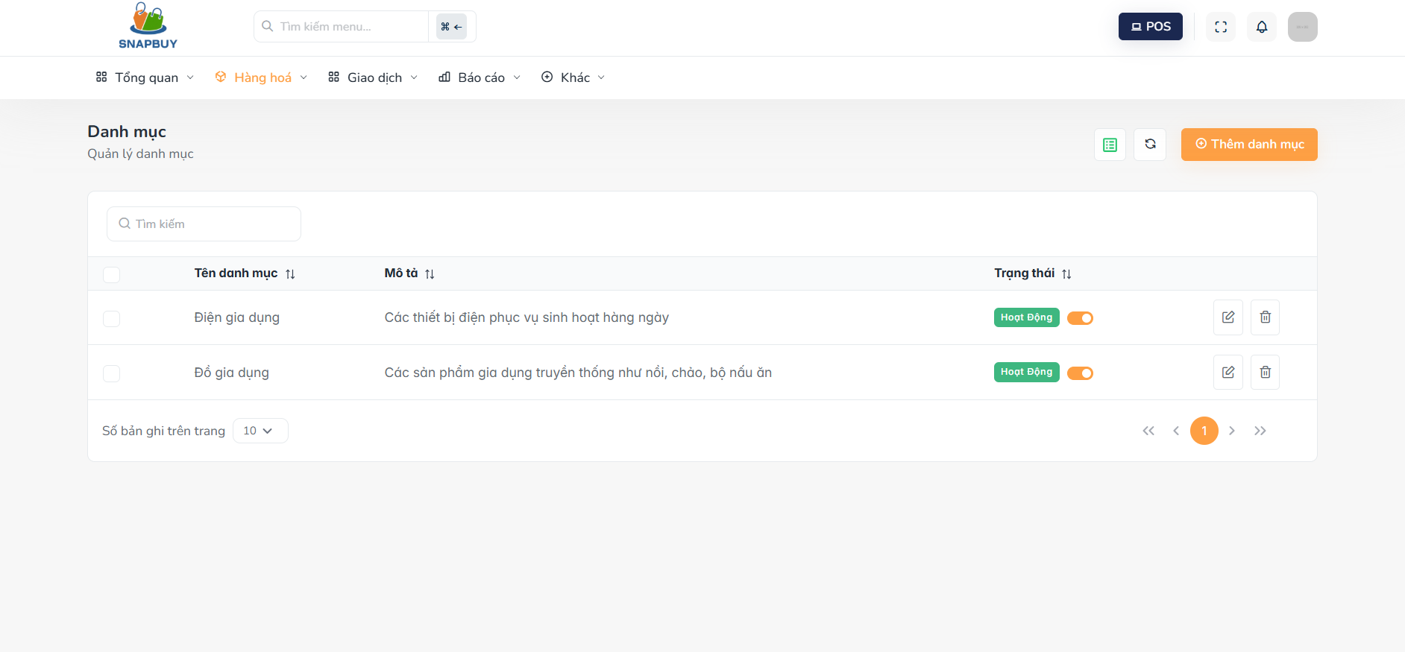
Figure 3.2.1. View Category List
Field Name | Description
Tên danh mục | String, required.
Mô tả | String, required.
Trạng thái | Boolean ( true/false )
Thêm danh mục | Button  Hyperlink: navigates user to Create category screen
Pen icon | Button  Hyperlink: navigates user to update category screen
Delete icon | Button  Hyperlink: navigates user to delete category screen

3.2.2 Create category screen
This screen allows the Admin to:
- Allows the administrator to add a new product category into the system, ensuring that the category is correctly recorded with necessary details such as category name and description.

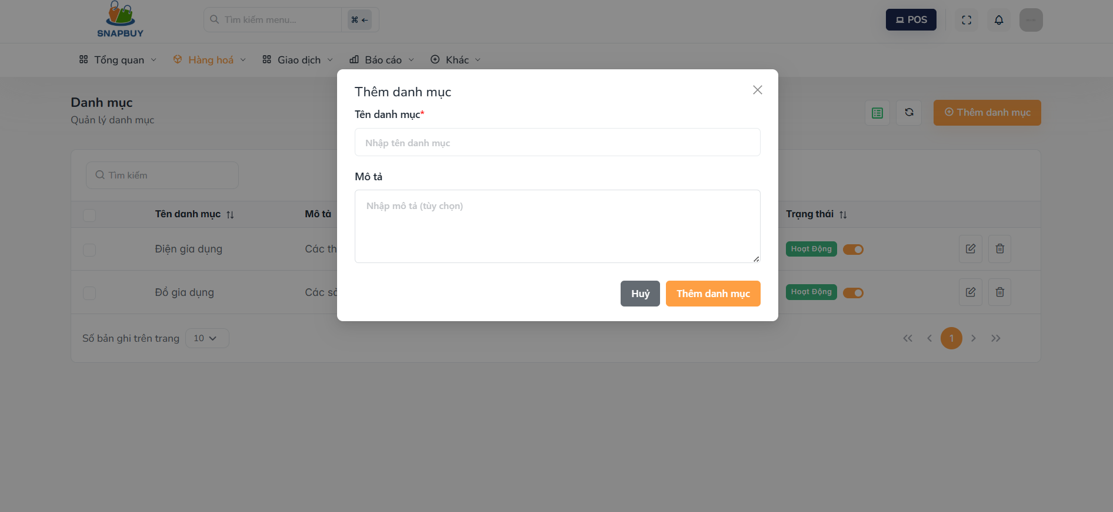
Figure 3.2.2. Create Category
Field Name | Description
Tên danh mục | Text, description of category name
Mô tả | Text, category description
Thêm danh mục | Action button: Save new category
Hủy | Action button:Cancel and close the form without saving.

3.2.3 Update category screen
This screen allows the Admin to:
- Allows the administrator to update the details of an existing product category, including the category name and description, ensuring the system reflects the latest category information.
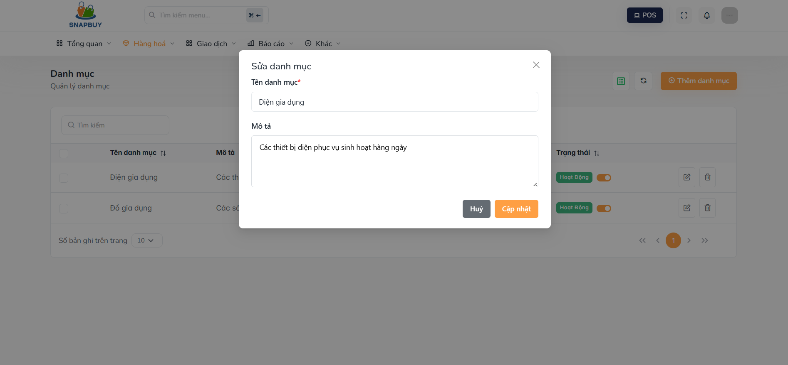
Figure 3.2.3. Update Category
Field Name | Description
Tên danh mục | Text, description of category name
Mô tả | Text, category description
Cập nhật | Action button: Save update category
Hủy | Action button:Cancel and close the form without saving.

3.2.4 Delete category screen
This screen allows the Admin to:
- Allows the administrator to delete an existing product category from the system, ensuring that the category is removed and no longer available for product assignments.

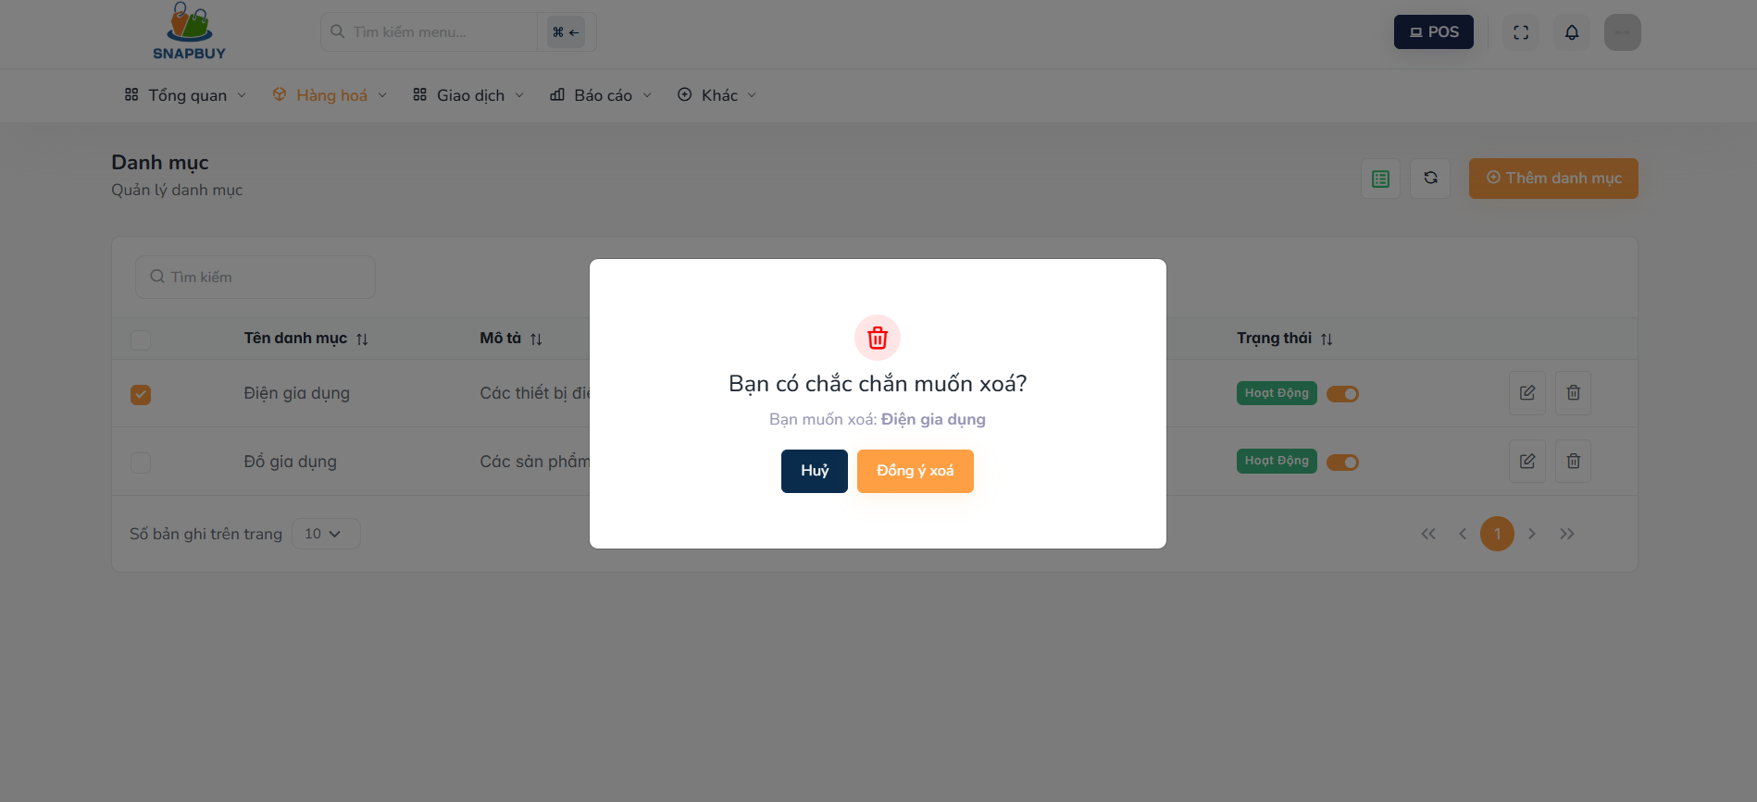
Figure 3.2.4. Delete Category
Field Name | Description
Đồng ý xóa | Action button: Save delete category
Hủy | Action button:Cancel and close the form without saving.

3.3 Product management

3.3.1 Product list screen
This screen allows the Admin to:
- Allows the administrator or user to view a list of all products available in the system
- Create product
- Update product
- Delete product
- Search product

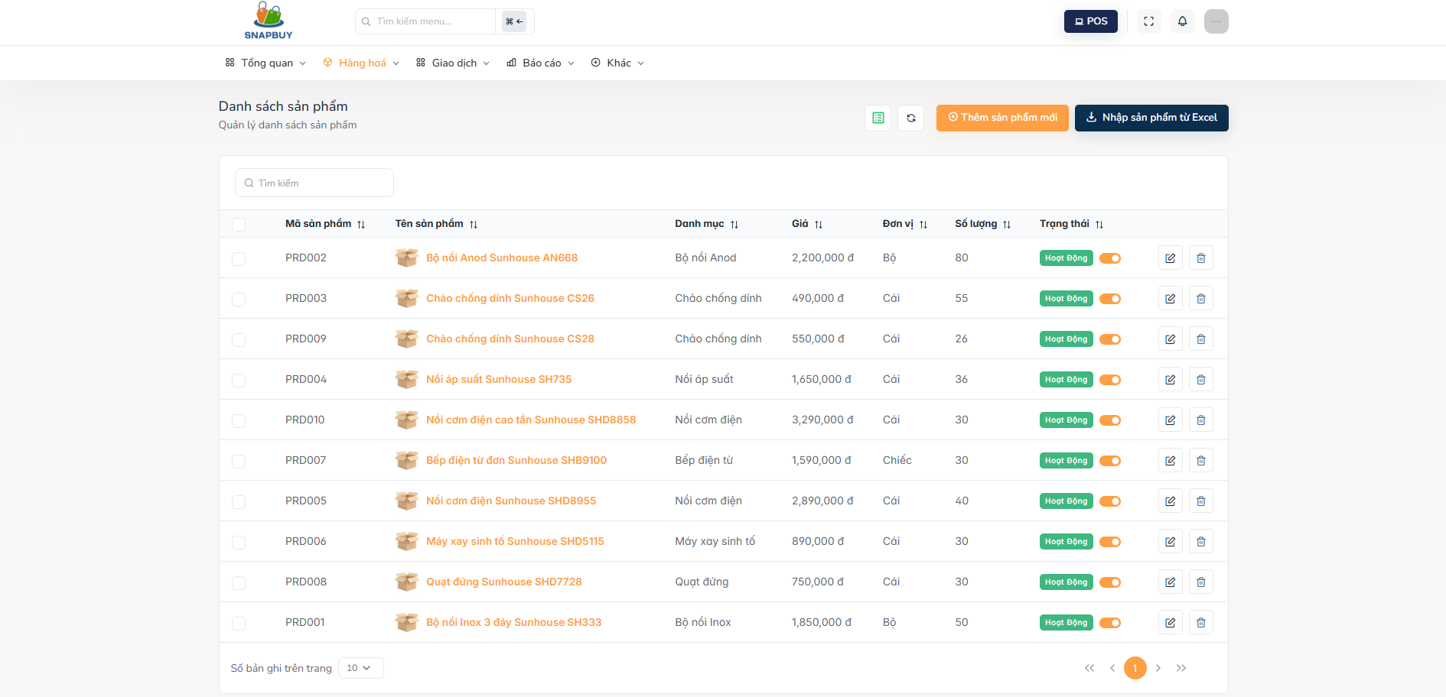
Figure 3.3.1.Product list
Field Name | Description
Mã sản phẩm | A unique identifier for the product used for management and lookup in the system.
Tên sản phẩm | The display name of the product shown to users in the system
Danh mục | The display category name
Giá | The selling price of the product, represented as a numeric value.
Đơn vị | The unit of measurement of the product (e.g. piece, item, ).
Số lượng | The stock quantity displayed for the product.
Trạng thái | The active status of the product (e.g., Active, Inactive)
Thêm sản phẩm | Button: Opens the form to create a new product.
Pen icon | Button: Opens the form to edit the selected product.
Delete icon | Button: Opens the form to delete the selected product.

3.3.2 Product details screen
This screen allows the Admin to:
- Allows the administrator or user to view detailed information about a specific product

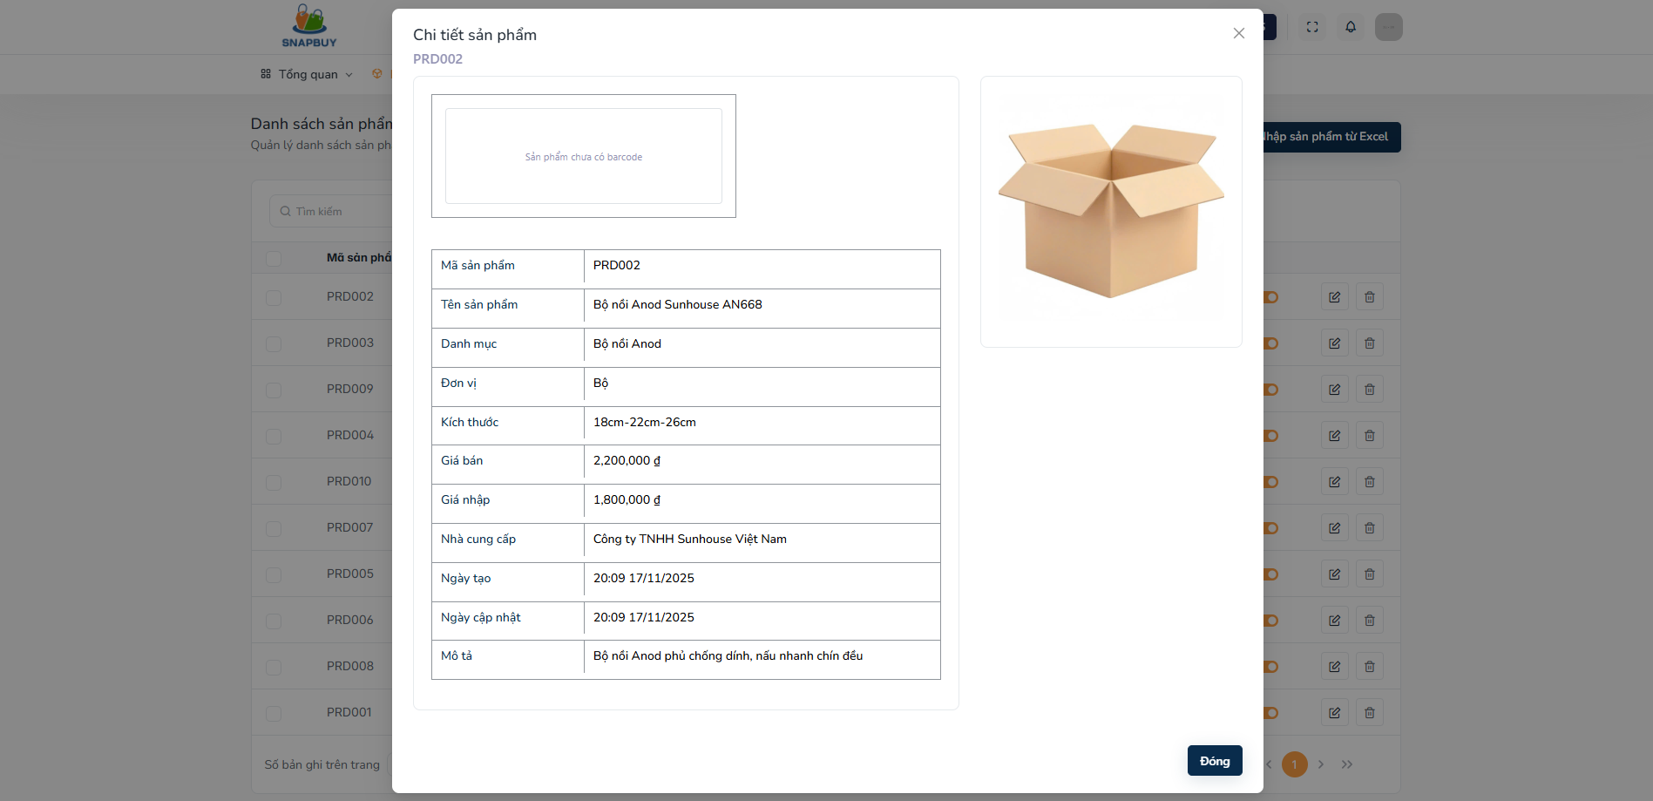
Figure 3.3.2.Product detail
Field Name | Description
Mã sản phẩm | A unique identifier for the product used for management and lookup in the system.
Tên sản phẩm | The display name of the product shown to users in the system
Danh mục | The display category name
Giá bán | The selling price of the product, represented as a numeric value.
Giá nhập | The import price of the product, expressed as a numeric value.
Đơn vị | The unit of measurement of the product (e.g. piece, item, ).
Kích thước | Show product dimensions
Số lượng | The stock quantity displayed for the product.
Nhà cung cấp | Show the product's supplier
Ngày tạo | The product creation date is displayed to the user in the system.
Ngày cập nhât | The product update date is displayed to users in the system.
Mô tả | The product description is displayed to the user in the system.
Đóng | Action button:Cancel and close the form

3.3.3 Create product screen
This screen allows the Admin to:
- Create a new product to the system

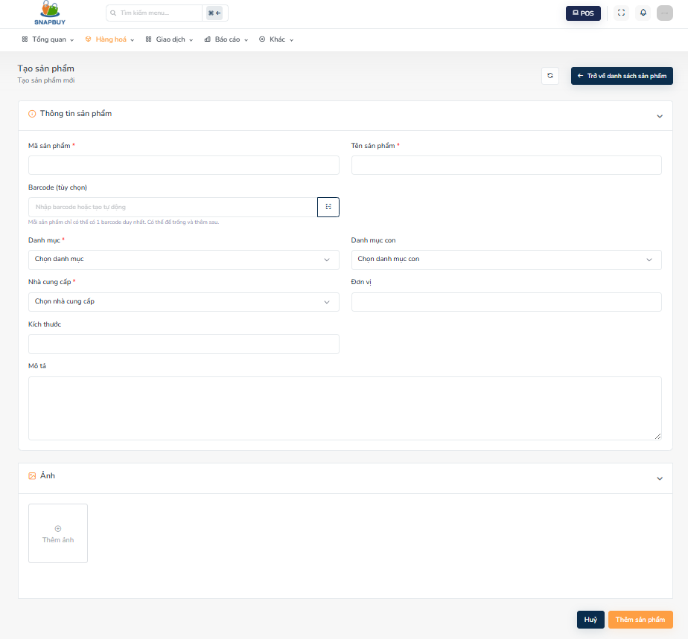
Figure3.3.3.Create Product
Field Name | Description
Mã sản phẩm | A unique identifier for the product, used for tracking and managing the product in the system.
Tên sản phẩm | The name of the product that will be displayed to users throughout the system.
Danh mục | The main product category selected from a predefined list. Used to classify and group products.
Danh mục con | A subcategory under the selected main category.
Barcode | A barcode value used for product scanning and identification.
Đơn vị | The unit of measurement of the product (e.g. piece, item, ).
Kích thước | The physical size or measurement details of the product
Nhà cung cấp | The supplier providing the product, chosen from an existing supplier list.
Mô tả | Additional product details or notes for internal tracking or customer-facing information
Ảnh | A product image uploaded to visually represent the item in the system.
Thêm sản phẩm | Action button:Saves all entered product information and creates a new product in the system.
Hủy | Action button:Cancel and close the form without saving any changes.

3.3.4 Update product screen
This screen allows the Admin to:
- Update product to the system

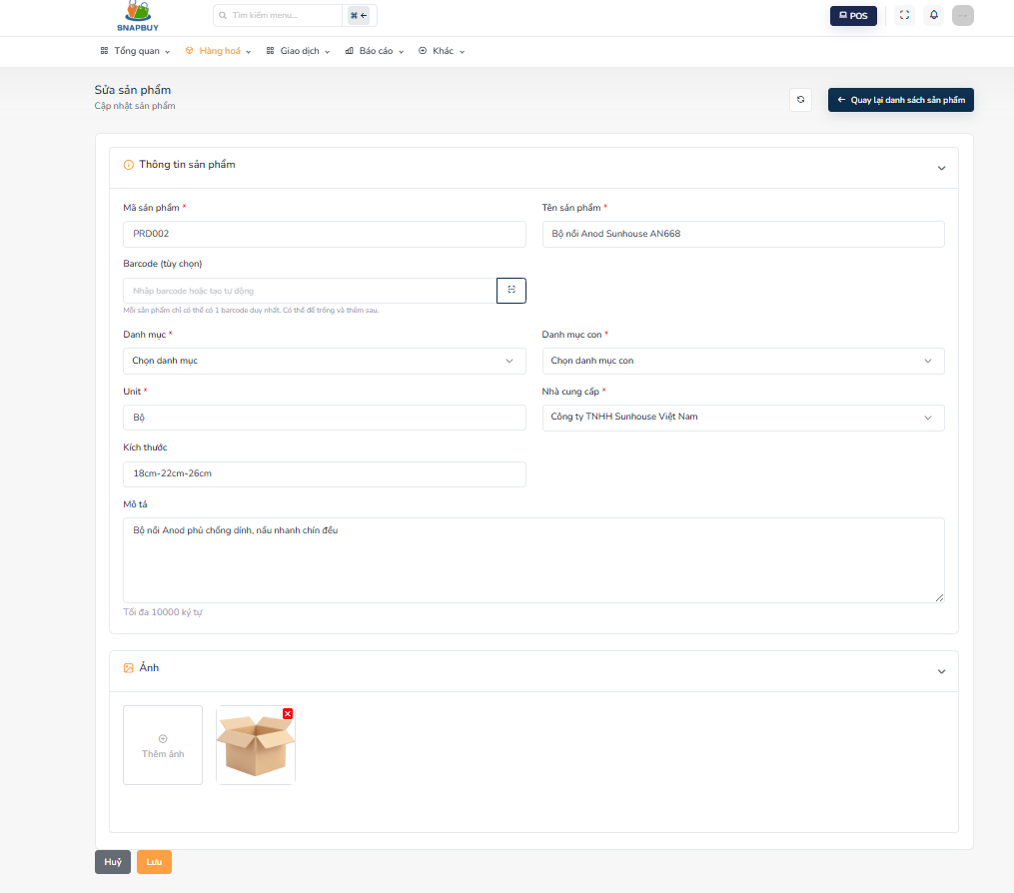
Figure 3.4.1. Update Product
Field Name | Description
Mã sản phẩm | The unique identifier of the selected product. This field is automatically populated with the product’s existing code when opening the update form
Tên sản phẩm | The current name of the selected product. The field is pre-filled with the product’s existing name for editing.
Danh mục | Select: The main category previously assigned to the product. When updating, the field automatically displays the product’s current category. Users can select a different one if needed.
Danh mục con | Select:The subcategory associated with the chosen category. The field is pre-populated with the product’s existing subcategory for easy review and modification.
Barcode | The existing barcode of the product. The value is automatically loaded into the field and can be updated if necessary.
Đơn vị | The unit of measurement already assigned to the product (e.g., piece, box, pack). The field is pre-filled with the current unit value.
Kích thước | The product’s existing size or measurement details (e.g., length, width, height). The field loads the current dimensions by default for editing.
Nhà cung cấp | The supplier is currently linked to the product. The field automatically displays the existing supplier selection and can be changed by the user.
Mô tả | The existing product notes or detailed information. The field is pre-filled with the current description and can be updated.
Ảnh | The current product image is displayed as the default preview. Users may choose to keep it or upload a new one to replace the existing image.
Lưu | Action button:Saves all entered product information and update product in the system.
Hủy | Action button:Cancel and close the form without saving any changes.

3.3.5 Delete product screen
This screen allows the Admin to:
- Remove products no longer in use from the system.

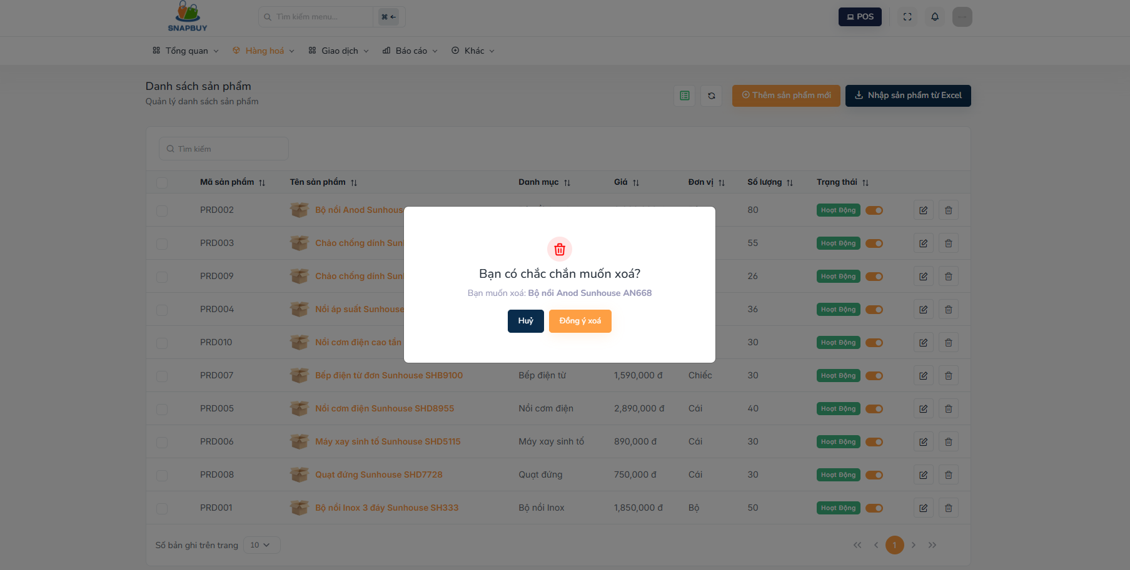
Figure3.3.5.Delete product
Field Name | Description
Đồng ý xóa | Action button: Save delete product
Hủy | Action button:Cancel and close the form without saving.

3.4 Order management

3.4.1 Order list screen
This screen allows the user to:
- View order list
- View order detail
- Search order
- Filter orders by creation time and order status
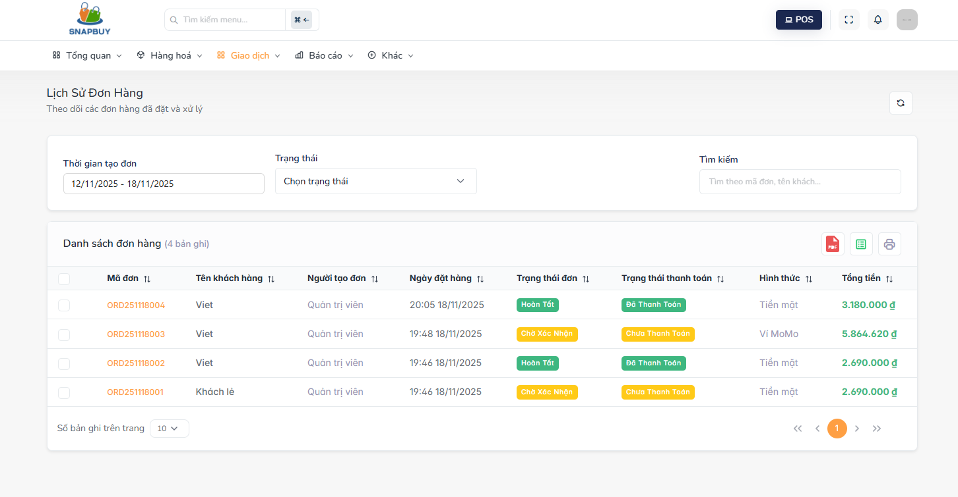
Figure 3.4.1. View Order List
Field Name | Description
Mã đơn | Displays the unique code of each order for quick identification and lookup.
Tên khách hàng | Displays the name of the customer who placed the order.
Người tạo đơn | Displays the sales staff member who created the order.
Ngày đặt hàng | Displays the date when the order was placed.
Trạng thái đơn | Displays the current status of the order( eg. Chờ xác nhận , Hoàn tất,Đã hủy)
Trạng thái thanh toán | Displays the payment progress of the order( Đã thanh toán , Chưa thanh toán )
Hình thức | Displays the method used to pay for the order
Tổng tiền | Displays the total amount of the order, including all items and fees.

3.4.2 Create orders screen
This screen allows the user to:
- Create new order
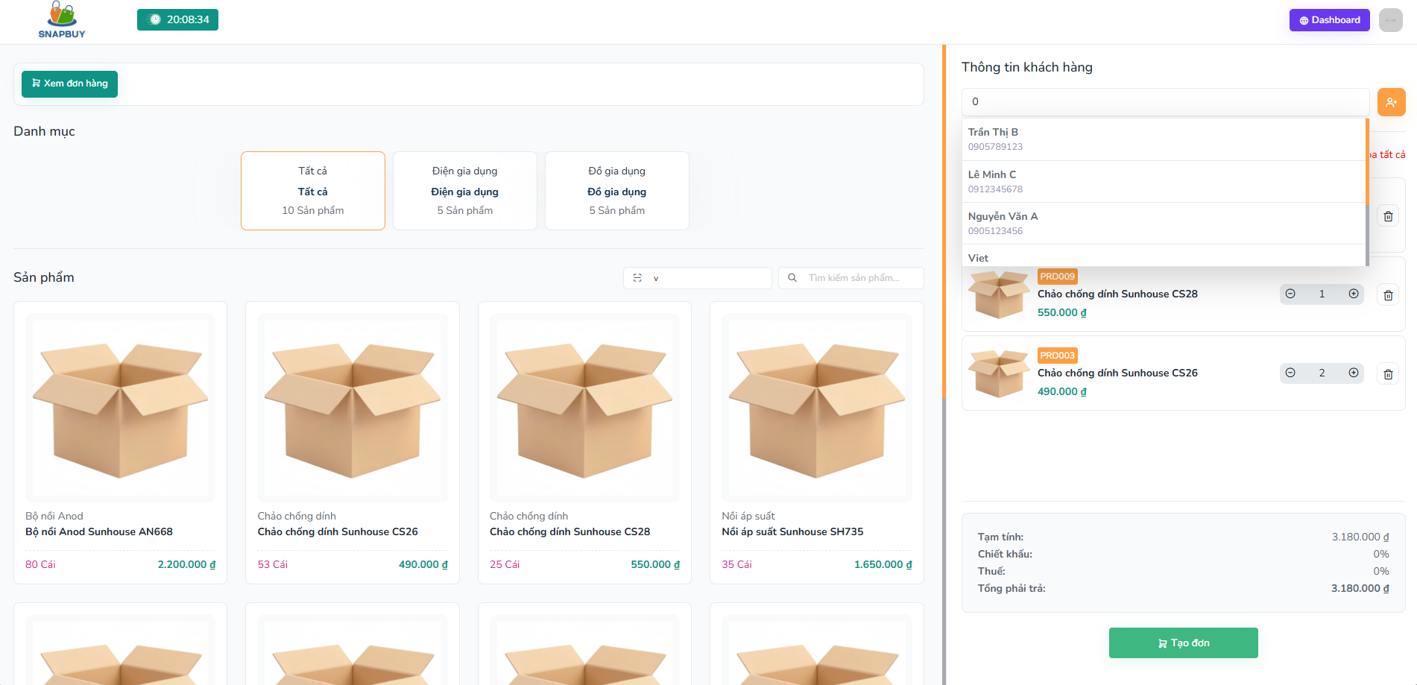
Figure 3.4.2. Create Orders
Field Name | Description
Danh mục | Filter and find products to add to the order.
Danh sách sản phẩm | Displays all products available within the selected category. Users can select products to add to the order.
Thông tin khách hàng | Displays details of the selected customer, including name, contact, and address. Used to associate the order with the customer.
Sản phẩm mua | Displays the products that have been selected for the order, including quantity, price, and unit.
Tạm tính | Displays the total amount of the selected products before discounts and taxes.
Chiết khấu | Displays the discount applied to the order based on the customer's accumulated points
Thuế | Displays the tax amount calculated for the order
Tổng phải trả | Displays the final total amount the customer must pay after applying discounts and taxes.
Tạo đơn | Action button: Save a new order

3.4.3 Order details screen
This screen allows the user to:
- View order details

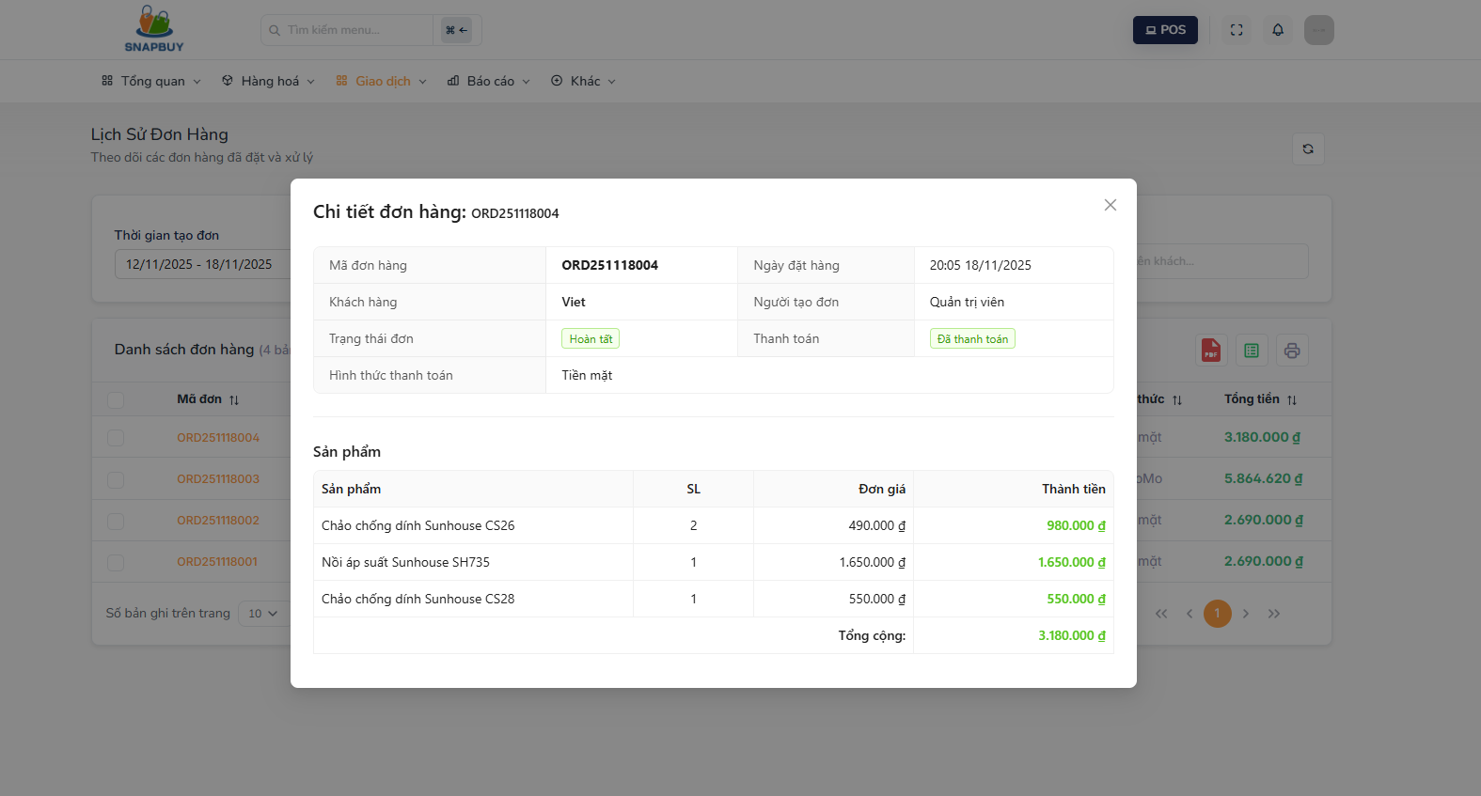
Figure 3.4.3. Order Details
Field Name | Description
Mã đơn | Displays the unique code of each order for quick identification and lookup.
Tên khách hàng | Displays the name of the customer who placed the order.
Người tạo đơn | Displays the sales staff member who created the order.
Ngày đặt hàng | Displays the date when the order was placed.
Trạng thái đơn | Displays the current status of the order( eg. Chờ xác nhận , Hoàn tất,Đã hủy)
Trạng thái thanh toán | Displays the payment progress of the order( Đã thanh toán , Chưa thanh toán )
Hình thức | Displays the method used to pay for the order
Sản phẩm | Display a list of products in the order
SL | Display the number of products purchased
Đơn giá | Display the unit price of the purchased product
Thành tiền | Display the total price of the purchased product

3.5 Account management

3.5.1 Account list screen
This screen allows the user to:
- View account list
- Create a new account
- Update account
- Delete account
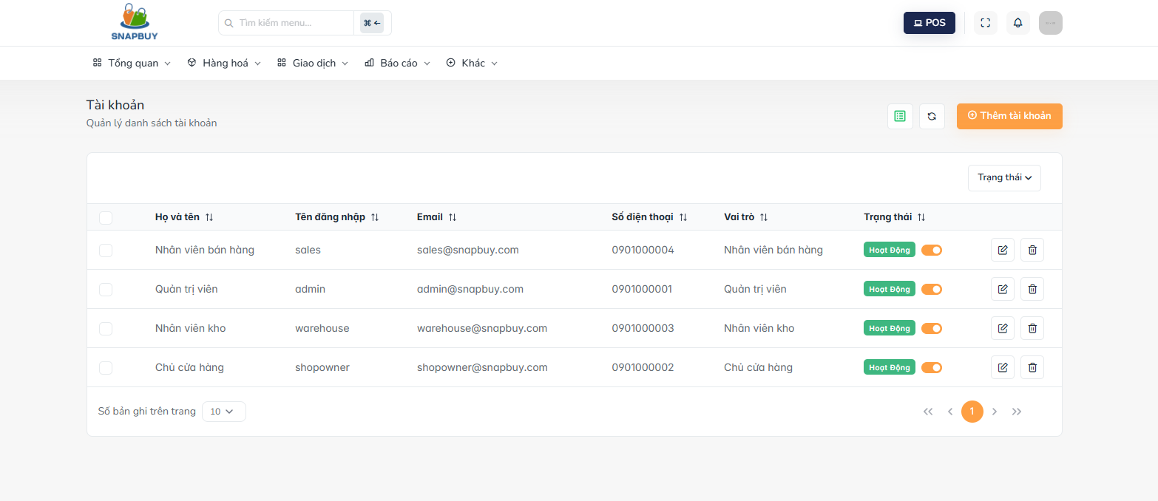
Figure 3.5.1.Account list
Field Name | Description
Họ và tên | Displays the full name of the account user.
Tên đăng nhập | Displays the login username of the account.
Email | Displays the email address associated with the account.
Số điện thoại | Displays the phone number of the account user.
Vai trò | Displays the user role
Trạng thái | Displays the current status of the account (e.g., Active, Inactive)
Thêm tài khoản | Button: Opens the form to create a new account in the system.
Pen icon | Button:Open the form to edit the selected account’s information.
Delete icon | Button:Opens the form to confirm delete account

3.5.2 Add new account screen
This screen allows the user to:
- Create a new account
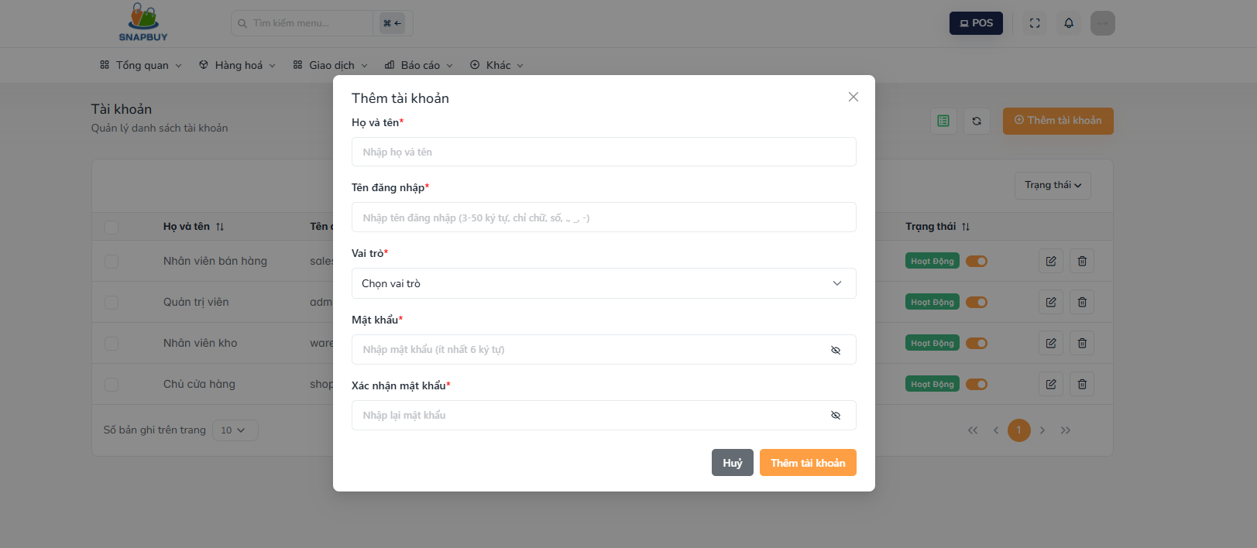
Figure 3.5.2.Add new account
Field Name | Description
Họ và tên | Field to enter the full name of the new account user.
Tên đăng nhập | Field to enter the login username for the new account.
Email | Field to enter the email address associated with the account.
Số điện thoại | Field to enter the phone number of the account user.
Vai trò | Dropdown to select the user role
Mật khẩu | Field to enter the password for the new account.
Xác nhận mật khẩu | Field to re-enter the password to confirm it matches the Password field.
Thêm tài khoản | Action button to save the new account and add it to the system.
Hủy | Action button to cancel the account creation process and close the form without saving.

3.5.3 Edit account screen
This screen allows the user to:
- Update account
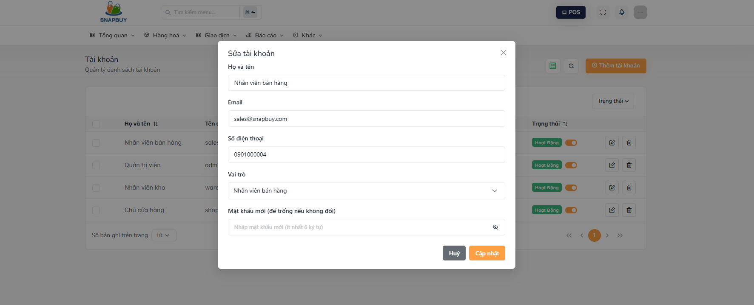
Figure 3.5.3.Edit account
Field Name | Description
Họ và tên | Field displaying the full name of the selected account. Can be edited to update the user’s name.
Tên đăng nhập | Field displaying the login username of the selected account. Can be updated if needed.
Email | Field displaying the email address of the account. Can be edited to update the email.
Số điện thoại | Field displaying the phone number of the account user. Can be updated.
Vai trò | Dropdown showing the current role of the account. Users can select a different role to update permissions.
Mật khẩu mới | Field to enter a new password if the user wants to change it. Can be left empty if no change is needed.
Cập nhật | Action button to save all changes and update the account information in the system.
Hủy | Action button to cancel the edit operation and close the form without saving any changes.

3.5.4 Delete account screen
This screen allows the user to:
- Delete account
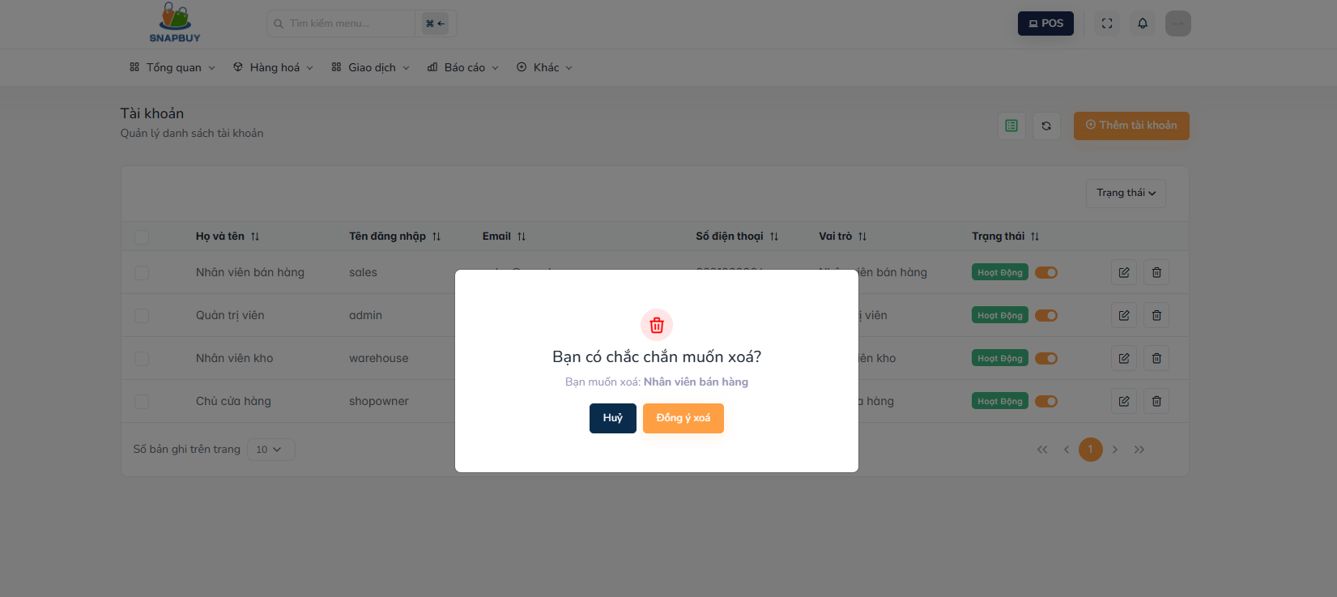
Figure 3.5.4.Delete account
Field Name | Description
Đồng ý xóa | Action button: Save delete account
Hủy | Action button:Cancel and close the form without saving.

3.6 Role & Permission Management

3.6.1 Role list screen
This screen allows the user to:
- View role list
- Add new role
- Update role
- Delete role
- Filter roles by status
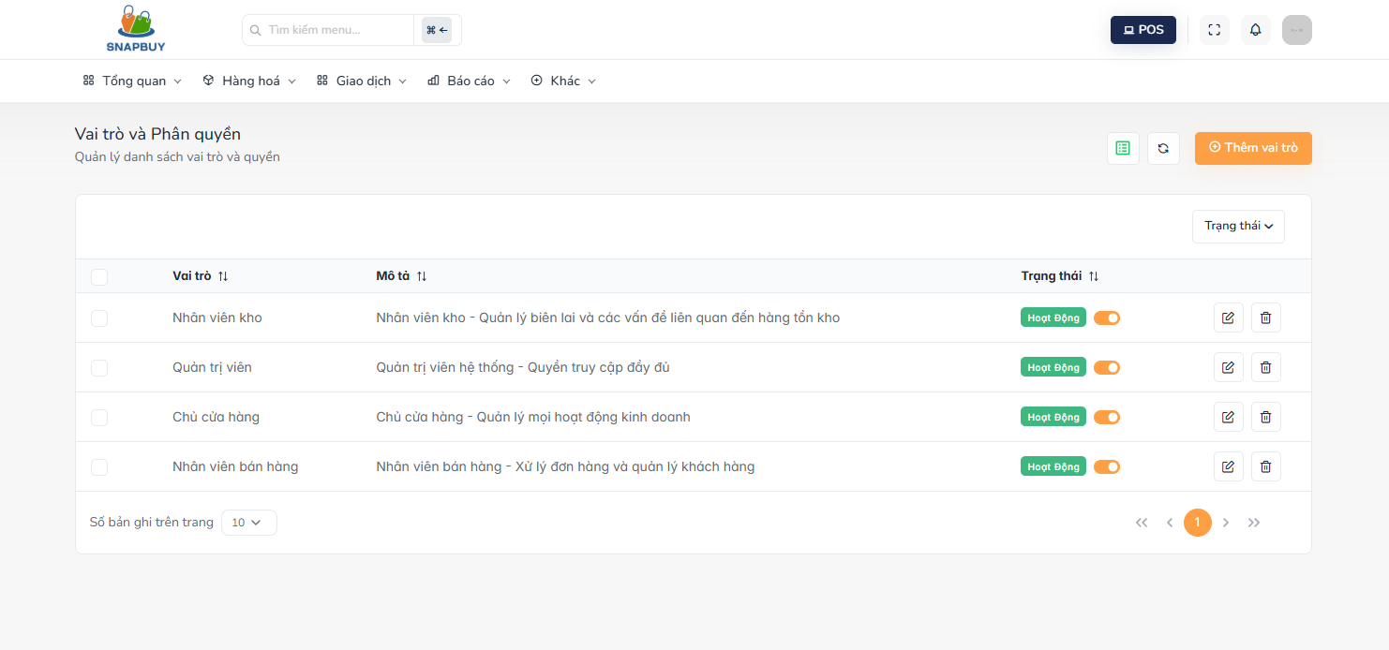
Figure 3.6.1.Role list
Field Name | Description
Vai trò | Displays the name of the role in the system
Mô tả | Displays the description or purpose of the role, providing context for permissions and access.
Trạng thái | Displays the current status of the role
Thêm vai trò | Button: Opens the form to create a new role in the system.
Pen icon | Button:Open the form to edit the selected role’s information.
Delete icon | Button:Opens the form to confirm delete role

3.6.2 Add new role screen
This screen allows the user to:
- Create a new role
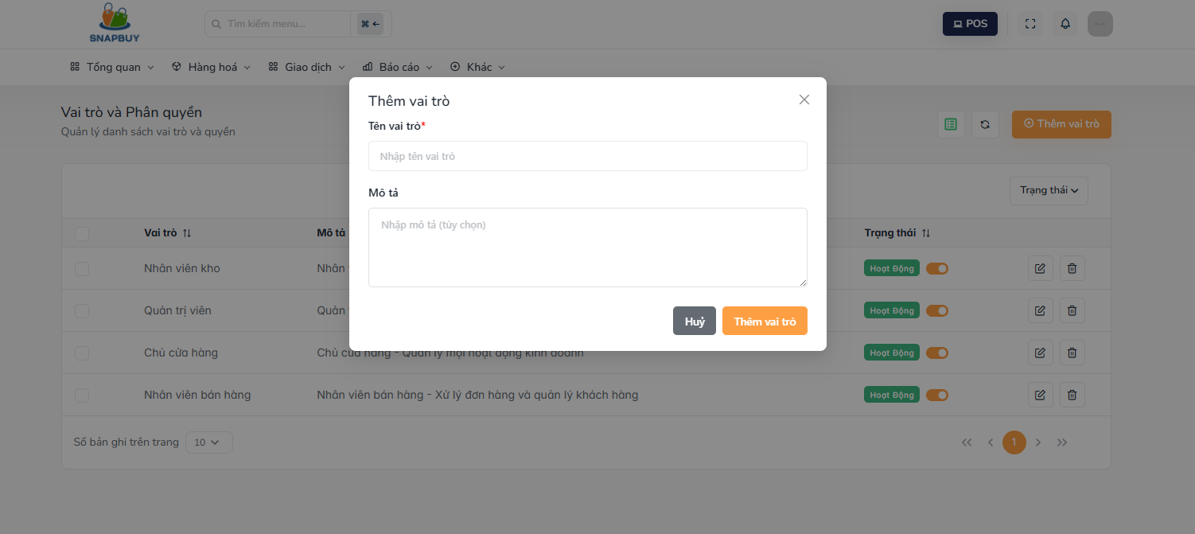
Figure 3.6.2.Add new role
Field Name | Description
Tên vai trò | Field to enter the name of the new role to be created in the system.
Mô tả | Field to enter details or the purpose of the role, explaining what this role is used for.
Thêm vai trò | Action button to save the new role and add it to the system.
Hủy | Action button to cancel the role creation process and close the form without saving.

3.6.3 Edit role screen
This screen allows the user to:
- Update role

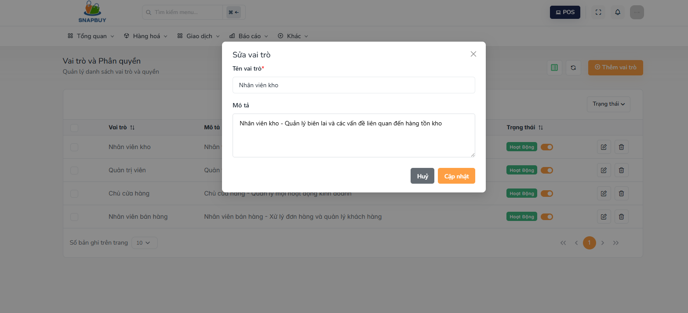
Figure 3.6.3.Edit role
Field Name | Description
Tên vai trò | Field displaying the current role name. Automatically populated with the selected role’s existing name and can be edited.
Mô tả | Field displaying the existing description of the selected role. Automatically populated and can be updated.
Cập nhật | Action button to save the updated information and apply changes to the role.
Hủy | Action button to cancel the update and close the form without saving changes.

3.6.4 Delete role screen
This screen allows the user to:
- Delete role

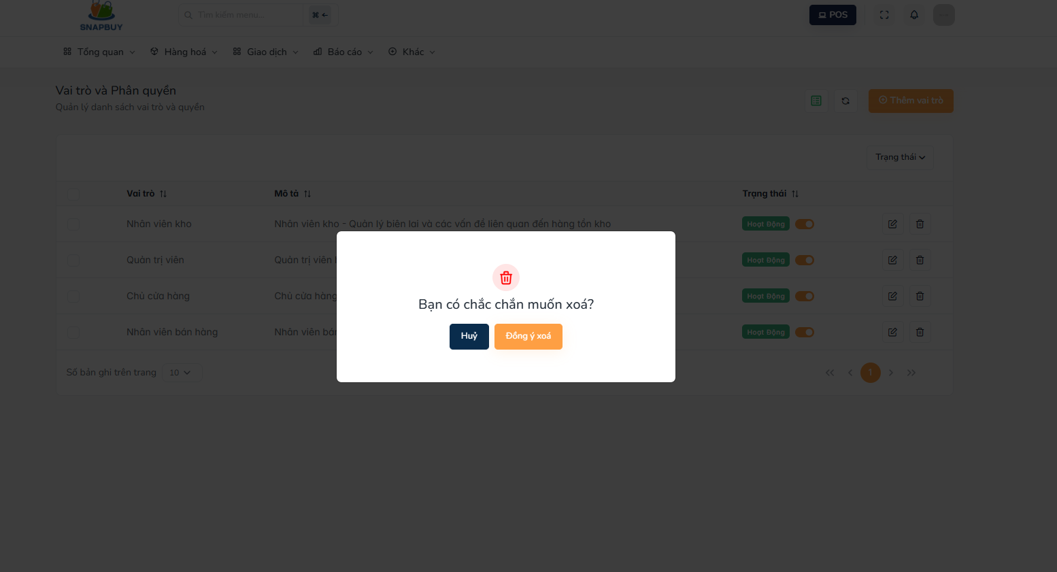
Figure 3.6.4.Delete role
Field Name | Description
Đồng ý xóa | Action button: Save delete role
Hủy | Action button:Cancel and close the form without saving.

3.7 Supplier Management

3.7.1 Supplier list screen
This screen allows the user to:
- View supplier list
- Search supplier
- Create a new supplier
- Update supplier
- Delete supplier

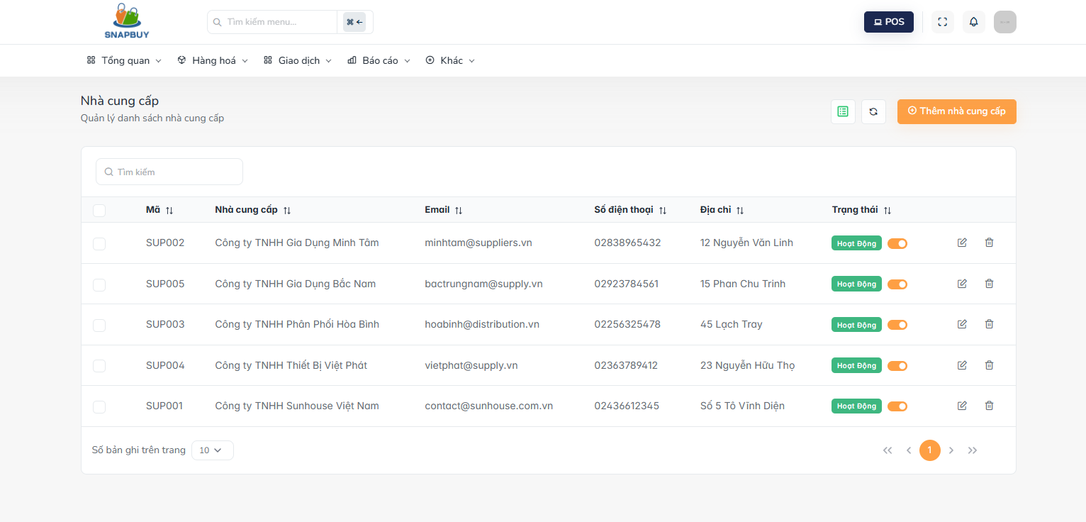
Figure 3.7.1. View Supplier List
Field Name | Description
Mã | Displays the unique supplier code used to identify each supplier in the system.
Nhà cung cấp | Displays the name of the supplier.
Email | Displays the email address associated with the supplier.
Số điện thoại | Displays the supplier’s contact phone number.
Địa chỉ | Displays the supplier’s physical address or location.
Trạng thái | Displays the current status of the supplier (e.g., Active, Inactive).
Thêm nhà cung cấp | Opens the form to create and add a new supplier to the system.
Pen icon | Open the form to edit the selected supplier’s information.
Delete icon | Opens the form to delete the selected supplier to the system.

3.7.2 Create supplier screen
This screen allows the user to:
- Create a new supplier

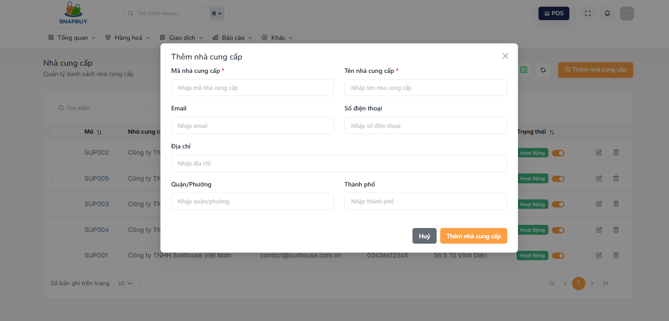
Figure 3.7.2. Create Supplier
Field Name | Description
Mã nhà cung cấp | Field to enter the unique code for the new supplier.
Tên nhà cung cấp | Field to enter the full name of the supplier.
Email | Field to enter the supplier’s email address.
Số điện thoại | Field to enter the supplier’s contact phone number.
Địa chỉ | Field to enter the supplier’s detailed address.
Quận/Phường | Field to enter the supplier’s district or ward.
Thành phố | Field to enter the city where the supplier is located.
Thêm nhà cung cấp | Action button to save the new supplier and add it to the system.
Hủy | Action button to cancel the creation process and close the form without saving.

3.7.4 Update supplier screen
This screen allows the user to:
- Update supplier

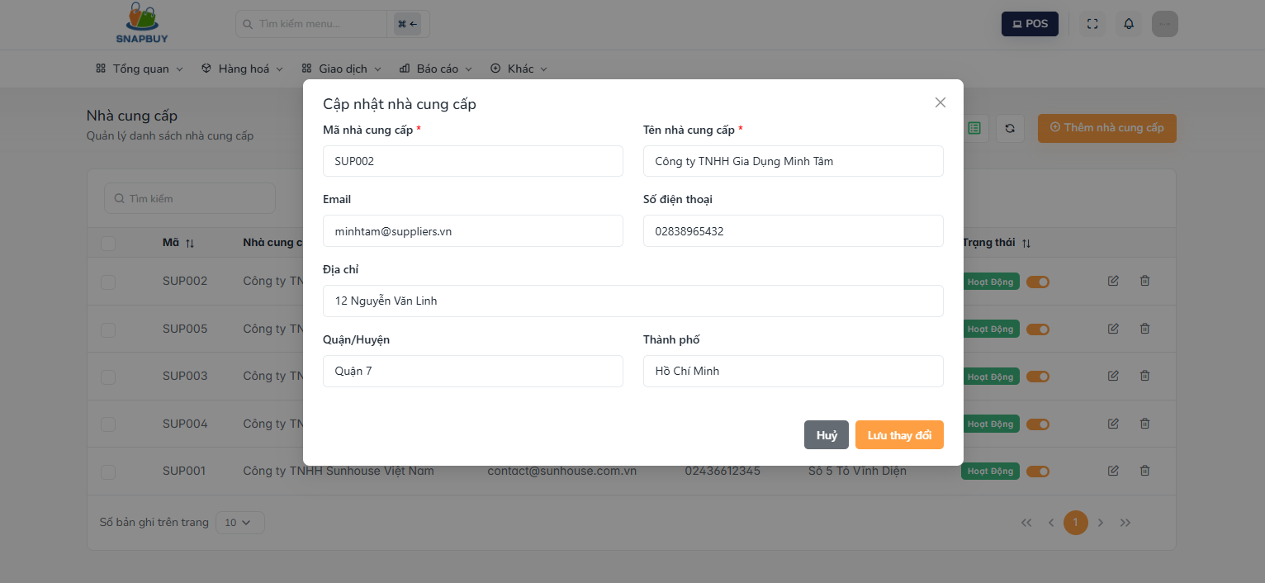
Figure 3.7.4. Update Supplier
Field Name | Description
Mã nhà cung cấp | Field displaying the existing supplier code. Automatically populated with the selected supplier’s current code and locked from editing depending on system rules
Tên nhà cung cấp | Field displaying the current supplier name. Pre-filled and can be updated.
Email | Field automatically filled with the supplier’s existing email. Can be edited.
Số điện thoại | Field pre-populated with the supplier’s contact number. Editable if needed.
Địa chỉ | Field displaying the supplier’s existing address. Can be updated.
Quận/Phường | Field showing the existing district/ward of the supplier. Editable.
Thành phố | Field displaying the supplier’s current city. Can be modified.
Lưu thay đổi | Action button to save changes and update the supplier’s information.
Hủy | Action button to cancel the update and close the form without saving changes.

3.7.5 Delete supplier screen
This screen allows the user to:
- Delete supplier

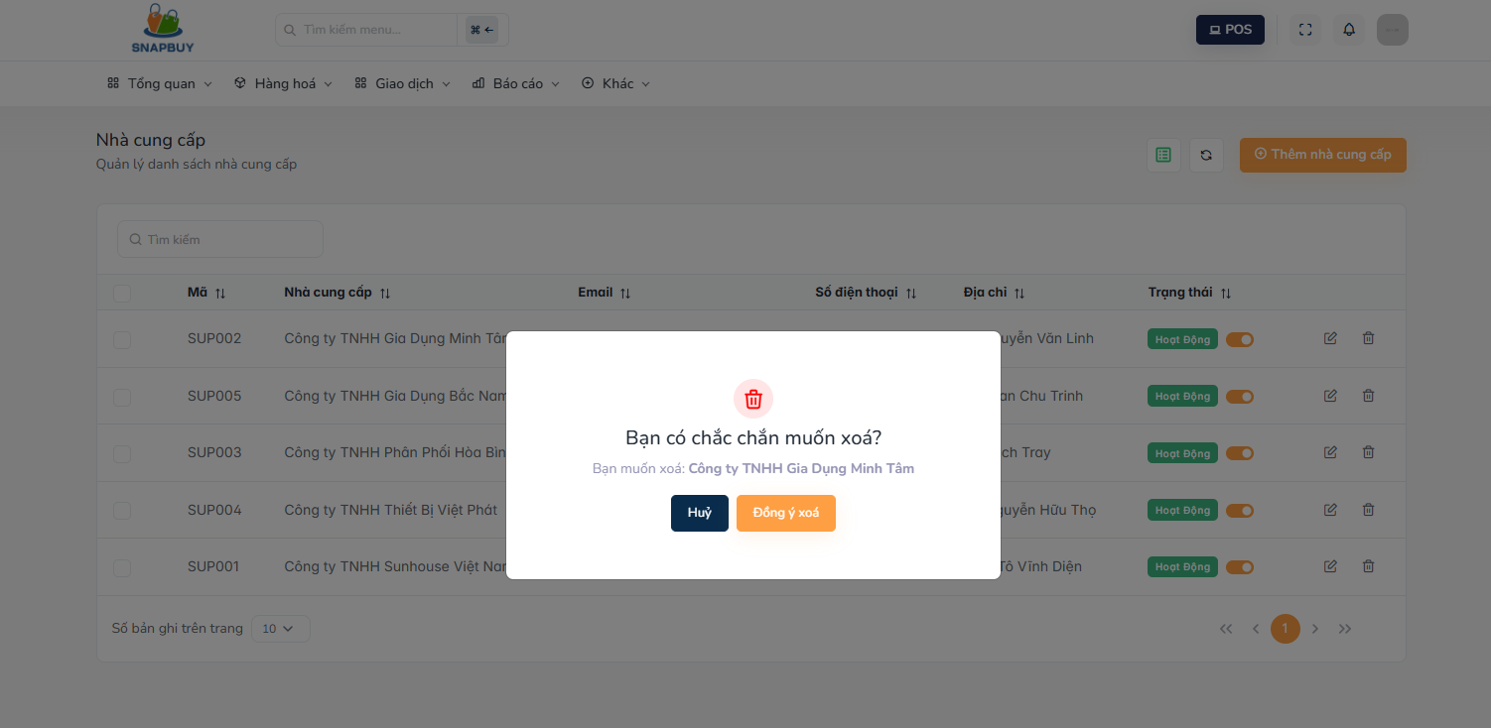
Figure 3.7.5. Delete Supplier
Field Name | Description
Đồng ý xóa | Action button: Save delete account
Hủy | Action button:Cancel and close the form without saving.

3.8 Customer Management

3.8.1 Customer list screen
This screen allows the user to:
- View customer list
- Search customer
- Update customer
- Delete customer

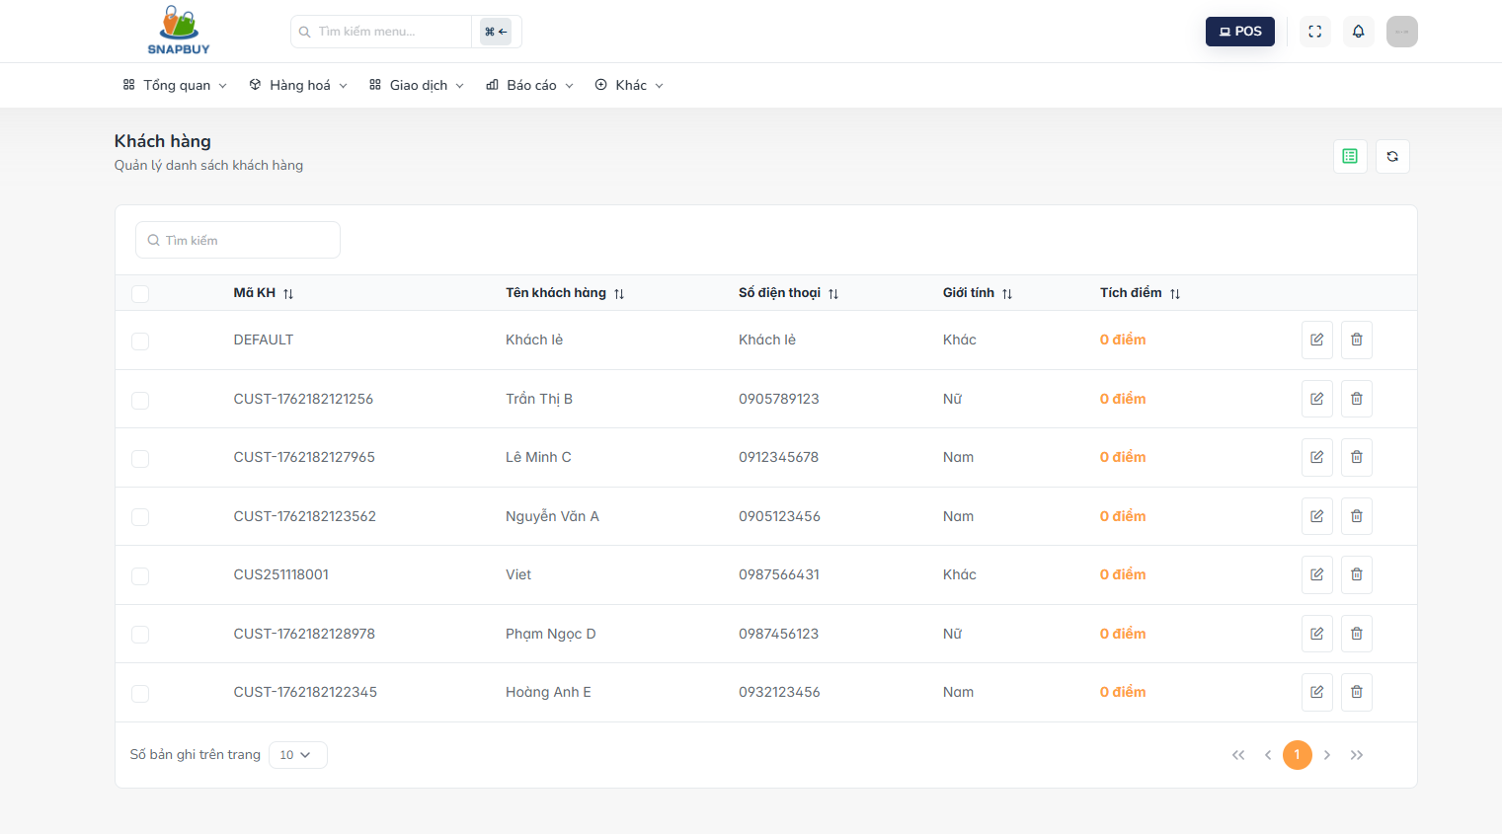
Figure 3.8.1.Customer list
Field Name | Description
Mã KH | Displays the unique customer code used to identify each customer in the system
Tên khách hàng | Displays the full name of the customer.
Số điện thoại | Displays the customer’s contact phone number
Giới tính | Displays the customer’s gender
Tích điểm | Displays the loyalty or reward points accumulated by the customer.
Pen icon | Opens the form to edit the selected customer’s information.
Delete icon | Opens the form to delete the selected customer

3.8.2 Add new customer screen
This screen allows the user to:
- Add new customer

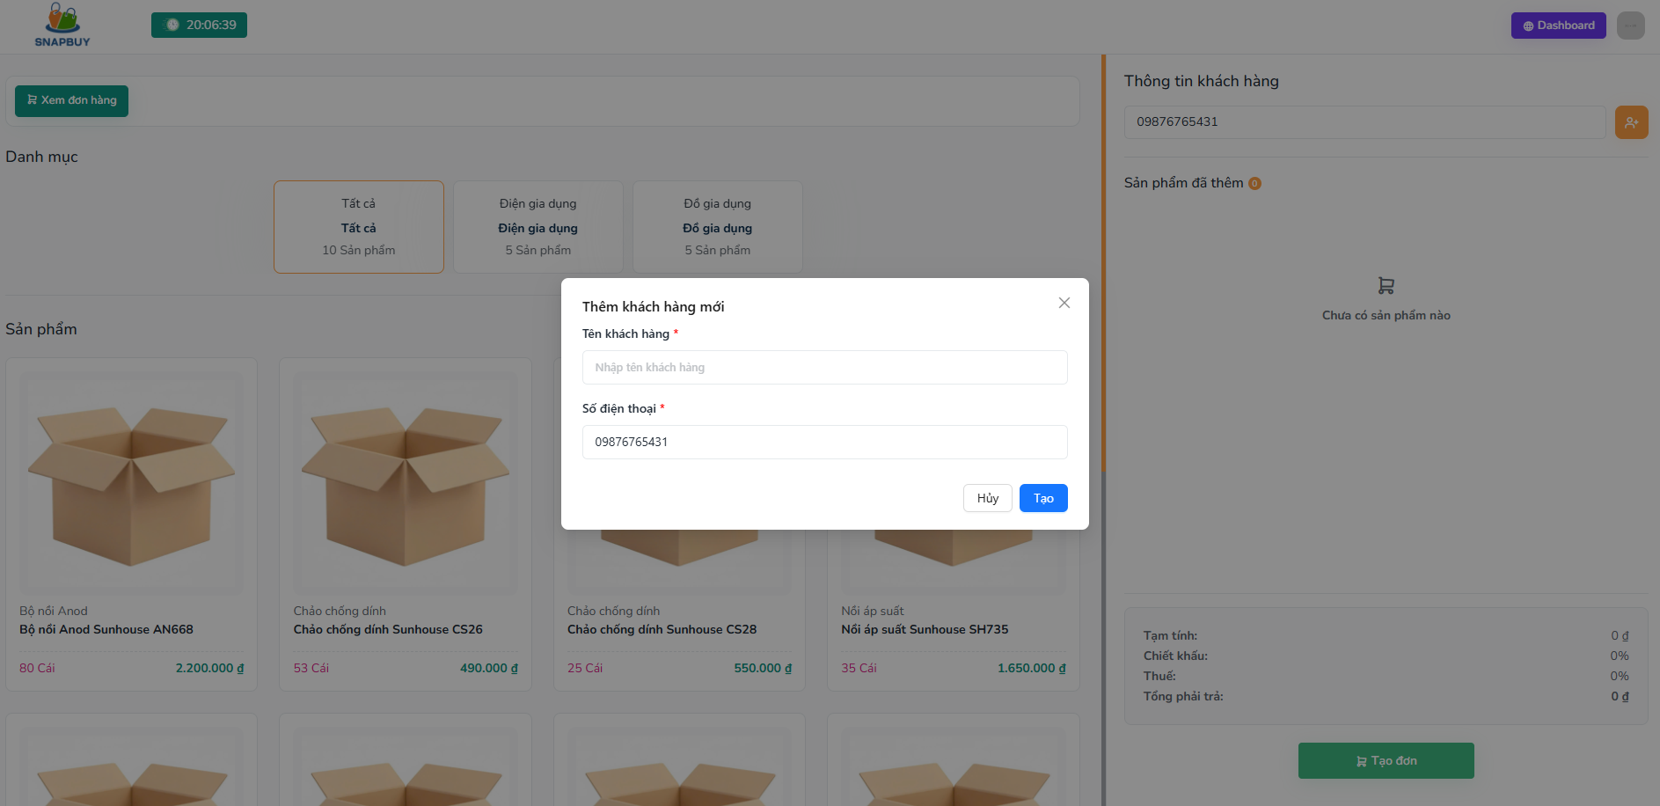
Figure 3.8.2.Add new customer
Field Name | Description
Tên khách hàng | Field to enter the full name of the new customer.
Số điện thoại | Field to enter the customer’s contact phone number.
Tạo | Action button to save the new customer and add them to the system.
Hủy | Action button to cancel the creation process and close the form without saving.

3.8.3 Edit customer screen
This screen allows the user to:
- Add new customer
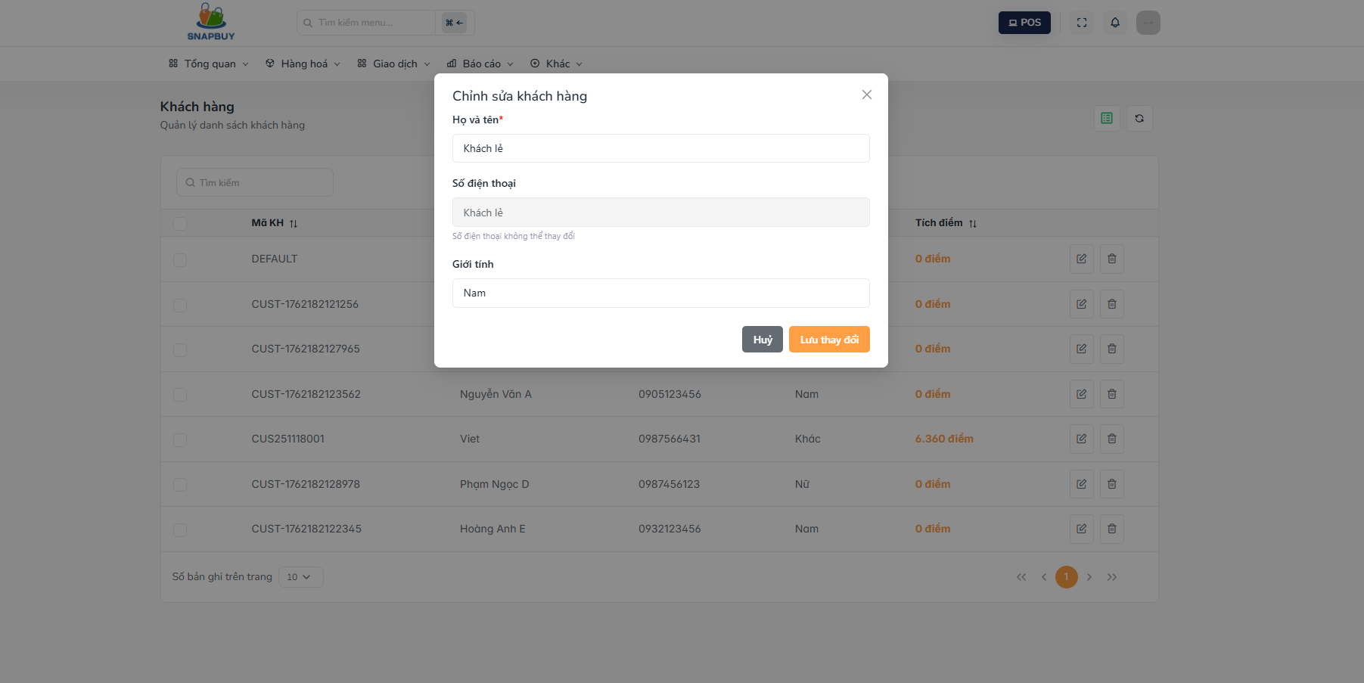
Figure 3.8.3. Edit customer
Field Name | Description
Họ và tên | Field pre-filled with the customer’s current name. Allows updating the customer’s full name.
Số điện thoại | Field pre-populated with the customer’s existing phone number. Allows editing if needed.
Giới tính | Field displaying the customer's current gender selection. Can be updated
Lưu thay đổi | Action button to save all updated customer information.
Hủy | Action button to discard changes and close the form without saving

3.9 Purchase order management

3.9.1 Purchase order list screen
This screen allows the user to:
- View purchase order list
- Create a new purchase order
- Update purchase order
- Search purchase order

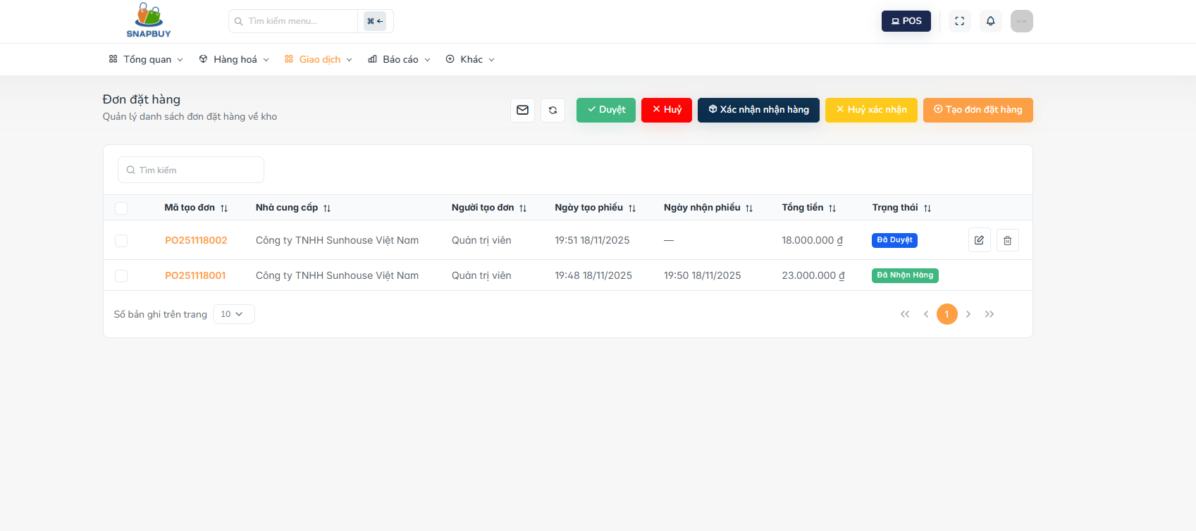
Figure 3.9.1. View Purchase Order
Field Name | Description
Mã tạo đơn | Displays the unique code of the purchase order created in the system.
Nhà cung cấp | Displays the name of the supplier associated with the purchase order.
Người tạo đơn | Displays the name of the user who created the purchase order.
Ngày tạo phiếu | Displays the date when the purchase order was created.
Ngày nhận hàng | Displays the expected or actual date the goods are received.
Tổng tiền | Displays the total value of all items in the purchase order.
Trạng thái | Displays the current status of the purchase order
Tạo đơn hàng | Action button: hyperlink to create a new purchase order screen
Duyệt | Action button: Approves the purchase order when it is in “Chờ duyệt” status
Hủy | Action button: Cancels the purchase order when it is in a status that allows cancellation
Xác nhận nhận hàng | Action button: Confirms that the goods for the purchase order have been received
Hủy xác nhận | Action button: Reverts the Purchase order confirmation and restores the previous status
Pen icon | Action button: Opens the edit form for the selected purchase order

3.9.2 Purchase order detail screen
This screen allows the user to:
- View purchase order detail

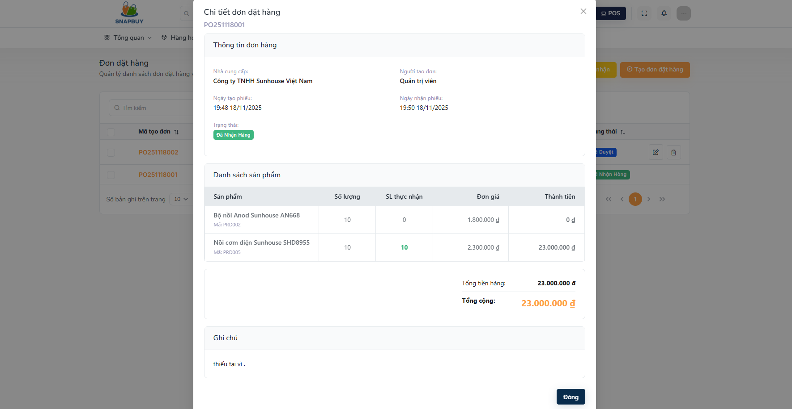
Figure 3.9.2. View Purchase Order Detail
Field Name | Description
Mã tạo đơn | Displays the unique code of the purchase order created in the system.
Nhà cung cấp | Displays the name of the supplier associated with the purchase order.
Người tạo đơn | Displays the name of the user who created the purchase order.
Ngày tạo phiếu | Displays the date when the purchase order was created.
Ngày nhận hàng | Displays the expected or actual date the goods are received.
Sản phẩm | Displays the name of each product included in the purchase order. Alongside, it shows the ordered quantity, received quantity, and unit price for each product.
Trạng thái | Displays the current status of the purchase order
Ghi chú | Displays any additional notes or remarks for the product or the purchase order
Đóng | Action button to close the Purchase Order Detail screen and return to the Purchase Order List without making changes.

3.9.3 Create purchase order screen
This screen allows the user to:
- Create purchase order

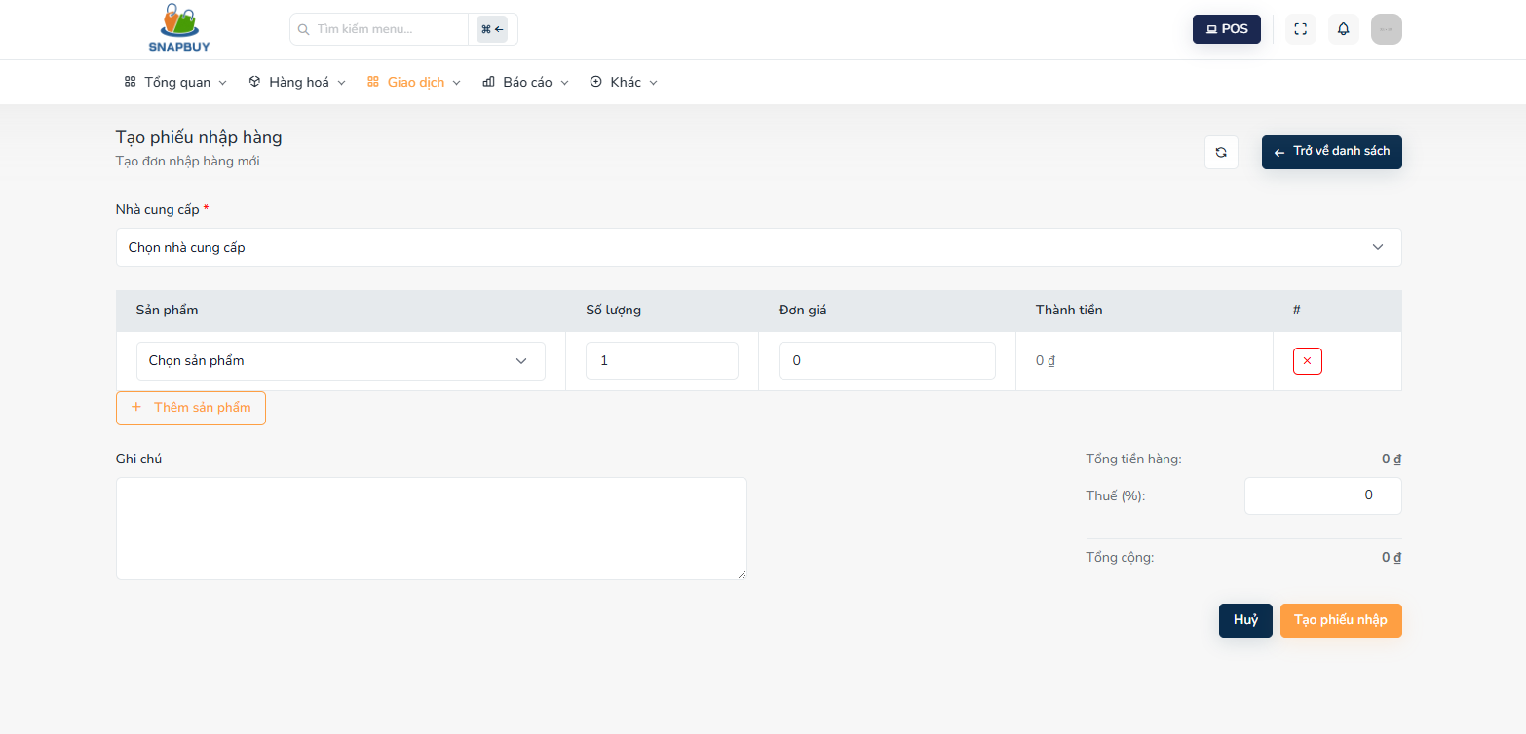
Figure 3.9.3. Create Purchase Order
Field Name | Description
Chọn nhà cung cấp | Dropdown to choose the supplier for the purchase order.
Chọn sản phẩm | Dropdown to select products to add to the purchase order.
Số lượng | Field to enter the quantity of the selected product to order.
Đơn giá | Field to enter the price per unit of the selected product.
Thành tiền | Displays the calculated total for the product line (Quantity × Unit Price).
Ghi chú | Field to enter additional remarks or notes for the product or order.
Thuế | Field to enter or display tax applied to the product line or overall order
Thêm sản phẩm | Action button to add product with entered quantity, unit price, and tax to the purchase order.
Tạo phiếu nhập | Action button to save and create the new purchase order in the system.
Hủy | Action button to cancel the creation process and close the form without saving.
Trở về danh sách | Action button to navigate back to the Purchase Order List screen.

3.9.4 Update purchase order screen
This screen allows the user to:
- Update purchase order
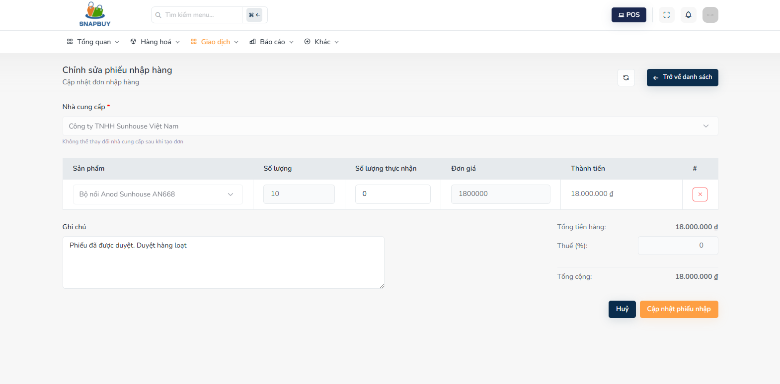
Figure 3.9.4. Update Purchase Order
Field Name | Description
Chọn nhà cung cấp | Dropdown displaying the supplier of the selected purchase order. Pre-filled with the current supplier and can be changed if allowed.
Chọn sản phẩm | Dropdown to add new products to the purchase order. Existing products are already listed with current quantities and prices.
Số lượng | Field showing the quantity of the selected product. Pre-filled with the ordered quantity and can be edited.
Đơn giá | Field showing the current unit price of the selected product. Editable if changes are needed.
Thành tiền | Displays the calculated total for each product line (Quantity × Unit Price). Updates automatically if quantity or unit price changes.
Ghi chú | Field displaying any existing notes for the product or order. Can be updated.
Thuế | Field showing any tax applied to the product line or overall order. Editable if necessary.
Thêm sản phẩm | Action button to add product with entered quantity, unit price, and tax to the purchase order.
Cập nhật phiếu nhập | Action button to save all changes and update the selected purchase order in the system.
Hủy | Action button to cancel the creation process and close the form without saving.
Trở về danh sách | Action button to navigate back to the Purchase Order List screen.

3.10 Promotion Management

3.10.1 View promotion list
This screen allows the user to:
- View promotion list
- Add new promotion
- Update promotion
- Delete promotion
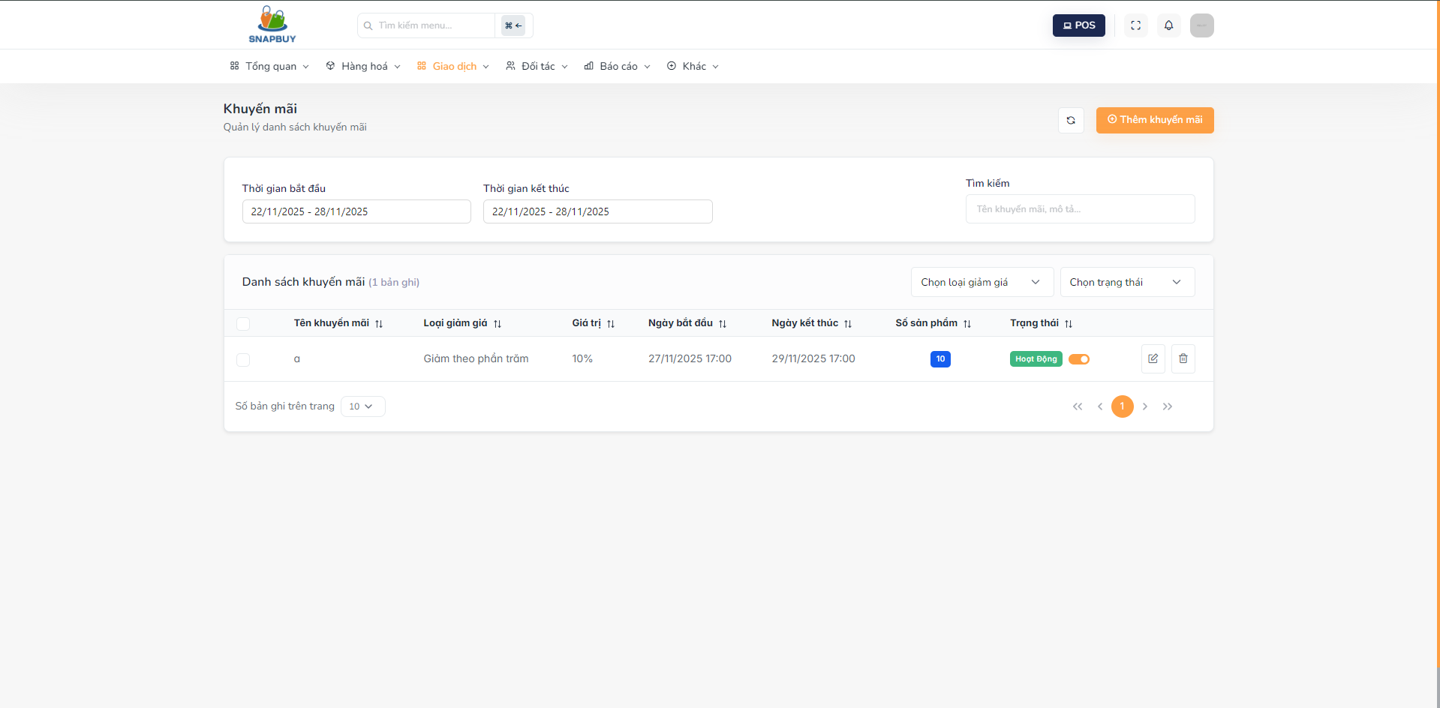

Figure 3.10.1. View Promotion List
Field Name | Description
Tên khuyến mãi | Displays the name of the promotion.
Loại giảm giá | Indicates the type of discount
Giá trị | The discount value based on the selected discount type.
Ngày bắt đầu | The date the promotion becomes effective.
Ngày kết thúc | The date the promotion ends
Số sản phẩm | Number of products associated with the promotion.
Trạng thái | Current status of the promotion
Chọn loại giảm giá | Filters allow users to select and view promotions by discount type.
Chọn trạng thái | Filter helps to filter the promotion list by current status.
Thêm khuyến mãi | Action button to create a new promotion and open the promotion creation form.
Pen icon | Opens the form to edit the selected promotion
Delete icon | Opens the form to delete the selected promotion

3.10.2 Add new promotion
This screen allows the user to:
- Add new promotion
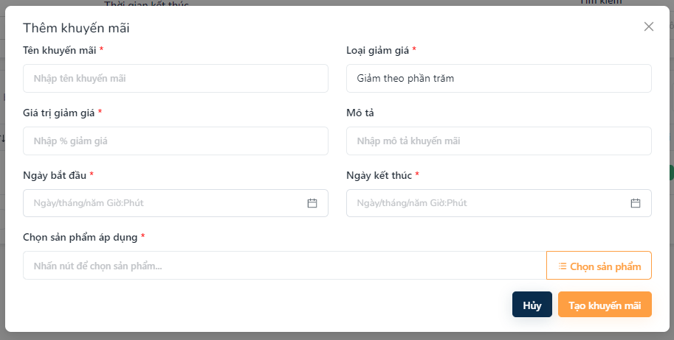

Figure 3.10.3. Add New Promotion
Field Name | Description
Tên khuyến mãi | Field for entering the name of the new promotion.
Loại giảm giá | Dropdown for selecting the type of discount
Giá trị giảm giá | Field for entering the discount amount based on the selected discount type.
Ngày bắt đầu | Field for selecting the date when the promotion becomes effective.
Ngày kết thúc | Field for selecting the date when the promotion ends.
Mô tả | Field for adding details or notes about the promotion
Chọn sản phẩm áp dụng | Dropdown or selector to choose products that the promotion will apply to.
Tạo khuyến mãi | Action button to save and create the new promotion.
Hủy | Action button to cancel the creation process and close the form without saving.

3.10.4 Edit promotion
This screen allows the user to:
- Update promotion
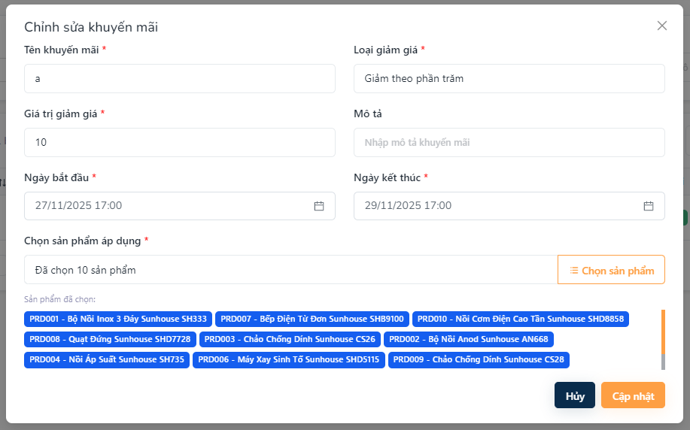

Figure 3.10.4. Edit Promotion
Field Name | Description
Tên khuyến mãi | Field displaying the current promotion name. Editable to update the promotion title.
Loại giảm giá | Dropdown showing the existing discount type. Can be changed if needed.
Giá trị giảm giá | Field showing the current discount value. Editable to modify the discount amount.
Ngày bắt đầu | Field displaying the start date of the promotion. Can be updated.
Ngày kết thúc | Field displaying the end date of the promotion. Can be modified if the promotion duration changes.
Mô tả | Field showing the existing promotion details or notes. Editable for updates.
Chọn sản phẩm áp dụng | Selector to view or update the list of products included in the promotion.
Cập nhật | Action button to save all changes and update the promotion.
Hủy | Action button to discard changes and return to the previous screen.

3.10.5 Delete promotion
This screen allows the user to:
- Delete promotion
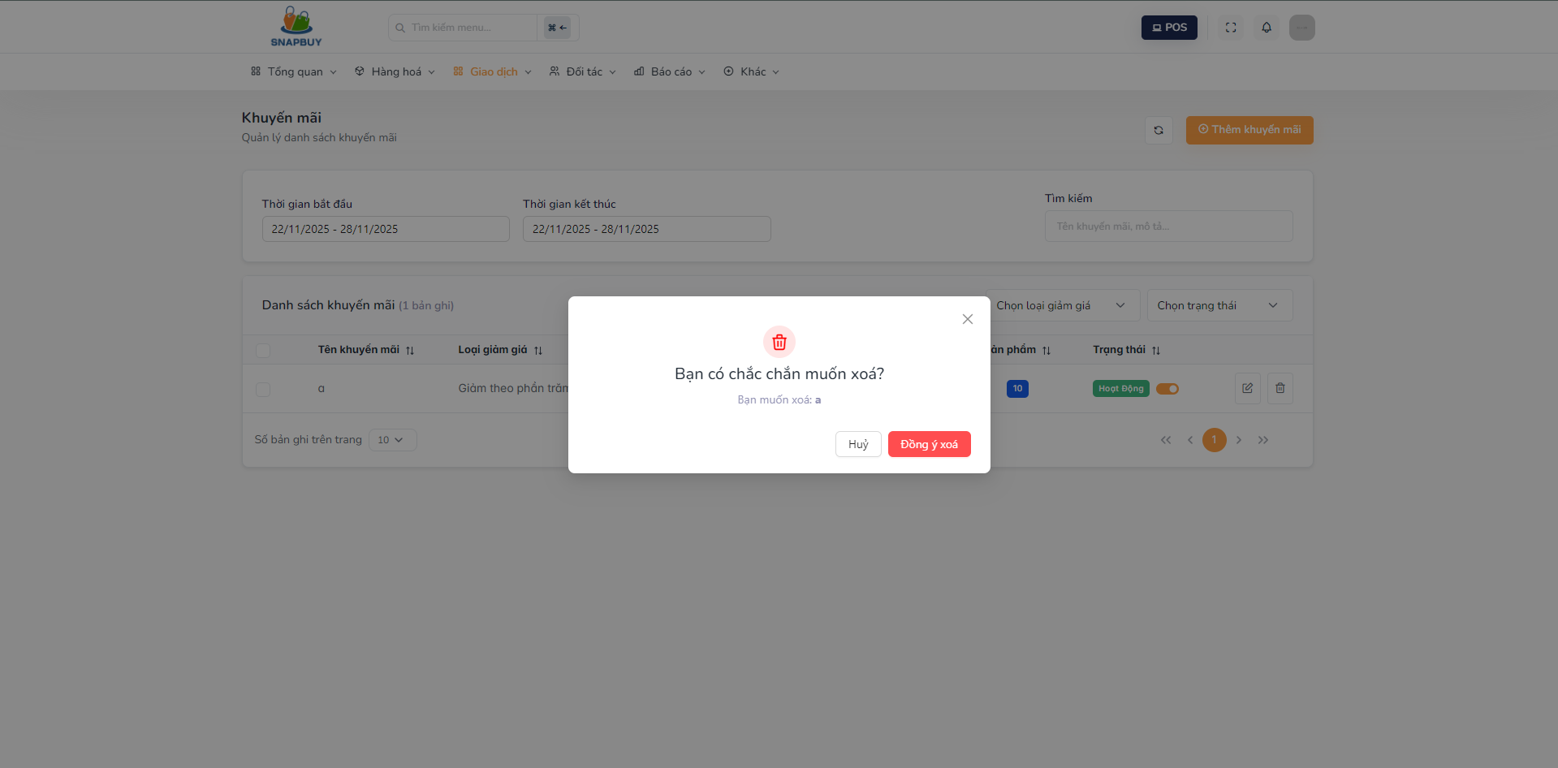

Figure 3.10.5. Delete Promotion
Field Name | Description
Đồng ý xóa | Action button: Save delete promotion
Hủy | Action button:Cancel and close the form without saving.

3.11 Product price

3.11.1 Product price list screen
This screen allows the user to:
- View Product price list
- Search product price
- Edit product price
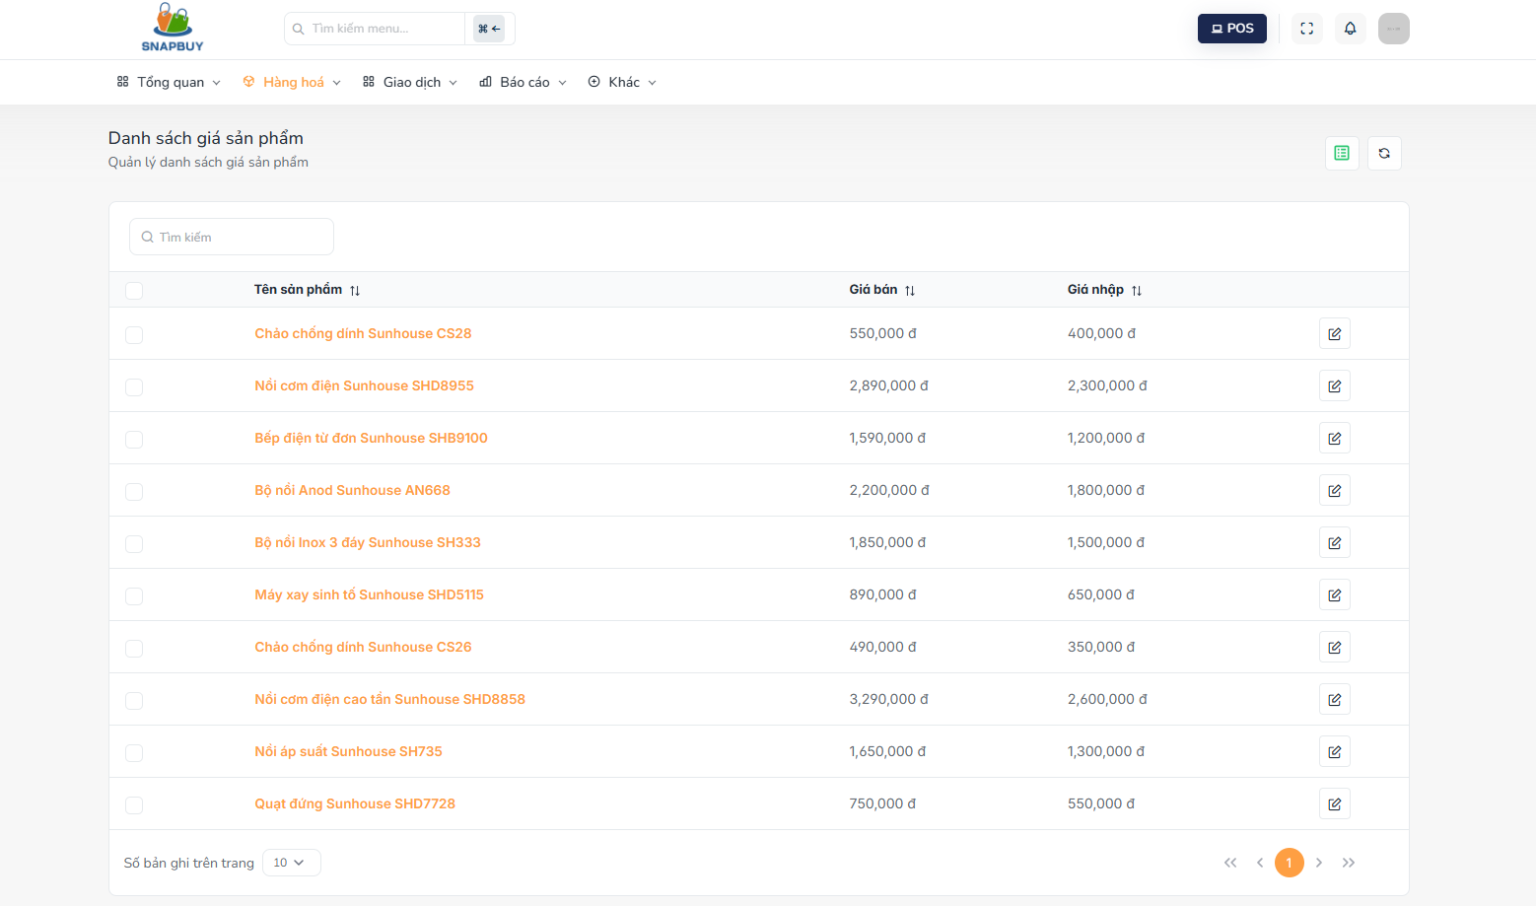
Figure 3.11.1. Product price list
Field Name | Description
Tên sản phẩm | Displays the name of the product price.
Giá bán | Shows the current selling price of the product.
Giá nhập | Shows the current cost price (purchase price) of the product.
Pen icon | Opens the form to edit the selling price and cost price of the selected product.

3.11.2 Edit product price screen
This screen allows the user to:
- Edit product price
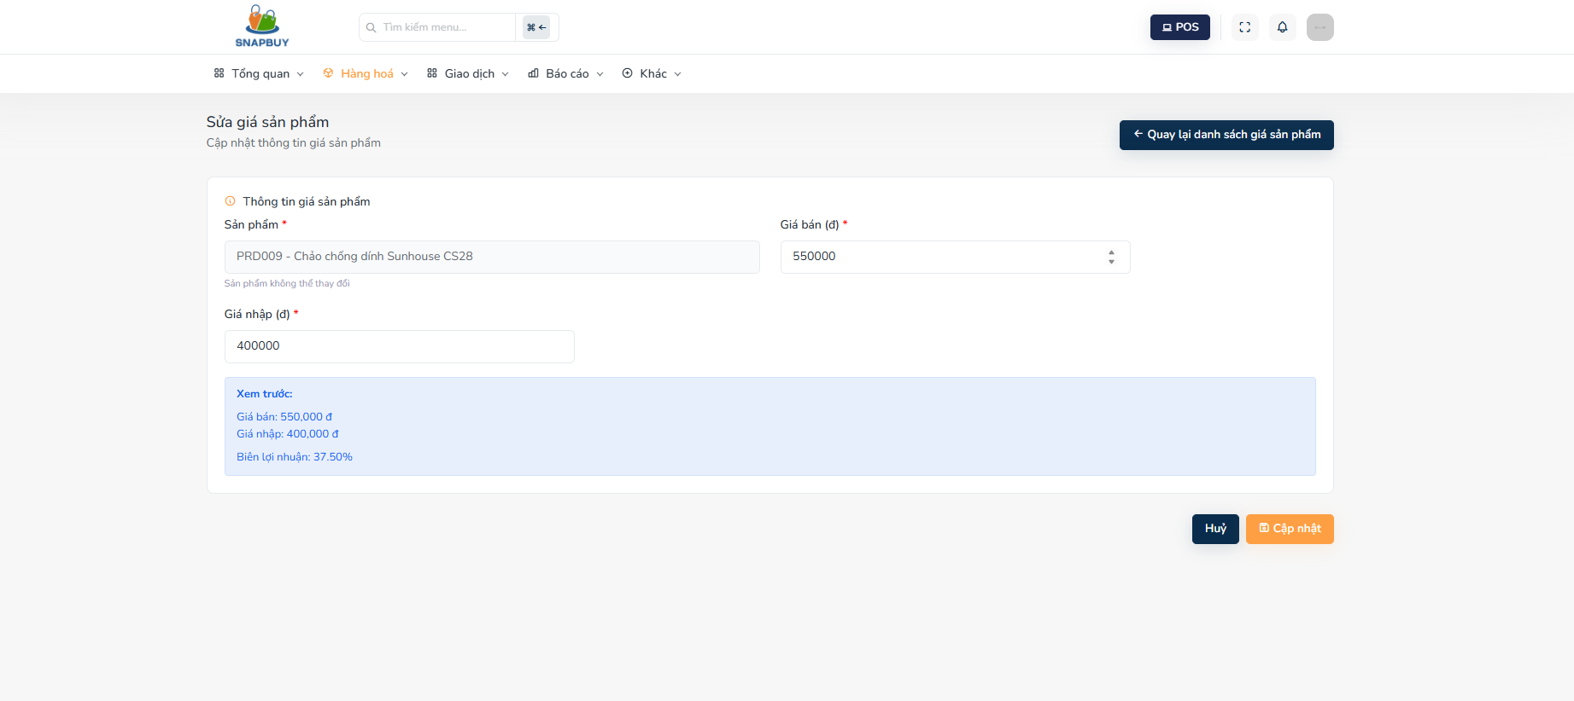
Figure 3.11.2 Edit Product Price
Field Name | Description
Sản phẩm | Displays the selected product. This field shows the product name and cannot be changed.
Giá bán | Field for entering or updating the product’s selling price.
Giá nhập | Field for entering or updating the product’s cost price (purchase price).
Cập nhật | Action button to save all changes to the product pricing.
Hủy | Action button to discard the changes and close the form without saving.
Quay lại danh sách giá sản phẩm | Action button to return to the Product Price List screen.

3.12 Report

3.12.1 Revenue Report
This screen allows the user to:
- View revenue performance for a selected date or reporting period.
- Filter revenue data by report type (daily, monthly, etc.) and by staff if needed.
- Load detailed revenue analytics including total revenue, number of orders, and average order value.
- Visualize revenue and average order value through interactive charts.
- Review a detailed list of sold products, including selling price, quantity sold, and total amount for each item.
- Analyze business performance and make data-driven decisions based on sales results
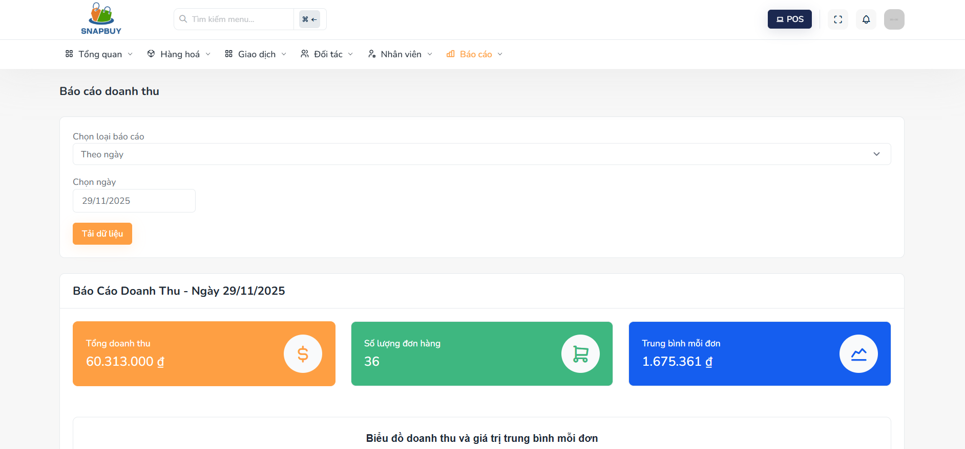
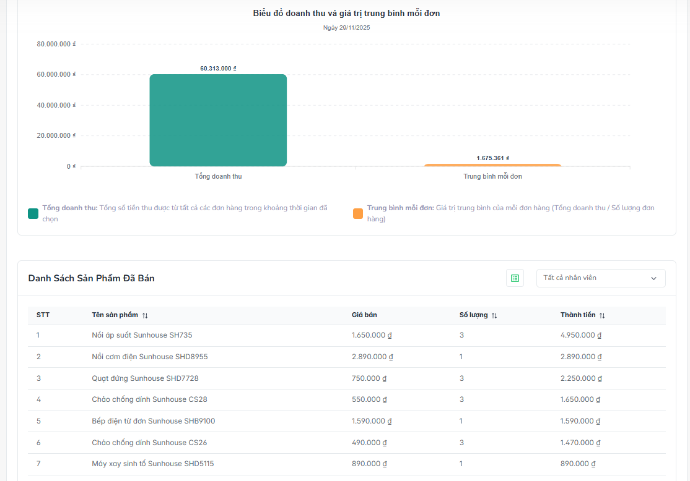
Figure 3.12.1 Revenue Report
Field Name | Description
Chọn loại báo cáo | Dropdown allows users to select the report type (e.g., daily, monthly).
Chọn ngày | Date picker used to select the specific date for generating the revenue report.
Tải dữ liệu | Action button to load and display the revenue report based on selected filters.
Tổng doanh thu | Displays the total revenue generated for the selected period.
Số lượng đơn hàng | Shows the total number of orders within the selected date range.
Trung bình mỗi đơn | Displays the average order value (Total Revenue / Number of Orders).
Biểu đồ doanh thu | Chart visualizing total revenue in the selected timeframe.
Biểu đồ giá trị trung bình mỗi đơn | Chart showing the average order value for the selected period.
Danh sách sản phẩm đã bán | List displaying all sold products for the selected date, including details such as name, price, quantity, and total amount.
STT | Index number of each product in the list.
Tên sản phẩm | Displays the name of the sold product.
Giá bán | Shows the selling price of each product.
Số lượng | Displays the number of units sold for each product.
Thành tiền | Displays the total amount for each product line (Selling Price × Quantity).
Tất cả nhân viên | Dropdown filter allowing users to view revenue by specific staff or all staff.

3.12.2 Product Report
This screen allows the user to:
- View detailed product sales performance for a selected date or reporting period.
- Filter and load product sales data quickly using predefined report types.
- Analyze total sold quantity and number of unique products sold.
- View a structured table of all sold products, including category, cost price, selling price, and quantity sold.
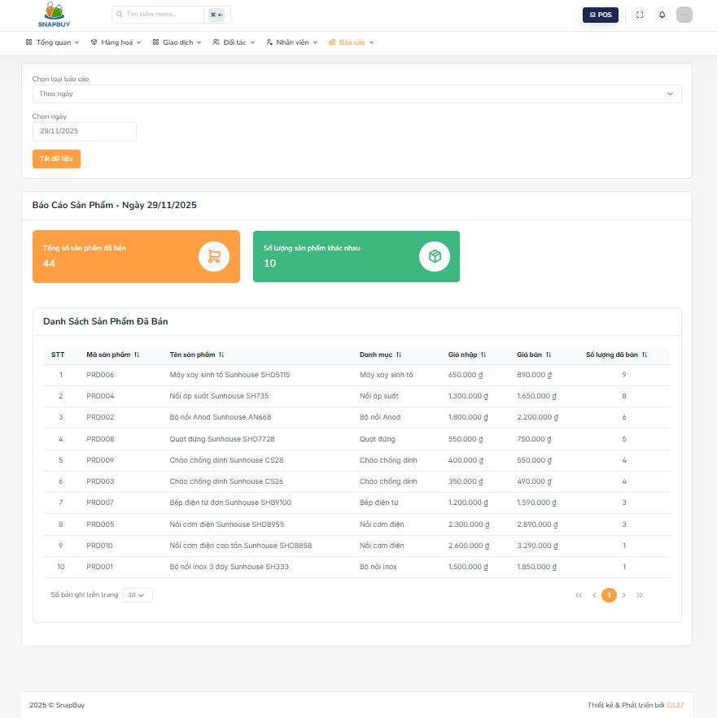
Figure 3.12.2 Product Report
Field Name | Description
Chọn loại báo cáo | Dropdown allows users to select the report type (e.g., daily, monthly).
Chọn ngày | Date picker for selecting the specific date to generate the product report.
Tải dữ liệu | Action button to load product report data based on the selected criteria.
Tổng số sản phẩm đã bán | Displays the total number of sold items for the selected period.
Số lượng sản phẩm khác nhau | Shows how many unique product types were sold.
Danh sách sản phẩm đã bán | Displays the list of all sold products including product details and quantities.
STT | Index number of each product in the list.
Mã sản phẩm | Displays the product code for identification.
Tên sản phẩm | Shows the name of the sold product.
Danh mục | Displays the product category.
Giá nhập | Shows the cost price (purchase price) of the product.
Giá bán | Shows the selling price of the product.
Số lượng đã bán | Indicates how many units of the product were sold during the selected period.

3.12.3 Customer Report
This screen allows the user to:
- View purchasing behavior and activity of customers for a selected date or reporting range.
- Load customer-related purchase data through report type and date filters.
- Analyze the total number of customers and total purchased products.
- Review detailed customer information including purchase quantity and product diversity.
- Identify customer buying trends and support customer management and business strategy decisions.

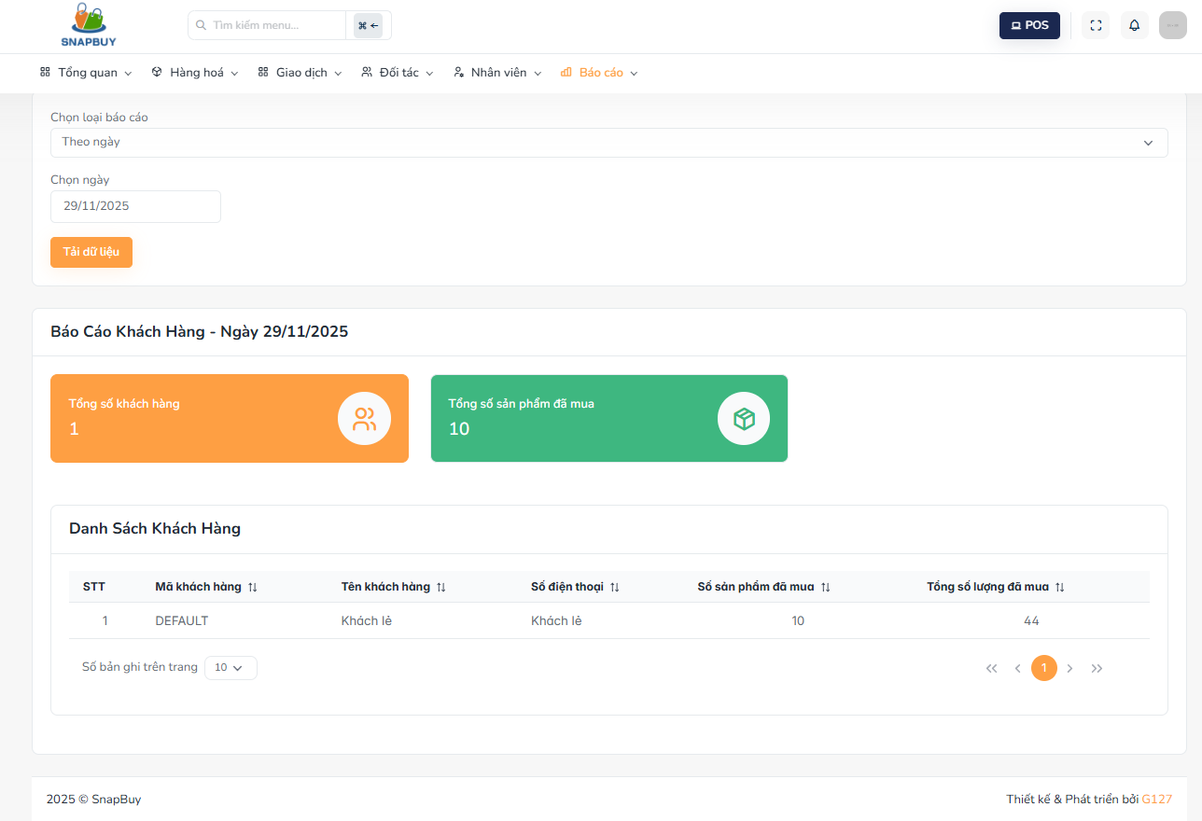
Figure 3.12.3 Customer Report
Field Name | Description
Chọn loại báo cáo | Dropdown allows users to select the report type (e.g., daily, monthly).
Chọn ngày | Date picker used to select the date for generating the customer report.
Tải dữ liệu | Action button to load customer report data based on selected filters.
Tổng số khách hàng | Displays the total number of customers who made purchases on the selected date.
Tổng số sản phẩm đã mua | Shows the total number of products purchased by all customers.
Danh sách khách hàng | Table listing customer details and their purchase statistics.
STT | Index number of each customer in the list.
Mã khách hàng | Displays the customer's unique ID or code.
Tên khách hàng | Shows the customer's name.
Số điện thoại | Displays the customer’s phone number.
Số sản phẩm đã mua | Shows how many different product items the customer purchased.
Tổng số lượng đã mua | Indicates the total quantity of all products purchased by the customer.

3.12.4 Supplier Report
This screen allows the user to:
- View purchase and import statistics by supplier for a selected date or time period.
- Filter and load supplier-related data using report type and date selections.
- Analyze total spending, number of suppliers, and diversity of imported products.
- Review a detailed table of each supplier, including total quantities and total cost of goods imported.
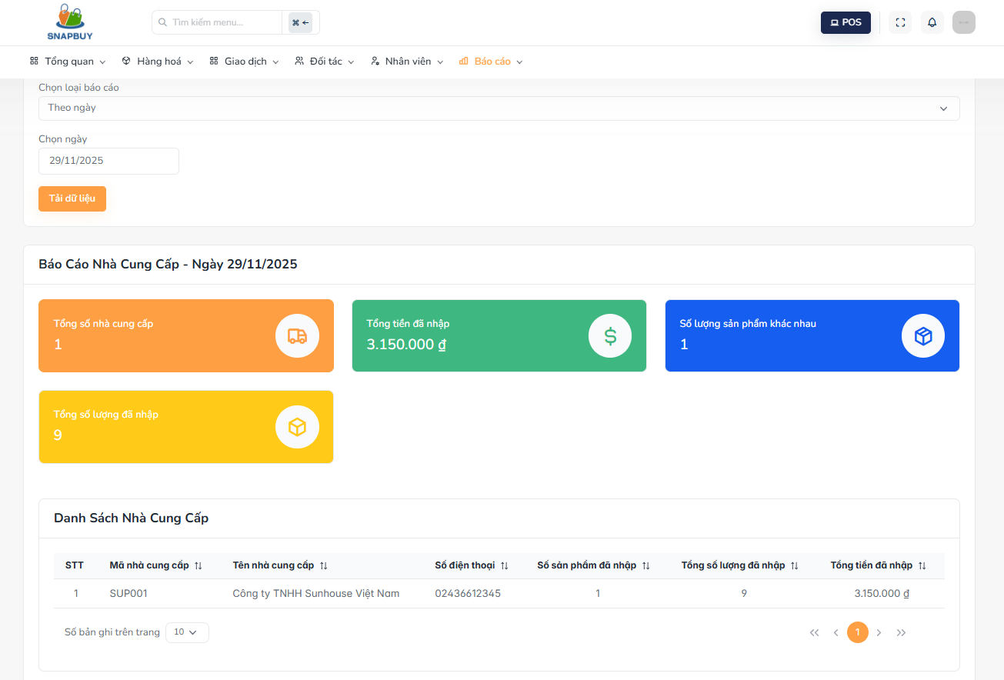
Figure 3.12.4. Supplier Report
Field Name | Description
Chọn loại báo cáo | Dropdown allows users to select the report type (e.g., daily, monthly).
Chọn ngày | Date picker for selecting the date to generate the supplier report.
Tải dữ liệu | Action button to load supplier report data based on selected filters.
Tổng số nhà cung cấp | Displays the total number of suppliers involved within the selected timeframe.
Tổng tiền đã nhập | Shows the total cost of goods purchased from suppliers.
Số lượng sản phẩm khác nhau | Displays the number of unique products purchased from suppliers.
Tổng số lượng đã nhập | Shows the total quantity of all products received from suppliers.
Danh sách nhà cung cấp | Table listing suppliers with detailed import/purchase information.
STT | Index number of each supplier in the list.
Mã nhà cung cấp | Displays the supplier’s unique code.
Tên nhà cung cấp | Shows the supplier’s name.
Số điện thoại | Displays the supplier’s contact phone number.
Số sản phẩm đã nhập | Shows how many different product types were imported from the supplier.
Tổng số lượng đã nhập | Indicates the total quantity of products received from the supplier.
Tổng tiền đã nhập | Displays the total amount spent on imported goods from this supplier.

3.13 Workshift management

3.13.1 Workshift list screen
This screen allows the user to:
- View all employees and their current workshift status.
- Open a new workshift for an employee.
- Close an existing workshift for an employee.
- Search employees by name or username.
- Filter workshift history by status.
- Monitor active, closed, and pending workshifts.
- Access detailed workshift information for each employee.
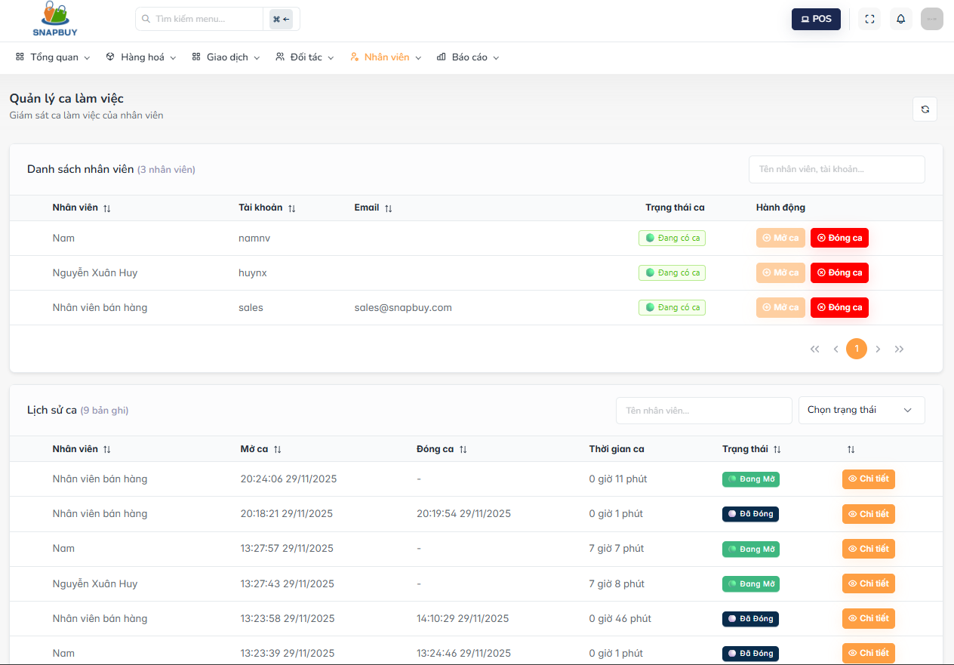
Figure 3.13.1. Workshift list
Field Name | Description
Danh sách nhân viên | Displays the list of employees and their current workshift status.
Nhân viên | Shows the name of the employee.
Tài khoản | Displays the employee’s username.
Email | Shows the employee's email.
Trạng thái ca | Indicates whether the employee is currently in an active shift or not.
Mở ca | Action button to open a new workshift for the selected employee.
Đóng ca | Action button to close the current workshift for the selected employee.
Lịch sử ca | Section displaying the list of past and ongoing workshifts.
Thời gian mở ca | Shows the timestamp when the shift was opened.
Thời gian đóng ca | Shows the timestamp when the shift was closed.
Thời gian ca | Displays the total duration of the workshift.
Trạng thái | Indicates whether the shift is active, closed, or pending.
Chi tiết | Action button to open the detailed view of the selected workshift.
Tìm kiếm nhân viên | Field allowing users to search by employee name or username.
Chọn trạng thái | Filter to view shifts by status.

3.13.2 Workshift detail screen
This screen allows the user to:
- View detailed information about an employee’s workshift.
- Compare opening and closing cash denominations.
- Review discrepancies between the beginning and end of a shift.
- View total revenue and the number of orders processed during the shift.
- Review the full list of orders associated with the shift.
- Check payment methods and order outcomes (successful or failed).
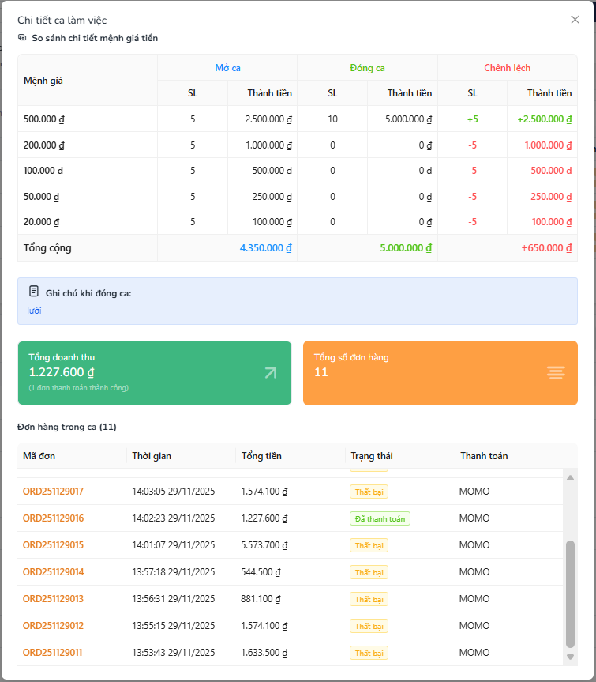
Figure 3.13.2 Workshift detail
Field Name | Description
So sánh chi tiết mệnh giá tiền | Section displaying cash denomination comparison between opening and closing.
Mệnh giá | Shows the currency denomination (e.g., 500đ, 1.000đ, etc.).
SL (Mở ca) | Quantity of each denomination recorded at the beginning of the shift.
Thành tiền (Mở ca) | Total cash amount per denomination at shift opening.
SL (Đóng ca) | Quantity of each denomination recorded at the end of the shift.
Thành tiền (Đóng ca) | Total cash amount per denomination at shift closing.
Chênh lệch | Displays the difference between opening and closing amounts.
Ghi chú khi đóng ca | Notes entered by the employee or manager when closing the shift.
Tổng doanh thu | Shows the total successful sales amount generated during the shift.
Tổng số đơn hàng | Shows the number of completed orders during the shift.
Danh sách đơn hàng trong ca | Displays all orders processed during the shift.
Mã đơn | Order ID.
Thời gian | Timestamp of the order.
Tổng tiền | Total order amount.
Trạng thái | Payment or order status (e.g., Completed, Failed).
Thanh toán | Payment method used for the order.

3.13.3 Open workshift screen
This screen allows the user to:
- Start a new workshift for an employee.
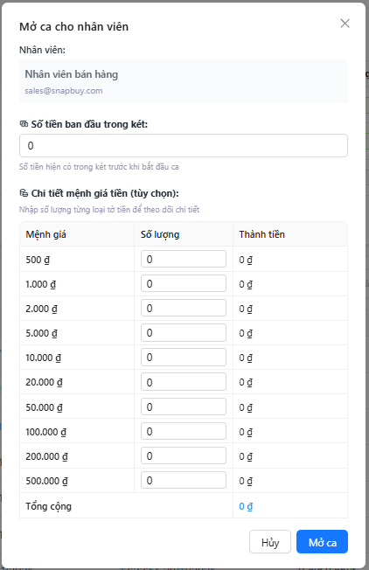
Figure 3.13.2 Open Shift
Field Name | Description
Nhân viên | Displays the name and email of the employee starting the shift.
Số tiền ban đầu trong két | Field for entering the starting cash amount in the register.
Chi tiết mệnh giá tiền (tùy chọn) | Optional section allowing users to input cash quantities per denomination at shift opening.
Mệnh giá | Currency denomination values.
Số lượng | Quantity of each denomination entered at opening.
Thành tiền | Total amount per denomination calculated automatically.
Tổng cộng | Sum of all denomination amounts.
Hủy | Action button to cancel the shift opening process.
Mở ca | Action button to confirm and open the new workshift.

3.13.4 Close workshift screen
This screen allows the user to:
- Close an active workshift for an employee.
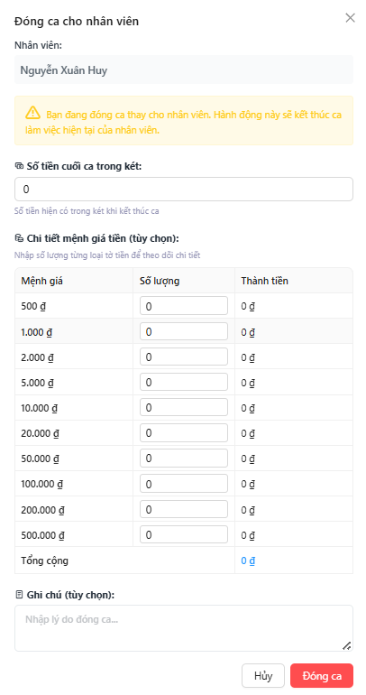
Figure 3.13.4 Close Shift
Field Name | Description
Nhân viên | Displays the name of the employee whose shift is being closed.
Số tiền cuối ca trong két | Field for entering the final cash amount in the register at shift closing.
Chi tiết mệnh giá tiền (tùy chọn) | Optional section to input cash quantities per denomination at shift closing.
Mệnh giá | Currency denomination values.
Số lượng | Quantity of each denomination at shift closing.
Thành tiền | Automatically calculated total per denomination.
Tổng cộng | Final total cash counted at shift closing.
Ghi chú (tùy chọn) | Optional field for adding closing notes.
Hủy | Action button to cancel the closing process.
Đóng ca | Action button to confirm and close the workshift.

4. Non-Functional Requirements

4.1 External Interfaces
User Interface (UI):
- The SnapBuy system interface must be simple, intuitive, and user-friendly for all roles (e.g., Administrator, Shop Owner, Staff, Customer).
- All core features (e.g., product management, order creation, payment, customer point management) should be accessible within three clicks or fewer from the dashboard.
- The system must support a web-based interface that works across all major browsers (Chrome, Firefox, Edge, Safari).
- The UI should provide clear status indicators (e.g., Pending, Approved, Canceled) and real-time feedback on user actions such as product import, payment, or order approval.
- The interface should also support responsive design, enabling use on desktop and tablet devices.
Hardware Interfaces:
- No direct hardware dependencies are required.
- However, the system should remain flexible for integration with external devices (e.g., barcode scanners, Purchase order printers, POS terminals) in future versions.
Software Integration:
- The system must integrate with the following external or internal services:
  - Payment Gateway APIs (e.g., MoMo).
  - Email and Notification Services via standard SMTP/IMAP protocols for sending order updates and notifications.
  - Database Server: MySQL for reliable data storage.
  - Authentication Service: Compatible with JWT-based security or OAuth2 .
- The system should provide RESTful APIs for integration with external systems (e.g., accounting, inventory tracking, or reporting tools).

4.2 Quality Attributes

4.2.1 Usability
- The system should be easy to navigate and operate by all user types, including non-technical users such as shop owners or staff.
- The average time to complete key tasks (e.g., create order, view product list, update stock) should be under 1 minute.
- Admins or managers who perform more complex operations (e.g., user management, system configuration) should require no more than 2 hours of initial training.
- All frequently used actions (e.g., create order, apply discount, view supplier) should be accessible within 3 clicks from the dashboard.

4.2.2 Performance
- The system should respond to user interactions within 3 seconds for 95% of operations under normal conditions.
- Critical operations such as order creation, payment processing, and product import must complete within 5 seconds.
- The system must support at least 1,000 concurrent users (e.g., multiple stores or staff members) without significant performance degradation.
- The API endpoints should be optimized to handle bulk operations (e.g., importing large product lists or budget files)

4.2.3 Reliability
- The system must maintain at least 99.5% uptime per month, excluding planned maintenance.
- In the event of system failure, the service should auto-recover within 10 minutes using mechanisms such as load balancing or automatic restart.
- All critical transactions (e.g., order creation, payment, inventory update) should be logged and auditable.
- The system should prevent data loss during network or server interruptions by implementing transactional integrity (e.g., rollback if payment fails).

4.2.4 Security
- Authentication & Authorization: All users must log in using secure credentials (username/password), with role-based access control (RBAC) enforced (e.g., Admin, Shop Owner, Staff).
- Data Protection: Sensitive information such as passwords and payment details must be encrypted in both storage and transmission (HTTPS, AES, or equivalent).
- Password Policy: Passwords must be at least 8 characters long and include uppercase, lowercase, numbers, and special characters.
- Access Control: Different roles have distinct permissions—for example, only Admins can manage system users, and only Shop Owners can create staff accounts.
- The system must log all login attempts, failed transactions, and administrative actions for audit and traceability.

5. Requirement Appendix

5.1 Business Rules
ID | Rule Definition
BR-01 | All user accounts must be assigned a unique User ID upon creation, ensuring traceability across all system activities.
BR-02 | Low stock alerts must be triggered when inventory levels fall below the defined reorder point, notifying relevant staff.
BR-03 | Customer complaints must be logged with a unique Complaint ID and assigned to Sales Staff for resolution within 72 hours.
BR-04 | Loyalty points must be automatically credited to a customer’s account after each qualifying transaction at the POS.
BR-05 | Daily sales reports must be generated automatically at the end of each day and stored in the system for Shop Owner review.
BR-06 | Payment transactions at the POS must be logged with a unique identifier for reconciliation in financial reports.
BR-07 | Staff performance metrics must be updated daily to reflect sales and customer service activities.
BR-08 | Promotional discounts must be validated against active promotion periods before application at the POS.
BR-09 | Customer loyalty status must be updated automatically when points reach predefined tier thresholds.

5.2 Application Messages List
# | Message code | Message Type | Context | Content
1 | MSG001 | Success | Create Account | Tài khoản đã được tạo thành công.
2 | MSG002 | Error | Create Account | Không thể tạo tài khoản. Vui lòng kiểm tra lại thông tin.
3 | MSG003 | Success | Update Account | Cập nhật thông tin tài khoản thành công.
4 | MSG004 | Error | Update Account | Lỗi khi cập nhật tài khoản. Vui lòng thử lại sau.
5 | MSG005 | Success | Delete Account | Tài khoản đã được xóa thành công.
6 | MSG006 | Warning | Change Password | Mật khẩu mới không được trùng với mật khẩu cũ.
7 | MSG007 | Success | Change Password | Đổi mật khẩu thành công.
8 | MSG008 | Error | Permission Validation | Người dùng không có quyền thực hiện hành động này.
9 | MSG009 | Success | Create Product | Sản phẩm đã được tạo thành công.
10 | MSG010 | Error | Create Product | Không thể tạo sản phẩm. Vui lòng kiểm tra dữ liệu nhập vào.
11 | MSG011 | Success | Update Product | Thông tin sản phẩm đã được cập nhật.
12 | MSG012 | Error | Delete Product | Không thể xóa sản phẩm vì đang được sử dụng trong đơn hàng.
13 | MSG013 | Success | Delete Product | Sản phẩm đã được xóa khỏi hệ thống.
14 | MSG014 | Info | Import Product | Import sản phẩm thành công.
15 | MSG015 | Error | Import Product | File không hợp lệ hoặc dữ liệu bị trùng.
16 | MSG016 | Success | Create Supplier | Nhà cung cấp đã được thêm thành công.
17 | MSG017 | Error | Update Supplier | Không thể cập nhật thông tin nhà cung cấp.
18 | MSG018 | Success | Delete Supplier | Nhà cung cấp đã được xóa.
19 | MSG019 | Error | Get Supplier List | Không tìm thấy nhà cung cấp nào phù hợp.
20 | MSG020 | Success | Create Order | Đơn hàng đã được tạo thành công.
21 | MSG021 | Error | Create Order | Không thể tạo đơn hàng. Vui lòng thử lại.
22 | MSG022 | Info | Add Reward Point | Khách hàng đã được cộng điểm tích lũy.
23 | MSG023 | Warning | Use Reward Point | Điểm tích lũy không đủ để sử dụng.
24 | MSG024 | Success | Cancel Order | Đơn hàng đã được hủy.
25 | MSG025 | Error | Cancel Order | Không thể hủy đơn hàng do đã thanh toán.
26 | MSG026 | Success | Confirm Purchase order | Phiếu nhập hàng đã được xác nhận và cập nhật vào kho.
27 | MSG027 | Error | Confirm Purchase order | Số lượng hàng thực tế không khớp với phiếu nhập.
28 | MSG028 | Success | Payment | Thanh toán thành công.
29 | MSG029 | Error | Payment | Thanh toán thất bại. Vui lòng kiểm tra lại.
30 | MSG030 | Info | Call Payment Gateway | Đang chuyển đến cổng thanh toán MoMo...
31 | MSG031 | Info | Show QR Code | Vui lòng quét mã QR để hoàn tất thanh toán.
32 | MSG032 | Warning | Cancel Payment | Giao dịch thanh toán đã bị hủy.
33 | MSG033 | Error | System | Lỗi không xác định. Vui lòng thử lại sau.
34 | MSG034 | Info | Session Expired | Phiên làm việc của bạn đã hết hạn. Vui lòng đăng nhập lại.
35 | MSG035 | Error | Access Control | Bạn không có quyền thực hiện hành động này.
36 | MSG036 | Info | Data Loading | Đang tải dữ liệu... Vui lòng chờ trong giây lát.
37 | MSG037 | Warning | Connection Lost | Mất kết nối máy chủ. Dữ liệu sẽ được đồng bộ lại khi kết nối trở lại.

